Kelly Kiel
Connecting the Optron Mini to FL Studio as a MIDI instrument Part 1

Category: Technology, arts
Overview: Students will get introduced to the Optron Mini, as well as go through step-by-step instructions on how to connect the Optron mini to FL Studio as a midi instrument. Students will get experience hands on with using multiple programs in conjunction in order to achieve a specific goal.
Suggested time: 50 minutes
Materials Needed:
- Computer
- Optron Mini
- FL Studio trial software
- Max 8 software
- Optron software
- LoopMIDI software
Activity: play some simple music with synthesizers in FL Studio on the Optron Mini
- Watch introduction video on the Optron Mini
  - https://media.oregonstate.edu/media/t/1_h569c7y2
- Download FL Studio trial
  - https://www.image-line.com/fl-studio-download/
- Download Max 8
  - https://cycling74.com/downloads
- Download Optron software
  - https:+//github.com/udellc/OptronMax
1. Click green “code” box
2. Click download zip
3. Navigate file explorer to: This PC > Documents > Max 8 > Packages
4. Open downloaded zip folder
5. Open “OptronMax-main” folder
6. Move folder named “Optron” from zip folder to packages folder from previous step
- Download LoopMIDI software
  - https://www.tobias-erichsen.de/software/loopmidi.html
- Watch tutorial on how to connect everything together
  - https://media.oregonstate.edu/media/t/1_l7ngsh1q
- Now return to Max 8 and open the Optron Mini tab. Set number of frets to 3 (This will give you 2 digital frets and an open string for 3 notes total)
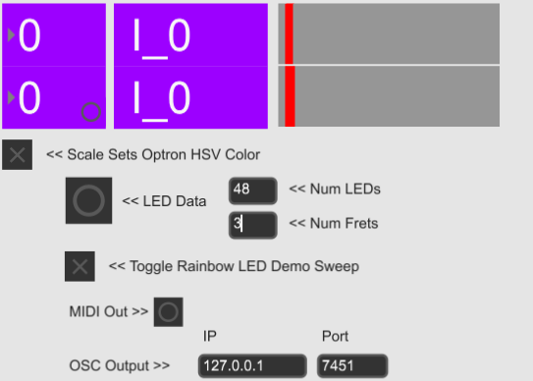
- Next, go to FL Studio
- Click on channel rack
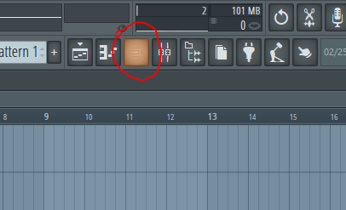
- Add a channel
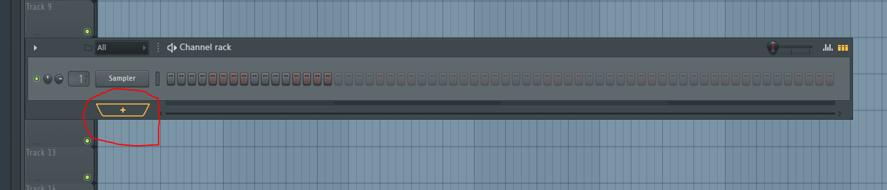
- Choose plugin called “Sakura”. (Try other plugins if you would like. Sakura is just an easy one for this activity).
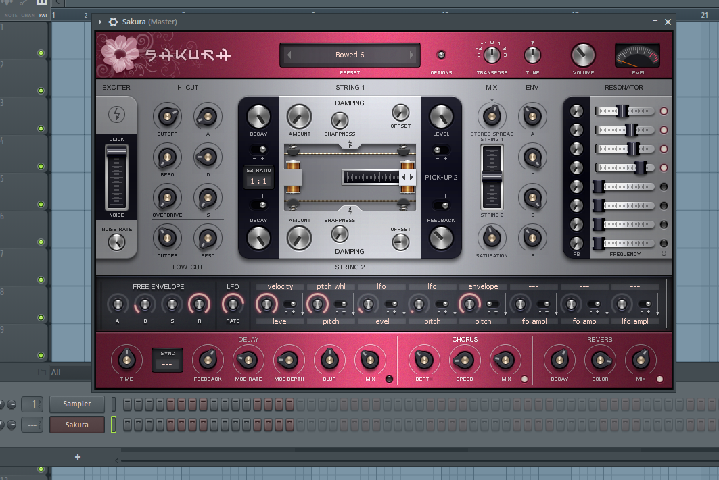
- Now try playing “Mary Had a Little Lamb” by using the colors from the Optron as reference to the following color-coded sheet music. Read left to right, one table at a time.

- Good Job!
- Here is a video of me playing this song:
  - https://media.oregonstate.edu/media/t/1_43soifof
- Once you get the hang of it, try this next one.
- For the next song, go back to the Optron Mini window and change the number of digital frets to 6.
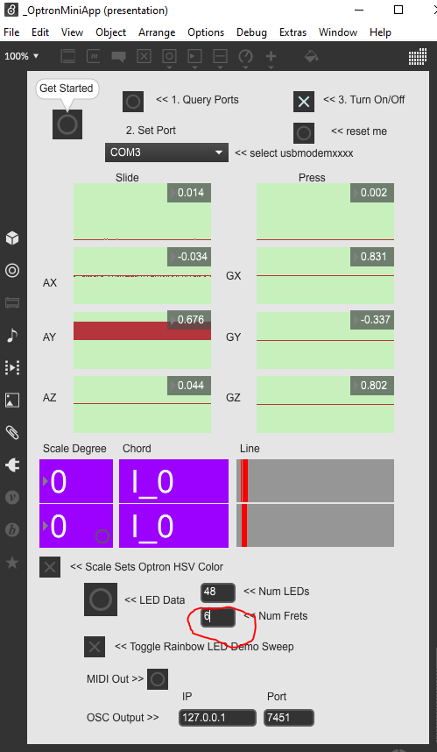
- Try and see if you can tell what song this is after playing it:

- Here is a video of me playing the song:
  - https://media.oregonstate.edu/media/t/1_vn4njcax
- *The song name will be found at the bottom of the last page
- Question: what happens when you change the number of digital frets? Try setting it to 20. Try 50. What are your findings?

Outcome goals:
- Basic imputing of values into a digital system, and evaluating the results
- Basic understanding of FL Studio
- General understanding of how to play Optron Mini
- Model how computer hardware and software work together as a system to accomplish tasks
- Generate musical ideas
- Use data to highlight or propose cause-and-effect relationships, predict outcomes, or communicate an idea.

Works Cited:
Sheet music- http://www.tubescore.net/2012/04/las-mananitas-sheet-music-for-violin.html
Outcome goals- https://www.k12.wa.us/student-success/resources-subject-area/computer-science/computer-science-k-12-learning-standards
Twinkle Twinkle Little Star

