Kelly Kiel
Connecting the Optron Mini to FL Studio as a MIDI instrument Part 1

Category: Technology, arts
Overview: Students will get introduced to the Optron Mini, as well as go through step-by-step instructions on how to connect the Optron mini to FL Studio as a midi instrument. Students will get experience hands on with using multiple programs in conjunction in order to achieve a specific goal.
Suggested time: 50 minutes
Materials Needed:
- Computer
- Optron Mini
- FL Studio trial software
- Max 8 software
- Optron software
- LoopMIDI software
Activity: play some simple music with synthesizers in FL Studio on the Optron Mini
- Watch introduction video on the Optron Mini
  - https://media.oregonstate.edu/media/t/1_h569c7y2
- Download FL Studio trial
  - https://www.image-line.com/fl-studio-download/
- Download Max 8
  - https://cycling74.com/downloads
- Download Optron software
  - https:+//github.com/udellc/OptronMax
1. Click green “code” box
2. Click download zip
3. Navigate file explorer to: This PC > Documents > Max 8 > Packages
4. Open downloaded zip folder
5. Open “OptronMax-main” folder
6. Move folder named “Optron” from zip folder to packages folder from previous step
- Download LoopMIDI software
  - https://www.tobias-erichsen.de/software/loopmidi.html
- Watch tutorial on how to connect everything together
  - https://media.oregonstate.edu/media/t/1_p729hnf4

- Now return to Max 8 and open the Optron Mini tab. Set number of frets to 3 (This will give you 2 digital frets and an open string for 3 notes total)
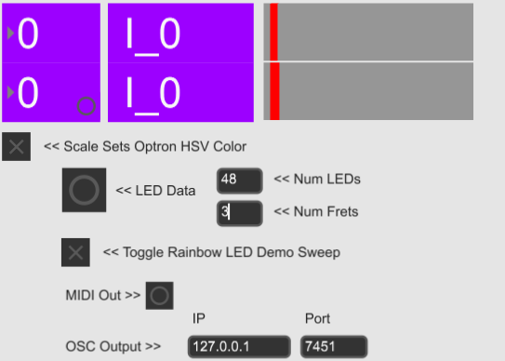
- Next, go to FL Studio
- Click on channel rack
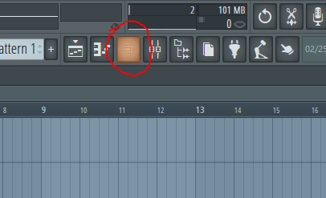
- Add a channel
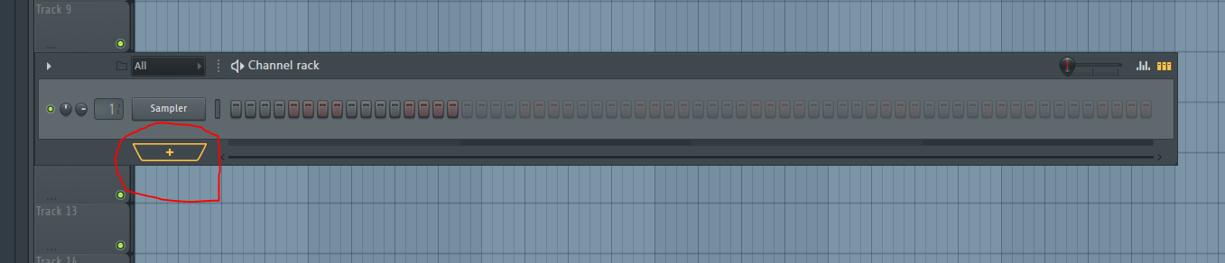
- Choose plugin called “Sakura”. (Try other plugins if you would like. Sakura is just an easy one for this activity).
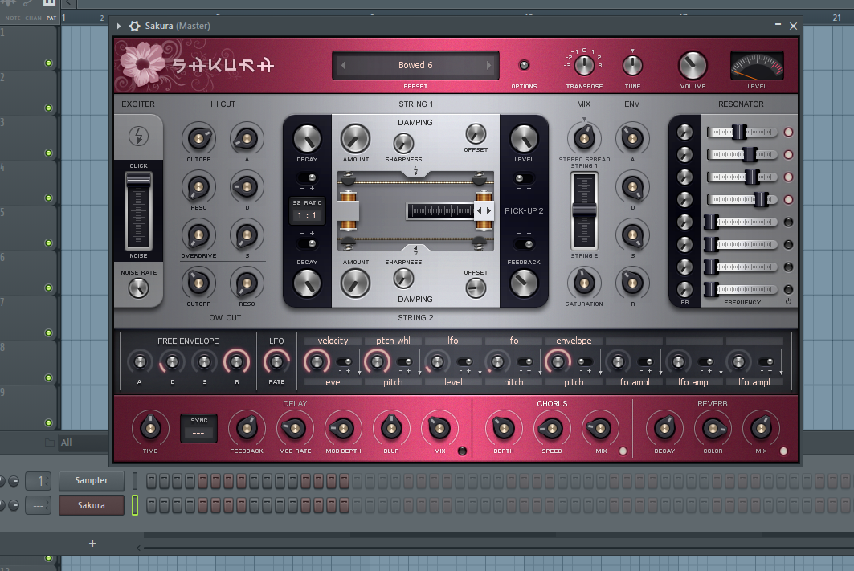
- Now try playing “Mary Had a Little Lamb” by using the colors from the Optron as reference to the following color-coded sheet music. Read left to right, one table at a time.
  - For this piece of music, the bottom bar is the open note, The middle bar is for the fret farthest out on the neck. The top bar is the farther down fret on the neck.
  - An important thing to note is that to play a note with a fret, you need to hold the fret before you hit the button.

- Good Job!
- Here is a video of me playing this song:
  - https://media.oregonstate.edu/media/t/1_43soifof
- Once you get the hang of it, try this next one.
- For the next song, go back to the Optron Mini window and change the number of digital frets to 6.
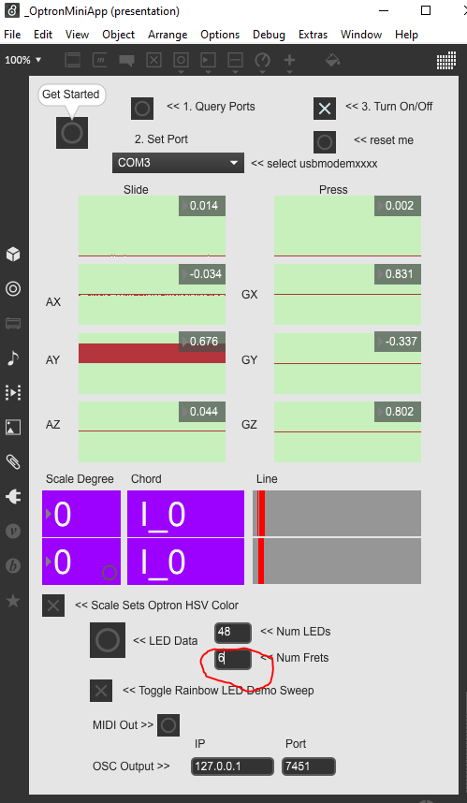
- Try and see if you can tell what song this is after playing it:

- Here is a video of me playing the song:
  - https://maedia.oregonstate.edu/media/t/1_vn4njcax
- *The song name will be found at the bottom of the last page
- Question: what happens when you change the number of digital frets? Try setting it to 20. Try 50. What are your findings?

Outcome goals:
- Basic imputing of values into a digital system, and evaluating the results
- Basic understanding of FL Studio
- General understanding of how to play Optron Mini
- Model how computer hardware and software work together as a system to accomplish tasks
- Generate musical ideas
- Use data to highlight or propose cause-and-effect relationships, predict outcomes, or communicate an idea.

Works Cited:
Sheet music- http://www.tubescore.net/2012/04/las-mananitas-sheet-music-for-violin.html
Outcome goals- https://www.k12.wa.us/student-success/resources-subject-area/computer-science/computer-science-k-12-learning-standards
Twinkle Twinkle Little Star

