Kelly Kiel
Connect Optron Mini to FL Studio (DAW)

Category: Technology, arts
Overview: Students will go through step-by-step instructions on how to connect the Optron mini to FL Studio as a midi instrument. Students will get experience hands on with using multiple programs in conjunction in order to achieve a specific goal.
Suggested time: 30-50 minutes
Materials Needed:
- Computer
- Optron Mini
- FL Studio trial software
- Max 8 software
- Optron software
- LoopMIDI software
Activity: play some simple music with synthesizers in FL Studio on the Optron Mini
- Download FL Studio trial
  - https://www.image-line.com/fl-studio-download/
- Download Max 8
  - https://cycling74.com/downloads
- Download Optron software
  - https://github.com/udellc/OptronMax
    - Click green “code” box
    - Click download zip
    - Navigate file explorer to: This PC > Documents > Max 8 > Packages
    - Open downloaded zip folder
    - Open “OptronMax-main” folder
    - Move folder named “Optron” from zip folder to packages folder from previous step
- Download LoopMIDI software
  - https://www.tobias-erichsen.de/software/loopmidi.html
- Watch tutorial on how to connect everything together
  - https://media.oregonstate.edu/media/t/1_l7ngsh1q
- Now return to Max 8 and open the Optron Mini tab. Set number of frets to 6
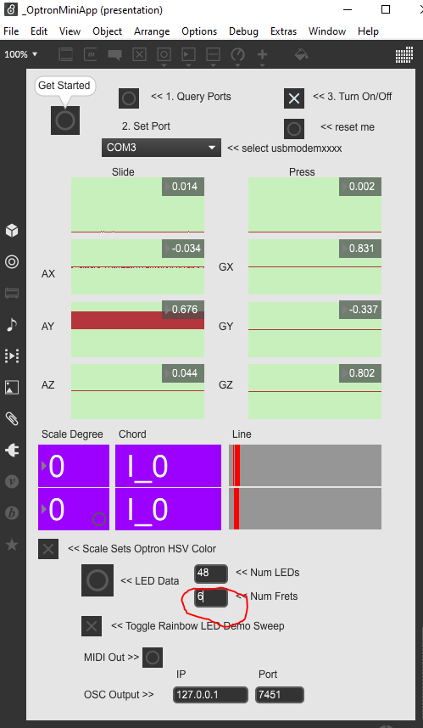
- Next, go to FL Studio
- Click on channel rack
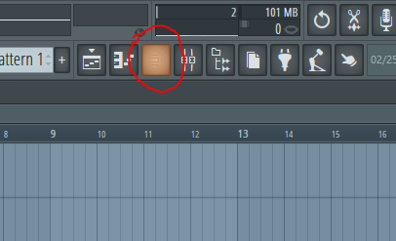
- Add a channel
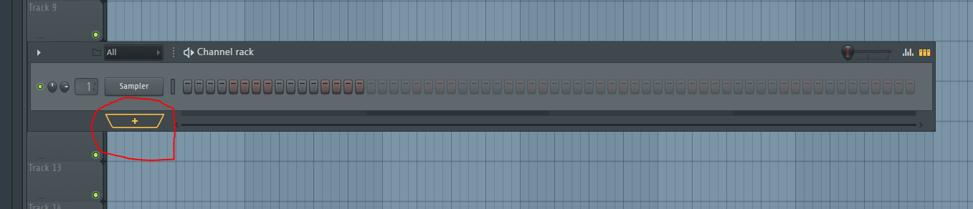
- Choose plugin called “Sakura”. (Try other plugins if you would like. Sakura is just an easy one for this activity).
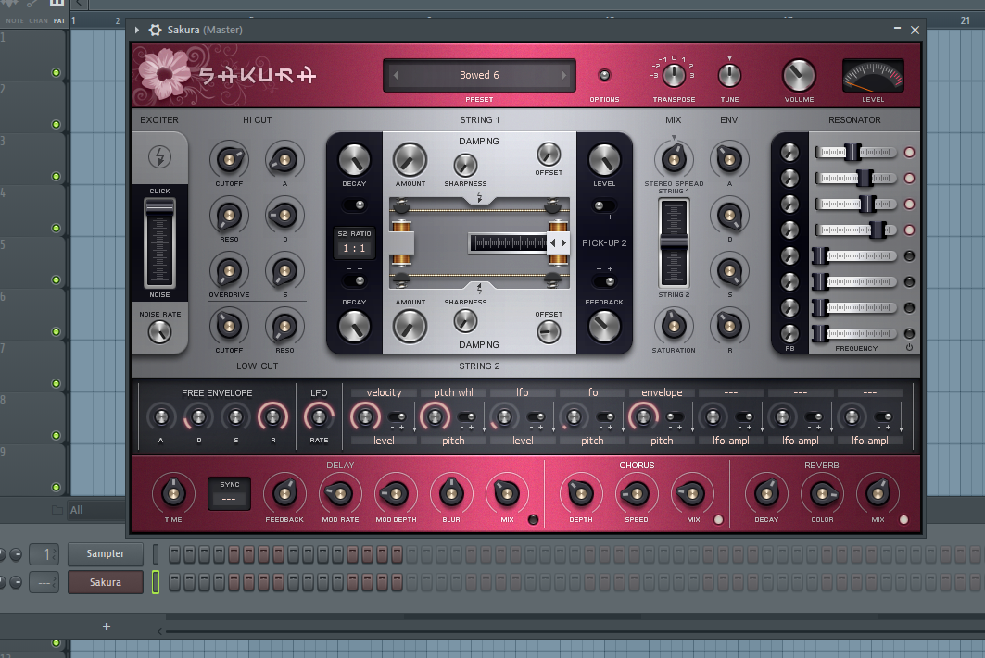
- Now try playing “Twinkle Twinkle Little Star” by using the colors from the Optron as reference to the following color-coded sheet music. Read left to right, one table at a time.

- Here is a video of me playing the song:
  - https://media.oregonstate.edu/media/t/1_vn4njcax

- If you get the hang of that song, try this next one.

