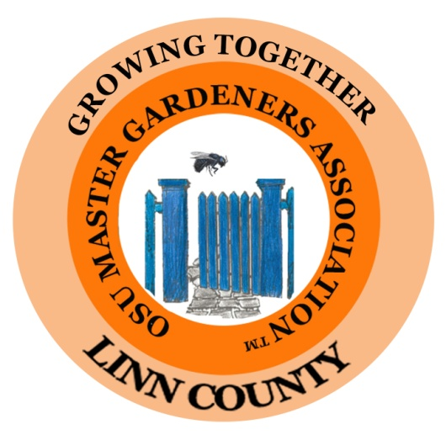

Board Meeting Minutes
Jan 5, 2021
Opening
The regular board meeting of the Linn County Master Gardeners Association was called to order at 1:08 pm via Zoom.

Present
Kelly Muller, President
Dan Murphy, 1st Vice President
Brenda Winslow, 2nd Vice President
Betty Goergen, Treasurer
Ranee Webb, Co-Secretary
Ann Kinkley, OMGA Representative
Janice Gregg- Mini-College Representative
Brooke Edmunds, OSU Extension
Diane White, Member-at-Large
Susan Morton
Peg Duerr
Nancy Ragghianti
Nancy Messman

Approval of Minutes
The October and December minutes were approved.

Treasurer’s Report
Expenses in December were $120.00 for bee supplies. And $120.40 for our website.
Total expenses for 2020 were $11,782,25, Total income for 2020 was $13,956.46 with a net income of $2,174.21.

The bank balance at the end of 2020 was $18,034.20 and the CD balance was $10,138.09
We now have a debit card for our bank account and it will be held by the treasurer.

Pollinator Conference Report – Susan Morton - Ranee Webb
The 2021 BEEvent Pollinator Conference will be held on March 6, 2021. It will be an on-line Conference this year due to COVID restrictions. The committee has been meeting weekly to work on logistics and to get speakers. The registration cost will be $20.00 giving those who register the opportunity to participate in live Q & A sessions with our speakers.

We are excited to have expert speakers lined up. Jim Cane, a retired bee researcher from the USDA Logan Bee Lab in Utah. will be the keynote speaker. Kathryn LeCroy from the University of Virginia will talk about research being done on native bee declines. August Jackson from OSU will talk about Bees of the Willamette Valley. Susan Morton and Ranee Webb will do a presentation on Mason Bees. In the past about 60% of our attendees were first time attendees and 80% were either first- or second-year attendees, so we will continue to do talks on mason bees each year.

This year we are using an OSU platform that will allow us up to 500 attendees. We hope to have registration available in about 2 weeks.

Diane White and Bobbye Rainey are organizing the pre-paid bee supply sales. Ranee is working with them too. The plan is to assemble orders at the Demo Garden and then deliver pre-ordered supplies with a no-contact delivery similar to grocery pick-ups. There will be several pick-up dates and locations that will include Albany, Corvallis, Salem and Eugene.

Ranee reported that more bee supplies are being made. Right now, blocks are the one supply with limited inventory. She and Rich are hoping to find a woodworker who can do routing for blocks. We may have less cocoons available, but we are getting some donations.

There are liners that still need to be split. Contact Ranee if you would like to help with that task. She has the letter openers and a big box of un-split liners at her house. You can do a porch pick up and drop off. She has already split liners from one box, so we have quite a few liners ready to go.

Garden Tour – Betty Goergen and Nancy Messman
There will not be a traditional Garden Tour in 2021. There is concern about liability and the high risk for master gardeners, but we may explore having 3-4 gardens that are close together with a front-yard-only walking tour. It was also suggested that we might put pictures of past gardens on our website instead. There would be no charge this year if we do some type of event. No decisions were made and this will be discussed again.

Thank you! Thank you! Thank you!
New Logos
We thanked Betty Goergen and Nancy Ragghianti for updating the LCMGA Logo.
Nancy has also updated the BEEvent logo.

Directory (Service Bars and membership/discount cards)
We thanked Brenda Winslow for her work in putting together the new directory. Betty will have them printed soon. The directories will be mailed with the OMGA membership card that has discount nursery information and will include any bars and badges that need to be distributed. Next year Brenda would like to add in the directory a list of those who have been Master Gardeners of the Year and Behind the Scenes award winners. All those who were in the directory last year will stay in the directory this year if they turned in the annually required paperwork.

Graduation
We thanked Kelly Muller and Elizabeth Records for the work they did to make the Zoom graduation special.

Website
We also thanked Nancy Ragghianti for all the great updates to the www.LinnMasterGardeners.com website.
NOTE: The “Members Only” password is 2021.
Nancy Ragghianti asked that we send any publications or videos to her for posting on our website. She will work on adding a link to other counties’ master gardener mini-series gardening presentations.

Extension Reports – Brooke Edmunds
A packet has been sent to Kelly that will be shared with all Board members. This packet will help us answer master gardening questions. She suggested that we put the packet in our Board handbooks.
Brooke and Elizabeth Records are working on some fun classes for our membership that will provide elevated continuing education training. Most of these will be recorded and posted for a while, so you can attend these even if you can’t attend on the date they are presented.

“Library Talks”- Dan Murphy
Dan wanted to discuss how we would do the “Library Talks” that we have had in the past. After discussion it was decided that we should be able to get speakers to do Zoom presentations. Please contact Dan with any suggestions for topics or speakers.
Brooke said that she and Elizabeth will do the marketing/advertising to master gardeners and to the public for these presentations. We could also put fliers at garden centers and have a playlist link on the Extension website and our website.
OMGA Report – Ann Kinkley and Janice Gregg
There has not been a lot of OMGA activity at this time of year. Ann is reading a lot of OMGA information and finding out when meetings will be held. The OMGA Celebration was a success. If it was recorded, Janice will try to put a link in the e-news.

The Board meeting adjourned at 1:59pm.

Respectfully submitted by:
Ranee Webb

