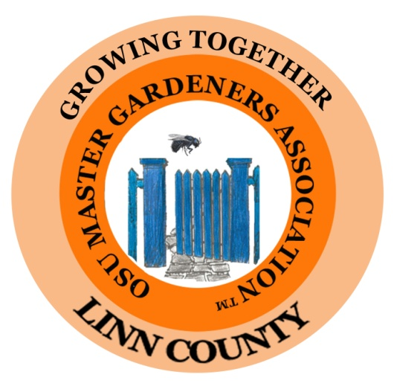

**Board Meeting Minutes**

**May 5, 2020**

**Opening**

The regular board meeting of the Linn County Master Gardeners Association was called to order at 1:00pm via Zoom.

**Present**

Kelly Muller, President

Brenda Winslow, 2nd Vice President

Betty Goergen, Treasurer

Ranee Webb, M/L and Past President

Karin Magnuson, Member at Large

Janice Gregg - OMGA Rep

Ann Kinkley – Alt OMGA Rep

Brooke Edmunds – OSU Extension

Elizabeth Records - OSU Extension

Nancy Messman

Susan Morton

**Approval of Minutes**

April minutes were approved. The minutes were amended to add Karin Magnuson as an attendee to the April Board meeting.

**Treasurer’s Report**

Deposits for the month were $678 for Bee Supplies.

Expenses for the month were $17,98 for the Pollinator Conference, $392.00 for OMGA dues, $95.00 for printing of the directory, and $99.99 for technology (annual office suite fee).

The bank balance was $19,536.46 and the CD balance was $10,062.47.

**Directory- Betty Goergen**

The directory is ready. There was a discussion about the OMGA membership cards and the garden center discount information. The OMGA cards are at the Linn Ext office and are not accessible. Janice will contact OMGA to see if we can get a set of cards sent directly to Betty. Betty will contact garden center/nurseries to confirm discounts. She will include a list of those discounts with the directory mailing.

**Extension Reports**

**Brooke Edmunds**OSU continues to follow the Governor’s stay-at-home orders and the OSU policies - through at least June 13th. She will keep us up to date. Watch the weekly e-mail for changes.

We are still reaching the public with Zoom and on-line classes. Examples are: a Zoom Mason Bee presentation by Rich Little and Ranee Webb, a Benton County Zoom presentation on Veggie Gardening, plant clinics on-line and Seed to Supper classes that were presented on-line.

A question was asked about keeping plants alive in the Demo Garden. Brooke suggested that we could ask the Linn Expo Center to see if they would water critical plants. There are no exceptions for watering plants and lots of forms to get permission from OSU. We would be far down the list for importance for getting exceptions.

**Elizabeth Records**

A shout out to those who helped set up on-line “Dashboard Plant Clinics”. Dan Murphy has done a test of the Dashboard Plant Clinic.

Training for these on-line Dashboard Plant Clinics will be held on May 6th and 7th. Mentors will work with the trainees using this on-line forum. Elizabeth reported that many of the 2020 trainees have deferred their training until the 2021 class. Nine trainees have completed the 2020 sessions on-line. (some of those are dual county trainees). Elizabeth will send mentors an updated list of trainees.

Extension is exploring many ways to find new opportunities for master gardeners to get hours and continuing education. They are working with the Community Gardens too. You can participate in a veggie experiment for your backyard. (Contact Extension for more info).

**Stay at home update:** “4/28/20 - Update from OSU about Stay Home Save Lives:

[**Gov. Brown’s executive order 20-17**](https://oregonstate.us7.list-manage.com/track/click?u=ea133437a402ab2b2efcb40a8&id=3b243d3cce&e=ce4a72f538)**extends remote teaching to June 13, unless extended or terminated earlier. This applies to all OSU teaching, including our Extension and noncredit education. This applies to OSU Extension volunteers also. Volunteers should be only doing those activities that can be done from home and without face-to-face contact.”**

***OSU wants to make sure that memo gets out to all volunteers who might be confused especially as some things are re-opening.***

**A Thank You and Bee Supplies - Ranee Webb**

Carolyn Larime sent a message (through Ranee) that she is doing well and that she very much appreciated the cards and other support given from Linn Master Gardeners!

Rich Little has requested a budget for travel expenses. With his major contributions in keeping the Bee Project going, the Board voted for a $500 fund to offset some of his costs. The money would come out of the Pollinator Conference budget.

Next month we will discuss ordering more of the “A Bee Named BOB” children’s book to have available for the cocoon harvesting classes. Ranee will get the cost information, so we can budget for ordering more of them. They sold very well at the Pollinator Conference.

**BEEvent Pollinator Conference**

Susan Morton reported that we are working on finishing the Search for Excellence Award again. Brooke will finish the application process.

**OMGA Report- Janice Gregg**

Janice Gregg reported that the 2020 Mini College has been cancelled. The good news is that all contracts and speakers have agreed to come for the 2021 Mini College with no additional expenses occurring.

The Board meeting adjourned at 1:52 pm.

Respectfully submitted by:

Ranee Webb (Substitute for Ann Capps)