Soil Texture Triangle!
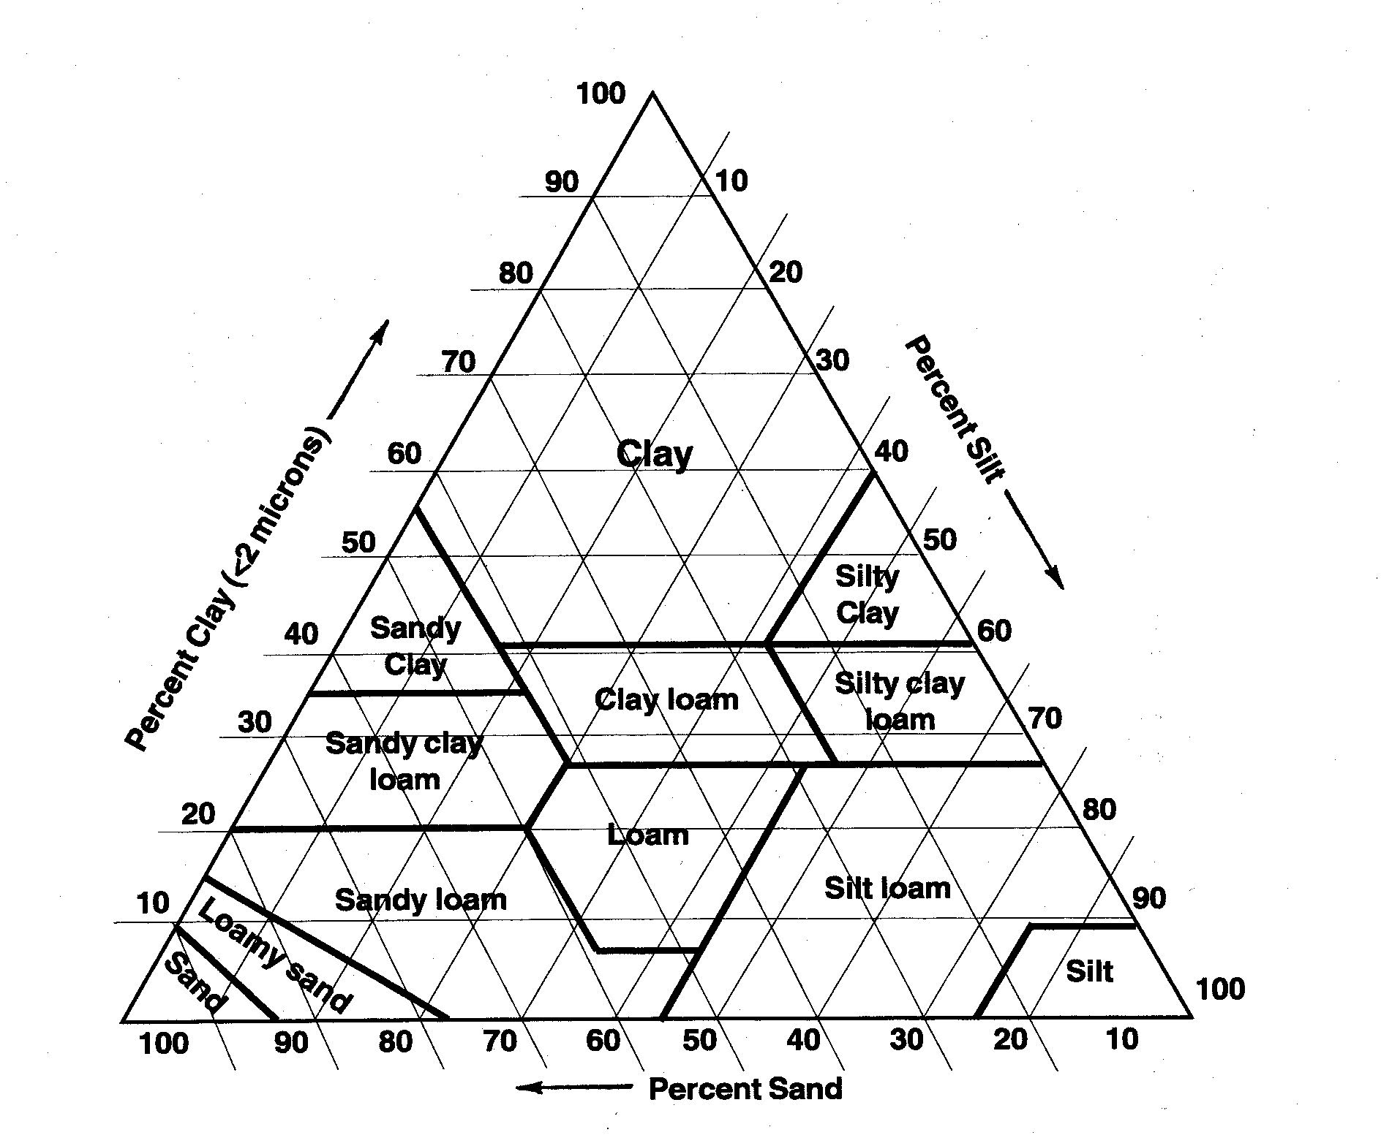

AMAZING electronic Resources – FREE!!!!
California Soil Resource Lab (UC Davis) – A great and easy-to-use soil mapping tool – Goggle “California Soil Resource Lab” click on “SoilWeb Apps” then, Click on “SoilWeb Earth” to permanently install and open in Google Earth!!! (if you don’t have Google Earth – Click on “SoilWeb”) Enter address info and “fly” there! Click on map to display soil type and click on any blue words for more information!
SoilWeb phone App – FREE Soil App for your smart phone – go to your ”App Store” and search for “SoilWeb” and install – its FREE - the only reason to have a smart phone!
NRCS Soil Web Survey – make a detailed soil map of you place!
Hand Texture Diagram – LEARN HOW TO DO IT!!!!
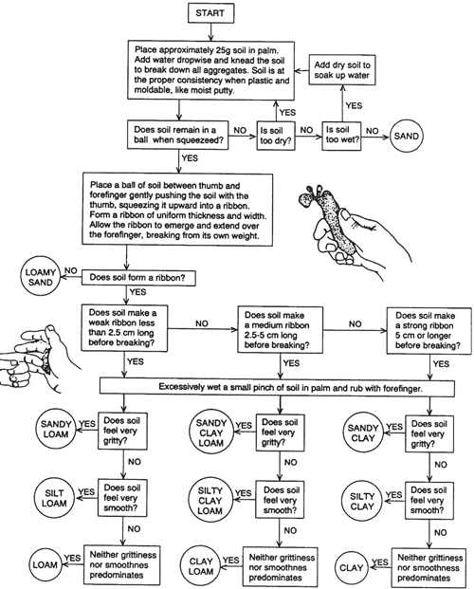

Important Extension Publications – FREE!!!
- Improving Garden Soils with Organic Matter – EC 1561
- A Guide to Collecting Soil Samples for Farms and Gardens – EC 628
- Soil Organic Matter as a Soil Health Indicator: Sampling, Testing and Interpretation – EM 9251
- OSU Small Farms web site – LOTS of great and usable information!

