January-2019
Basic Entomology: Master Gardeners Training
OSU Extension Service Richard Little (Linn/Benton Co)

Basic background
Most insects are very small less than 6mm (¼ inch). In some ecosystem there are several million insects in one acre. Insect can be found in great numbers in every ecosystem on our planet except for the ocean. In addition to the numbers there is incredible diversity among the insects.

In our world there are an estimated 740,000+ identified species Plant and animal life in the world excluding insects & Bacteria. There are over a million different identified species of insects.

There is an estimated 31,000 identified species of ‘Mammals’, ‘Birds’, ‘Reptiles’ and ‘Amphibians’ in the world. There are over 28,000 different identified species of insects in the Pacific North West.

You cannot study any part of nature without including directly or indirectly insects’ connection. Insects interact with almost all other living species in one way or another.

Insects & man:
Of the more than 100,000 different insect species found in North America, very few are harmful to mankind’s welfare.
A “Bad Insect” is an undesirable insect that is doing something we do not want: Chewing holes in our flowers eating our fruits or annoying us in general. The same insect in another location or at another time we might consider “Good”.
Most insect found in our gardens and yards are ‘benign’ or ‘beneficial’. The beneficial ones are either pollinating our plants or eating the others that are trying to eat our plants.

The Value of insects to man:
- Pollination for many of our food crops.
- Beneficial parasitoids and predators keep many of our injurious insects & weeds under control.
- Master recyclers & decomposers in nature, improves soil fertility.
- Silk, dyes, pigments, shellac, honey, beeswax, fish bait, galls (tannic acid & inks).
- Insects themselves as a source of food, for other animals and humans.
- Scientific investigations genetics, medicine.
- Aesthetic & entertaining value.

The growth of insects:
Most of the insects (+90%) undergo a change in their shape during the life. This change is called Metamorphosis. Insect’s orders follow one of three different ‘types’ of metamorphosis. Primitive insects like silverfish have no true metamorphosis. The insect when it hatches from the egg looks just like the adult except in size.

In ‘Gradual or simple Metamorphosis’ there are three life stages egg, nymph & Adult. All the life stages look similar in shape, often behave similar. All life stages can be found together. Wing pads will form and in the last development stage (the adult) wings become fully develop.

In complete Metamorphosis the insect has four life stages: egg, larvae, pupa & adult.
The classification(s) system of insects is an ongoing changing system. As result there are several different classification system currently used by entomologists. I am using one that has been widely used for many years and one most books are still based on. This makes it easier to follow up on references when you are looking for identification help.

Some of the insect orders are ones you will rarely encounter during your MG work. I have focused on 11 common orders. These are insects that many you already recognize. Give yourself credit: you know more about insects then you think. The eleven orders we will cover today are:

FOLLOWING ARE NOTES & GENERAL CHARACTERS OF SOME COMMON OREGON INSECT ORDERS THAT YOU MAY ENCOUNTER AS A MASTER GARDENER.

GRASSHOPPERS CRICKETS: ORDER-ORTHOPTERA (STRAIGHT-WINGS)

Cockroaches, mantids, walkingsticks: ORDER-DICTYOPTERA (Includes Blattodea, Manodea, Phasmida)

TERMITES: ORDER-ISOPTERA (EQUAL-WINGS)

EARWIGS: ORDER-DERMAPTERA (COVERING WITHOUT-WINGS)

TRUE BUGS, PLANT HOPPERS, SCALES MEALYBUGS WHITEFLIES: ORDER-HETEROPTERA includes Homoptera (Different–wings) & Homoptera

thrips: Order-Thysanoptera (fring-wing)

LACEWINGS, ANTLIONS, SNAKEFLIES: ORDER-NEUROPTERA (NERVE or NET-WINGS)

BEETLES: ORDER-COLEOPTERA (Sheath–wing)

FLIES, MOSQUITOS, GNATS: ORDER-DIPTERA (TWO-WINGS)

MOTHS & BUTTERFLIES: ORDER-LEPIDOPTERA (Scale–wings)

SAWFLIES, ANTS, WASPS, BEES: ORDER-HYMENOPTERA (membrane–wings)

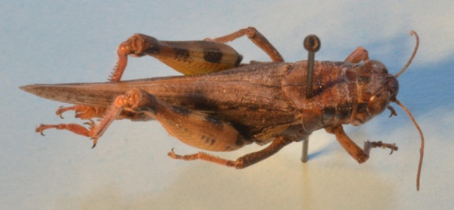
GRASSHOPPERS CRICKETS:
ORDER ORTHOPTERA (STRAIGHT-WINGS

NOTES & GENERAL CHARACTERS OF THE ORDER ORTHOPTERA:
- The numbers of known species in this order is about +25,700 species.
- Orthoptera are the largest group of insects that have ‘Simple/Gradual’ metamorphosis, 3 stages-egg, nymph, and adult.
- Immature stages (nymphs) resemble adults but are wingless.
- Hearing is acutely developed n most Orthoptera. Auditory stimuli are important in courtship in many species.

ID CHARACTERS
- Hind leg enlarged for jumping. Nearly all Orthoptera are readily distinguished from other insects orders by the enlarged hind femora and the characteristic grasshopper like shape
- Forewings are elongated, narrow leathery or parchment like with branched veins. Hind wings with numerous straight longitudinal veins, numerous cross veins forming many closed cells. Wing folding by pleats.
- Compound eyes present. Acute vision occurs with some.
- Chewing mouthparts. The great majority are herbivores with specialized dentition for consuming ‘tough’ plant matter. Both adults and nymphs are damaging.
- Antennae multiarticulate, filiform [thread like] or moniliform [beaded like a necklace].

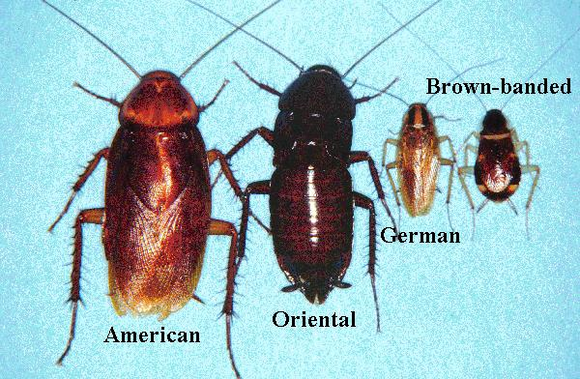
Cockroaches, mantids, walkingsticks:
ORDER DICTYOPTERA (Includes Blattodea, Manodea, Phasmida)

NOTES & GENERAL CHARACTERS OF THE ORDER DICTYOPTERAn:
COCKROACHES: BLATTODEA
- One of the most familiar insect to a non-entomologist.
- This order has an old fossil record. There are about +3,500 species in the world.
- About 30 species are cosmopolitan (worldwide) co-inhabitators with mankind.
- Mode of oviposition (egg laying) is unique; an egg case is produced.
- Usually nocturnal [comes out at night] – positive thigmotactic [contact loving; applied to species that tend to live close together or in touch, one with the other].
- Some adults can live up to 4 years. Most are a very hardy insect.
- Does not bite, sting or spread human diseases, however potential medical importance can carry pathogenic organisms.
- Order has Simple/Gradual metamorphosis, 3 stages-egg, nymph, and adult.
ID CHARACTERS
- Large compound eyes.
- Chewing mouthparts.
- Antennae are long filiform [thread like] & multiarticulate [many jointed].
- Forewings are hard and leathery relative to hind wings. Hind wings are membranous with large fan shaped anal lobe, many pleats in wing to aid in folding.
- Hind femur not enlarged but legs are robust, usually long and often spiny. Tarsi with five segments.
MANTIDS: MANTODEA
- There are about +3,500 species in the world
- Order has Simple/Gradual metamorphosis, 3 stages-egg, nymph, and adult.
- The classic ‘Praying Mantis’ pose is actually their ambush pose. As predators (sit & wait-ambushers), they are generalist they will eat ‘anything’ they can subdue.
- Like ‘Cockroaches’ Mantids lay their eggs in an egg case. The arrangement and form of the egg case is unique to this suborder of insects.

ID CHARACTERS
- Long body with small head that is freely mobile on a slender neck.
- Large compound eyes situated far apart (as in other visually orienting predators ex: Dragonflies)
- Chewing mouthparts.
- Antennae slender filiform [thread like] & multiarticulate [many jointed].
- Fore wings narrow usually thickened and leathery; hind wings much broader and membranous with many pleats.

WALKING STICKS: PHASMATODEA
- There are about +2,000 species in the world.
- Order has Simple/Gradual metamorphosis, 3 stages-egg, nymph, and adult.
- All are herbivores.
- Generally rare even given their ability to hide in plain sight. Seldom economically important.
- Order has largest known living insect,

ID CHARACTERS
- Body shape is cylindrical, elongated and flattened.
- Antennae filiform [thread like] or moniliform [beaded like a necklace].
- Compound eyes present.
- Chewing mouthparts.
- Fore wings narrow usually thickened and leathery, hind wings much broader and membranous with many pleats.
- Legs usually elongated and slender.

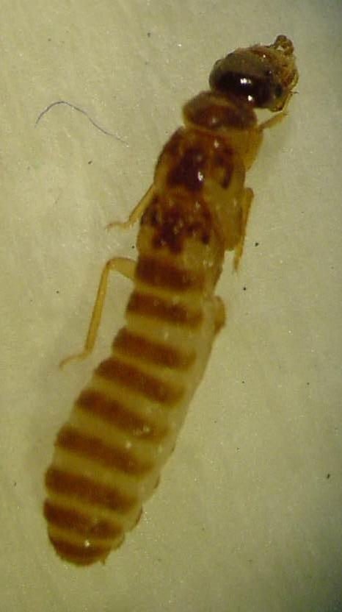
TERMITES:
ORDER ISOPTERA (EQUAL-WINGS
NOTES & GENERAL CHARACTERS OF THE ORDER ISOPTERA:
- The numbers of known species in this order is about +2,000 species.
- Termites seldom venture out of their concealed nest, with the exception of the reproductive which disperse (swarm) by air to found new colonies.
- Because of the damage termites can cause especially in subtropical and tropical regions they are one of the most destructive arthropods. Found in all but extremely cold regions.
- Like some Hymenoptera families termites are of special biological interest because of their highly developed social behavior and colonies.
- Order has simple/gradual metamorphosis, 3 stages-egg, nymph, and adult.

ID CHARACTERS
- Front and hind wings are similar in size and shape, hence the order name. Wings with numerous longitudinal veins, many cross veins creating many closed cells. Wings present only on reproductives’ and the wings are twice the length of the body.
- The abdomen is broadly joined to the thorax.
- Compound eyes.
- Chewing mouthparts
- Antennae moniliform [bead-like] with 10 to 32 segments.

Simple guide to SOME identifying characters
The difference between termites and ants:
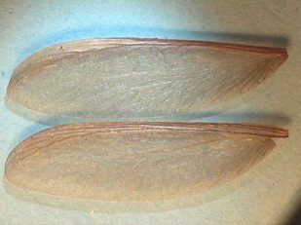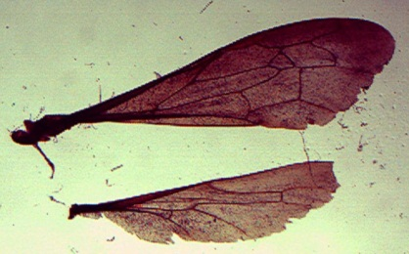
Termites reproductives’ have two large wings on each side, similar in size and shape longer then the body
Ants also have two wings on each side but the hind wing is much smaller than the fore wing.

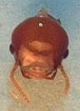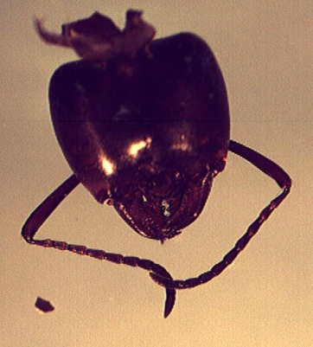
Termite antennae look like a string of beads (moniliform).
Termites have reduced eyes.
Ants antennae are elbowed, a distinct bend is visible in the antennae. Ants usually have large compound eyes.

Waist (how the thorax & abdomen are connected):
Termites have no waist, the thorax & abdomen is broadly connected resembling a solid tube that is rounded at the end.
Ants have a narrow connection between the thorax & abdomen which is slightly pointed at the end.
EARWIGS:
ORDER DERMAPTERA (Leather-WINGS)
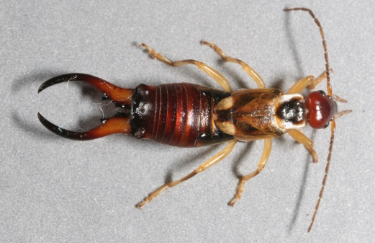

NOTES & GENERAL CHARACTERS OF THE ORDER dermaPTERA:
- The numbers of known species in this order is about +1,200 species.
- Often confused with some ‘Rove Beetles’ Staphylinidae (which have no ‘forceps’)
- Order has ‘Simple/Gradual’ metamorphosis, 3 stages-egg, nymph, and adult. Adults and nymphs similar in appearance.
- Most are omnivorous but some are predatory.
- Most are nocturnal (out at night)
- The highly developed maternal care of their young makes this order different and notable. The females often protect their eggs and young nymphs for several weeks.

ID CHARACTERS
- The forcipulae [forceps] cerci (the pinchers/forceps) on the end of the abdomen distinguish earwigs from all other insects except some uncommon Diplura.
- Antennae multiarticulate, filiform [thread like].
- Chewing mouth parts.
- When present, front wings are short elytriform [thickened/leathery]. Hind wings “ear shaped” are semicircular in form with distinctive radiating venation.
- Body elongated, slightly flattened with leathery cuticle.
- Compound eyes moderate or absent.

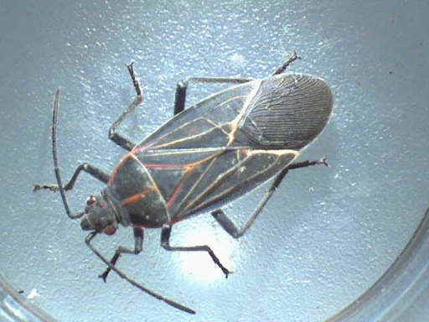
TRUE BUGS, PLANT HOPPERS, SCALES MEALYBUGS WHITEFLIES:
ORDER HETEROPTERA

The Heteroptera includes both the Hemiptera (true bugs, plant hoppers) and the Homoptera (such as aphids, scales, mealybugs, and whiteflies). Heteroptera order has ‘Simple/Gradual’ metamorphosis, 3 stages-egg, nymph, and adult.

NOTES & GENERAL CHARACTERS OF THE ORDER HETEROPTERAN:
Hemipterans: (Different–wings) True Bugs
- The number of known species in this sub order Hemiptera is about +80,000 species.
- Adults and nymphs usually resemble each other. Both stages can be damaging.
- When used for an insect in the order Hemiptera, the bug of the name is written as a separate word: examples Stink bug, Assassin bug, Bed bug.
- Most Hemiptera have scent glands on the thorax which give off a characteristic odor and are unpleasant to most people.
- Many feed on plants and are serious pests of cultivated plants. Some are predaceous and very beneficial to man. Still others attack human and other animals sucking blood or acting as disease vectors.

ID CHARACTERS
- One of the most distinctive features of the Hemiptera, and one from which the order gets its name, is the structure of the front wings. hemi = half, ptera = wings. In most Hemiptera the front portion of the front wing is thickened and leathery or parchment like and the hind portion (wing tip) of the wing is membranous. One wing but different textures on same wing. The hind wings are entirely membranous and are slightly shorter than the front wings. There are 2 Pairs of wings (4 wings total).
- Hemiptera wings fold flat over abdomen usually without folds but cross over each other and form a triangular shield on the back. Fore wings larger then hind wings.
- Hemiptera mouthparts are piercing sucking and formed into a needle like beak extending from the front part of the head. (Homoptera the mouthparts arise at the rear of the head)
- Compound eye well developed.
- Antennae usually have 10 or fewer segments which can be short, but usually long, filiform or setaceous of four to five segments

Homoptera: (same wing) Aphids, Whiteflies, scales, cicadas.
- The number of known species in the sub order Homoptera is about +32,000 species.
- Most are small, soft bodied insects. Exception cicadas.
- There is considerable variation in body forms with some very complex life histories.
- All Homoptera are plant feeders, exclusively as phloem feeders and many species are serious pests of cultivated plants.
- Some species transmit plant diseases.
- Homoptera are major ‘honey dew’ producers.
- Eggs usually of simple ovoid structure.
- A few Homoptera are beneficial and serve as a source of shellac, dyes or other materials.

ID CHARACTERS
- Homoptera sucking mouthpart is formed into a needle like beak extending from the back part of the head. (Hemiptera the mouthparts arise at the front of the head)
- Winged and un-winged form. When wings are present in Homoptera the wings are either uniformly membranous or uniformly leathery or parchment like. The name Homoptera means uniform wing.
- Aphids have cornicles on end of their abdomen.

some common HETEROPTERAN you might encounter as a Master Gardener in oregon

- Stink bugs
- Harlequin bug
- Squash bugs
- Milkweed bugs
- Assassin bugs
- Plant bugs
- Bed bugs
- Mealybugs
- Whiteflies
- Scales
- Aphids

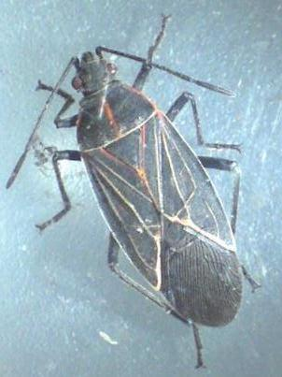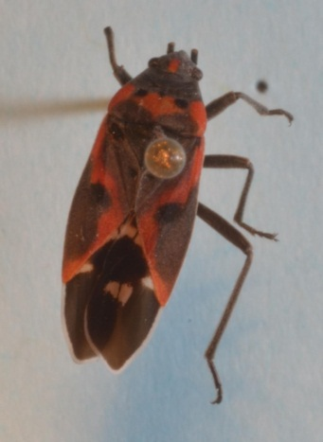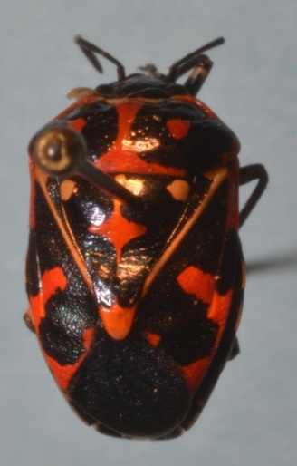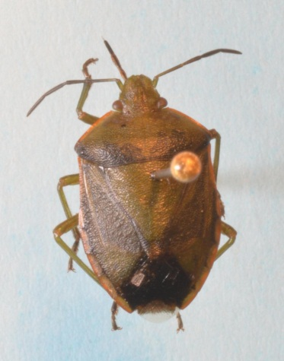
Western Box Elder Bug Small Milkweed Bug Harlequin Bug Say’s Stink bug
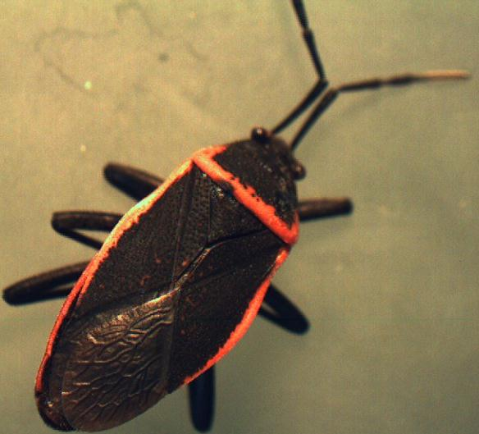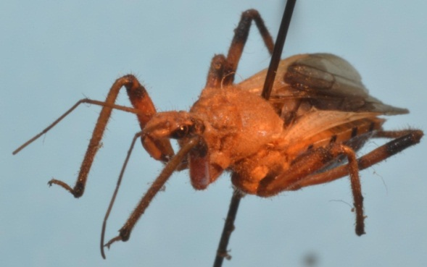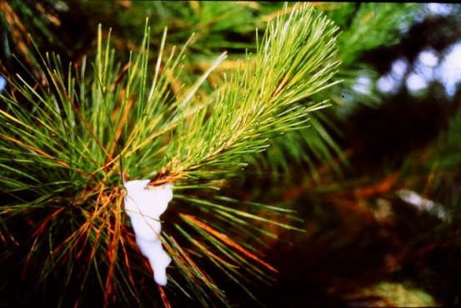
Bordered Plant Bug Assassin Bug Spittle Bug

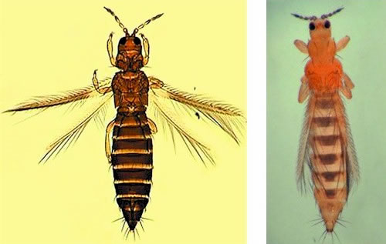
thrips:
ORDER
THYSANOPTERA
(FRINGE-WINGS)

NOTES & GENERAL CHARACTERS OF THE ORDER thysanoPTERA:
- The number of known species in this order is about +2,000 species.
- Thrips are highly distinctive insects that inhabit all sorts of vegetation, as well as leaf litter, fungus, and decaying parts of trees.
- Many thrips are plant feeders. They preferentially infest the reproductive structures of plants, and the most serious economic damage involves buds, flowers, and young fruits.
- Some are vectors of bacterial, fungal, or viral diseases of plants.
- Some are predators of aphids or other small soft-bodied arthropods, especially eggs of mites and Lepidoptera.
- Thrips have occasionally caused problems or have become a nuisance by biting humans.
- Order has ‘Simple/Gradual’ metamorphosis, 3 stages-egg, nymph, and adult.
- Winged thrips are competent fliers which may be disseminated long distances by favorable winds.

ID CHARACTERS
- Small in size usually less than 1.5mm (1/16 inch).
- The four wings are narrow, strap like, fringed with long setae. Fringe of hairs is often as long as wing is wide. This is a specialization which appears repeatedly in very small insects.
- Eyes prominent, round or kidney-shaped with large round facets.
- Mouthparts modified as piercing stylets. This method of feeding produces a characteristic mottling or silvering of the affected plant surfaces.
- Antennae are 4 to 9 segmented.

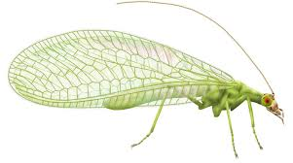
LACEWINGS, ANTLIONS, SNAKEFLIES:
ORDER NEUROPTERA (NERVE or NET-WINGS)

NOTES & GENERAL CHARACTERS OF THE ORDER NEUROPTERAn:
- The numbers of known species in this order is about +5,000 species.
- Wings usually longer then the abdomen. Most all Neuropteran are weak, erratic+ fliers.
- Order has complete metamorphosis, 4 stages-egg, larva (grubs), pupa, and adult.
- Adult Neuropterans are predominantly predators and help in regulating damaging invertebrate populations on plants. Immature of Neuropterans are all predatory.
- The famous ‘Antlion’ is of this order. The ant lion has abroad head with enormous sickle-shaped jaws. They lie in ambush at the bottom of a conical pitfall that ants and other insect fall into are captured then eaten.

ID CHARACTERS
- Usually large lateral eyes.
- Biting/chewing mouthparts.
- Antennae multiarticulate, usually filiform or moniliform.
- Two pairs of membranous wings with numerous branched longitudinal veins, many closed cells.
- Most species are elongate-oval in shape and similar in size.

some common NEUROPTERAns you might encounter as a Master Gardener in oregon.

Antlions: Adult antlions look very similar to damselflies with their long, slender abdomen and long, narrow, many-veined wings.
Snakeflies: Lacewings: Green & Brown

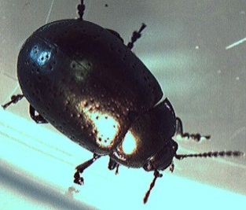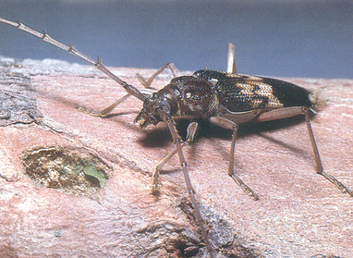
BEETLES:
ORDER COLEOPTERA
(Sheath–wing)

NOTES & GENERAL CHARACTERS OF THE ORDER COLEOPTERA:
- This is the largest insect order in numbers of species (+300,000 species).
- Order has complete metamorphosis, 4 stages-egg, larva (grubs), pupa, and adult.
- Due to the large number of beetles, they are exceedingly variable in their form, their biology, and the ecological habitat they are found in.
- Beetles are hard (armored) and compact in form. Tanks of the Insect World.
- Generally beetles are relatively inefficient fliers.
- Beetles may be found in almost every type of habitat in which insects are found. Many are plant feeders but some are important predators of other invertebrates.
- Often antennae and legs fit into groves or depressions on the body as further protection.
- One of the more common insects in arid habitats.
- Weevils - Curculionidae: There are more than 60,000 weevils in the world. Their jaws are at the end of their nose.

ID CHARACTERS
- One of the most distinctive characters of the Coleoptera is the structure of the wings. When wings are present there are always 2 Pairs of wings (4 wings total). The front wings are thickened, hard brittle or leathery. Usually meeting in a straight line down the middle of the beetle’s back covering the hind wings. Hence the order’s name. Elytra are the name given to these special front wings. The hind wings of beetles fold under the elytra. This is accomplished by a complex series of folding so the relativity large hind wing will fit under the elytra.
- Antennae almost always with 11 or fewer segments.
- Well-developed chewing month parts. One species is known for chewing through the lead sheathing of telephone cables.
- LARVAE: Head capsule, 3 pairs of legs on the thorax, no legs on the abdomen. Weevils do not have any legs in larvae stage.

SOME common BEETLES you might encounter as a Master Gardener in oregon.

Less than 6mm (¼”) in length:
Flea beetles
Drug Store beetles
Dermestid beetles
Small ground beetles
General storage pest beetles
Fruit/Sap beetles
Bark beetles

6- 20mm (¼ - ¾”) in length
Ladybird beetles
Black Ground beetles
Tule beetles
Click beetles
Brown Leatherwing
California Glowworm
Western Spotted Cucumber
Strawberry Root Weevil
20mm (¾”) or longer
Nautical Borer
Ten-Lined June beetles
Pine Sawyer
California Prionus
Banded Alder Borer

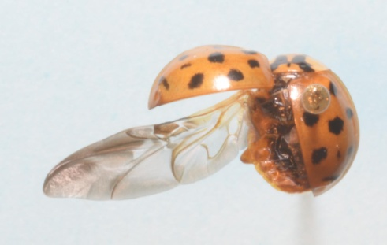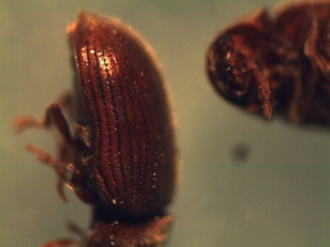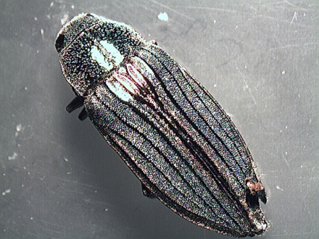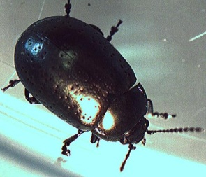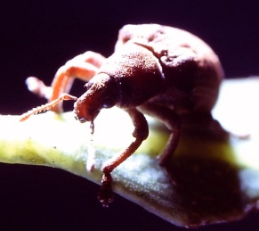
Ladybird beetle Drugstore beetle Wood boring beetle Leaf beetle Weevil

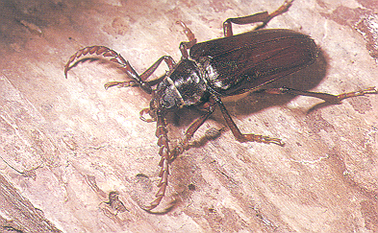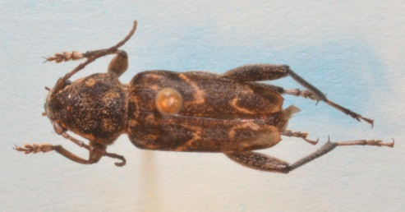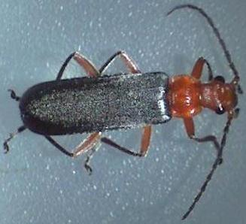
California Prionus Nautical Borer Leather wing

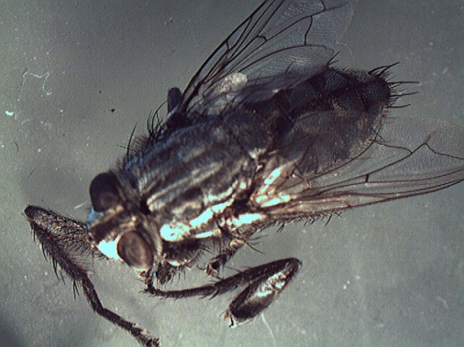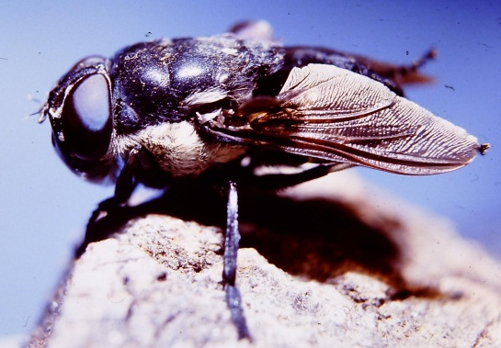
FLIES, MOSQUITOS,
GNATS:
ORDER DIPTERA
(TWO-WINGS)

NOTES & GENERAL CHARACTERS OF THE ORDER DIPTERA:
- For true flies the word ‘Fly” is separate from the name, example: House fly, Bot fly. For all other ‘flies’ the name is combined, example Butterfly, Dragonfly, Caddisflies.
- The numbers of known species in this order is about +120,000 species.
- Order has complete metamorphosis, 4 stages-egg, larva (grubs), pupa, and adult.
- Dipterans are considered one of the dominant insect groups because of their extreme abundance over a great variety of ecological situations.
- Most are liquid feeders and live on or in dead/decaying animal or vegetable matter; however some are important predators, parasites, and parasitoids.
- Almost no adult Diptera directly damages living plants except by oviposition
- Most larvae occur predominantly in moist or subaquatic situations and are noted for fast development.
- For Dipterans, the larvae stage is usually the feeding stage and the adult is the short lived reproductive and dispersal stage.
- Diptera larvae are the only significant groups of insects to have acquired habit being internal parasites of vertebrates.
- The major impact of Diptera (mosquitoes) on mankind stems from their transmission of virulent diseases of human and domestic animals. Mosquitoes through the diseases they have vectored have changed the course of mankind several times. (Malaria, Yellow Fever, Encephalitis to name a few).
- Dipterans wings have evolve with a high degree of adaptation for rapid, efficient flight.

ID CHARACTERS
- The most unique differences that separate the Dipterans from all other insect orders is that Dipterans only have one Pair of wings (2 wings total). The front wings are membranous. Located behind the front wings where the second pair of wings is in other insects are halters. Halters look like a club and aid the ‘Fly’ to maintain its balance while flying.
- Wings with few or numerous longitudinal veins, few closed cells.
- Usually large compound eyes.
- Mouthparts are modified, usually as a proboscis for imbibing liquid foods. They do this by rasping, cutting, sucking, sponging, piercing,
- Antennae multiarticulate, filiform, moniliform, or reduced with terminal segment bristle-shaped.
- Larva usually maggot like or vermiform (having the shape of a worm). No true legs occur on larvae.

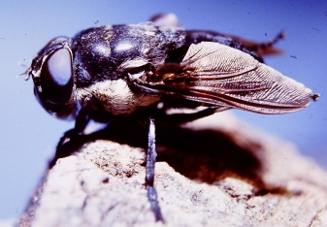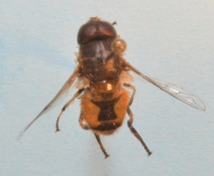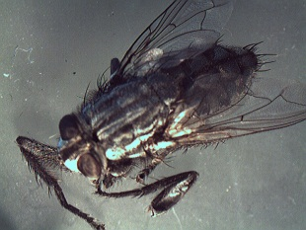
Bot Fly Hoover Fly Tachinid Fly

Quick & dirty guide to identifying
some common DIPTERA of oregon
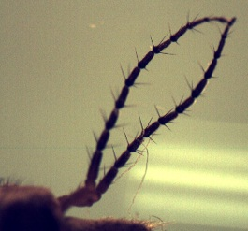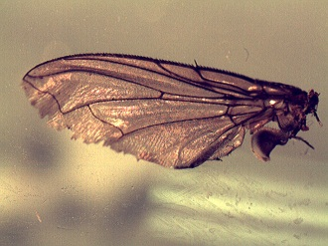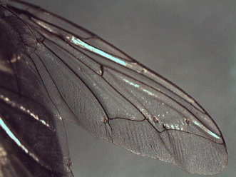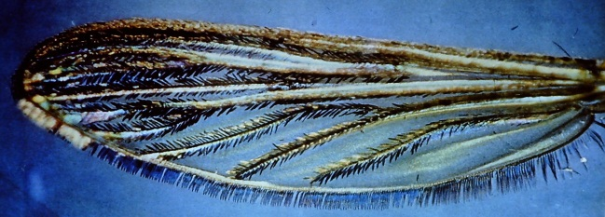
Crane fly antennae Typical Fly wing Flesh Fly Mosquito

Antennae with six or more segments and feathery ‘Long Horned Flies’: Crane flies, Midges, Gnats, Mosquitoes, Black Flies.

Antennae with less than six segments, very short antennae ‘Short Horned Flies’: Horse flies, House flies, Flower flies, Fruit flies,

MOTHS & BUTTERFLIES:
ORDER LEPIDOPTERA (Scale–wings)

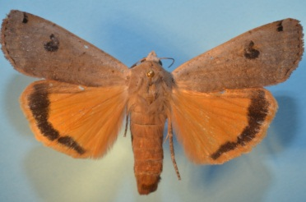

NOTES & GENERAL CHARACTERS OF THE ORDER LEPIDOPTERA:
- The numbers of known species in this order is about +130,000 species.
- Order has complete metamorphosis, 4 stages-egg, larva (worms-caterpillars-inchworms), pupa (cocoons-chrysalis), and adult.
- Most larvae feed on flowering plants and conifers (gymnosperms) and can cause great damage to plants.
- Silk production is universal among Lepidoptera larvae.
- Egg forms are extremely variable. (cylindrical, barrel-shaped, flat wafers)
- Flight is powered by both wings.

ID CHARACTERS
- Mouthparts are a modified coiled proboscis. Adults with few exceptions feed on nectar, honeydew, fermenting sap or similar products.
- Adults soft bodied.
- 2 Pairs of membranous wings (4 wings total), wings are scaly or powdery and often showy in color. (Care must be taken when handled or the scales can easily rub off and the specimen will have a difficult flying)
- Hind wing coupled to forewing through several different ways of overlapping the wings.
- LARVAE: Have chewing mouthparts. Caterpillar, worm-like. True legs on the thorax pro-legs found on the abdomen. Pro-legs are not true legs can be variable in color. Due feeding habits larvae can be very damaging to plants.

Simple guide to SOME identifying characters & some LEPIDOPTERIAN of oregon
Antennae of various forms, but not knobbed/clubbed at tip… ‘Moths’: Usually fly by night and are hairier with bushier antennae.
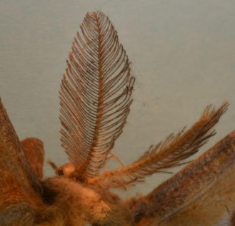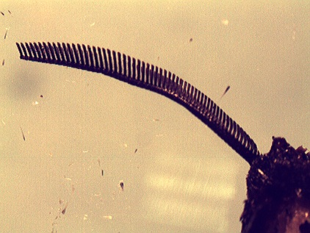
Moth antennae Moth antennae
Antennae threadlike, swollen or knobbed or clubbed at tip… ‘Butterflies & Skippers’: Usually fly during the day and have delicate antennae.

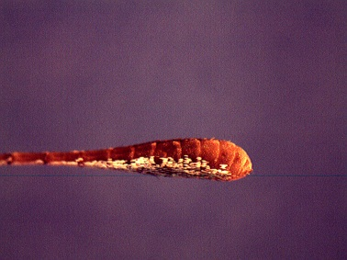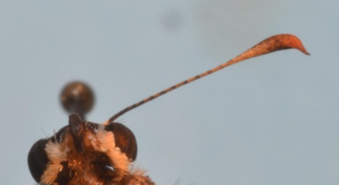
The clubbed antennae are not hooked at the tip… Butterflies

The clubbed antennae is hooked at the tip…’Skippers’

To key beyond this simple separation of the superfamilies’ of the Lepidoptera you will have to use wing venation to separate out the different families such Swallowtails (Papilionidae),

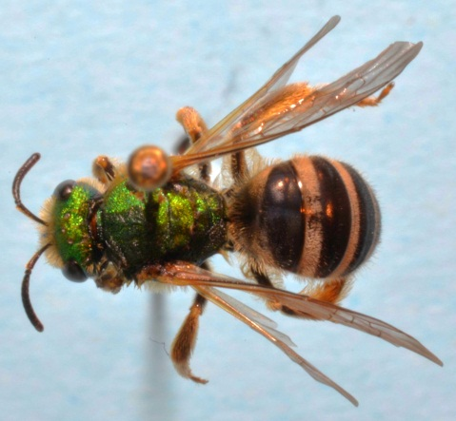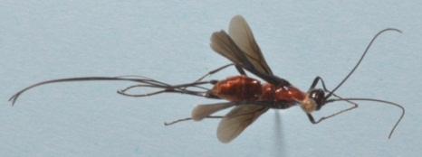
SAWFLIES, HORNTAILS,
ANTS, WASPS, BEES:
ORDER HYMENOPTERA
(Membrane–wings)

NOTES & GENERAL CHARACTERS OF THE ORDER AN HYMENOPTERA:
- One of the larger insect orders with over 140,000 named species.
- Flight is powered by both wings. Hymenoptera have unique hook-like setae (bristle) to hold the fore and hind wings together so they act as one wing. Many are strong efficient fliers.
- The only ants with wings are swarmer’s.
- Order has complete metamorphosis, 4 stages-egg, larvae, pupa, and adult.
- The Hymenoptera are exceedingly important insects from mans’ point of view. Most are beneficial predators or parasites. Others are major pollinators for many of our plants.
- Ants of the species Oecophylla were first deliberately used to protect plants from pests in China 4 000 years ago. The Chinese encouraged the ants to live in fruit trees because their presence was known to improve fruit yields.
- The economic importance of Hymenopterans easily amounts to Billions every year. If all the Hymenopterans were to suddenly disappear from this earth among the numerous changes would be the collapse of human society.
- Hymenoptera are known as social insects due to the colonies and complex societies some families have formed.
- The largest single colony of insects so far recorded are ants of the genus Formica in Japan (F. yessensis with over 300 million ants living in one super colony of 45 interconnected nests)
- Parthenogenesis is more common among the Hymenoptera than any other order of animals, though in many it is the means of sex determination i.e. fertilized eggs become one sex and unfertilized eggs the other, there are some species in which males have never been found and reproduction occurs only as a result of parthenogenesis.
ID CHARACTERS
- Most have Chewing month parts. Bees have lapping mouth parts.
- Antennae are usually filiform [thread like] or moniliform [beaded like a necklace] and shorter than the body.
- Have large compound eyes.
- Most Hymenoptera have a constricted/narrow waist (petiole).
- LARVAE: Some sawflies have 3 pairs of legs on the thorax and more than 4 pairs of legs on the abdomen. Larva of ants, wasp and bees do not have legs.
- When wings are present there are always 2 Pairs of wings (4 wings total).
- Wings are membranous and clear and stiff with relatively few veins. Fore wings are about 1.5 to 2 times as long as hind wings.
- An ovipositor is always present in females in one form or other, often adapted for sawing and or piercing and stinging.
- Tarsi with three usually 5 segments.

A FEW common HYMENOPTERA you might encounter.

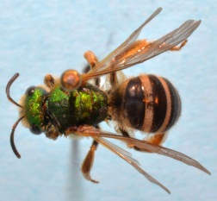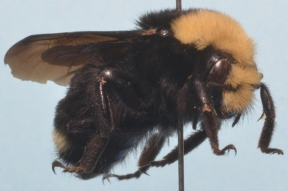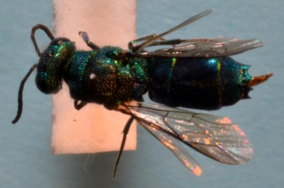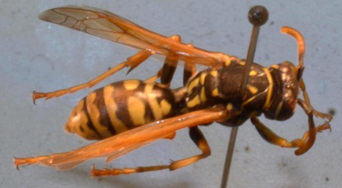
Halictidae Bee Bumble Bees Cuckoo Wasps Paper Wasps

Abdomen broadly joined to thorax: Sawflies, Horntails.
Abdomen narrowly constricted at attachment point to thorax: Ants, Wasps & Bees

Following are the insect orders we did not cover today:
COLLEMBOLA coll = ”glue” -embol = “peg” (refers to the collophore and adhesive organ) springtails
MICROCORYPHIA micro = small -coryphia = head jumping brisletails
THYSANURA thysan =”bristle or fringe” -ura = “tail” (refers to the bristle-like tail appendages)
silverfish, firebrats
EPHEMEROPTERA ephemero = “but a day” -ptera = ”wing” (refers to fact most adults live only a day or short time} mayflies
ODONATA odon = ”tooth” (refers to the toothed mandibles) dragonflies, damselflies
PLECOPTERA pleco = “folded or plaited” -ptera = “wing ( pleated or folded hind wings) stoneflies
PSOCOPTERA psoc =”rub small” –ptera =”wings” (refers to the gnawing habits of these insects)
psocids,, booklice, barklice
PHTHIRAPTERA chewing lice and sucking lice have been combined lice
TRICHOPTERA tricho = “hair” -ptera = “wing” (refers to the many hairs which cover the wings’ surface) caddisflies
SIPHONAPTERA siphon = “tube” -aptera = “wing” (refers to the beak-like sucking mouth parts & no wings) fleas MECOPTERA meco = “long” -ptera = “wing” scorpionflies
Embioptera Webspinners
Mecoptera Snakeflies
Strepsiptera Twisted winged parasites
Zoraptera (strong winged) Zorapterans

other non-insects orders you MAY encounter:
ARACHNIDS: Not all Arachnids are listed here.
- Basic characteristics of arachnids include four pairs of legs and a body divided into two segments: the cephalothorax and the abdomen.

Spiders: Araneae-
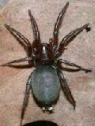
- Two body parts: head, cephalothorax joined by narrow pedicel. Body parts unsegmented.
- One prominent pair of pedipalps.
- Simple eyes usually 6 or 8, rarely 0, 2, or 4. Jumping spiders have the most highly developed arthropod eyes.
- Four pairs of legs.
- Variable in wide range of colors with or without patterns.
- Can spin silk for many uses.
- Can live from 1 to 25 years.

SCORPIONS: SCORPIONES-
- Two body parts broadly joined together so body looks undivided.
- One prominent pair of palps, the claw like pinchers.
- Three to six pairs of eyes.
- Four pairs of legs

- Last five segments of abdomen form tail with terminal sting.
- Color varies from black, dark brown, yellow, green with or without patterns.

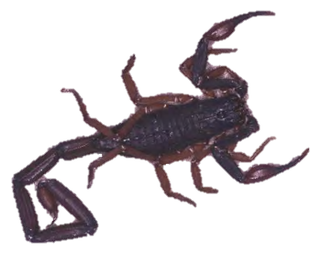

PSEUDOSCORPIONS: PseudoscorpioneS-
- Body parts joined together so body looks undivided.
- Resembles a tiny scorpion without the stinging tail.
- One prominent pair of palps, the pinchers.
- None, one or two pairs of simple eyes.
- Four pairs of legs.
- End of abdomen rounded at the end no tail present.
- Color varies with or without patterns.
- Size ranges from 7-8mm or smaller.
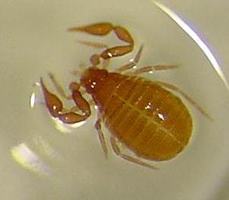

HARVESTMEN: OPILONES-
- Two body parts broadly joined together so body looks undivided and oval in shape.
- One pair of palps.
- Simple eyes are on a raised turret atop of the front part of the body.
- Four pairs of legs
- Wide range of color varies with or without pattern.
- Body length not including legs is from 3 – 10 mm.
- Each pair of legs is different in length then the others.
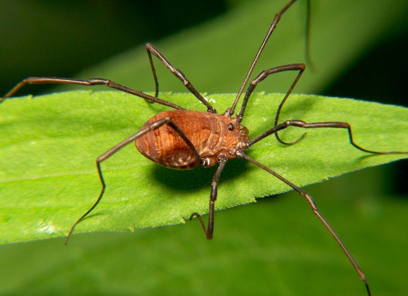

- Two body parts broadly joined together so body looks undivided.
- One pair of palps.
- Usually eyes not present but when present one pair of simple eyes.
- Four pairs of legs
- Body unsegmented.
- Largest varied range of feeding habits for all arthropods.
- Wide color range varies with or without pattern.
- Mites are the smallest of the arthropods ranging from 0.1 mm to over 30 mm.
MITES & TICKS: ACARI-
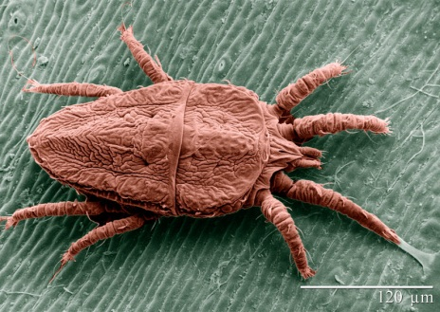

ARTHOPODS OTHER THEN INSECTA & ARACHNIDS

SOWBUGS, PILLBUGS: ISOPODA-

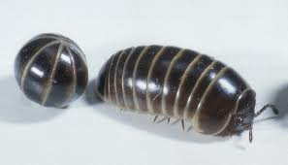
- Three body parts: head, thorax, abdomen .
- One prominent pair of antennae (one inconspicuous pair).
- Simple eyes.
- Seven pairs of legs.
- Seven separate segments on thorax.
- Paired appendages at end of abdomen called uropods.
- Color varies from dark gray to white with or without patterns.

Millipede: Diplopoda-
- Many body parts.
- Except for the first several trunk segments following the head, each truck segment has two pairs of legs per segment.
- Color varies from black, dark gray, yellow, to white with or without pattern
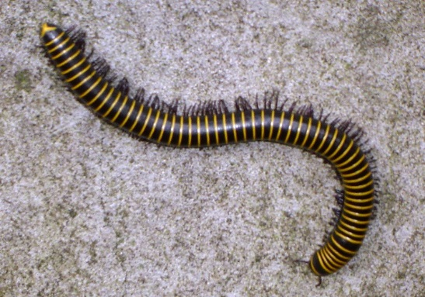

Centipedes: Chilopoda
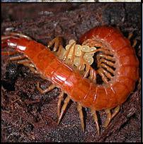
- Many body parts.
- One prominent pair of antennae.
- One pairs of legs per trunk segment.
- Color varies from dark gray to white with or without pattern.
- Size ranges from 5mm to 50 mm in length.

References:
References in Bold Print are good for identification help.

Borror, Donald J., Charles A. Triplehorn, Norman F. Johnson. 1989. An Introduction to the Study of Insects 6th Ed.Saunders College. ISBN 0-03-025397-7.

Borror, Donald J., White, Richard E. A Field Guide To The Insects of America North of Mexico”, (The Peterson Field Guide Series) 1970, ISBN 0-395-07436-3 (hardbound) ISBN 0-395-18523-8 (paperbound)

Eiseman, Charley, & Charney, Noah. Tracks & Sign of Insects and other invertebrates – A Guide to North American Species. 2010. Stackpole Books.ISBN -13:978-0-8117-3624-4

Griffin, Brian L.. The Orchard Mason Bee (Osmia lignaria propinqua Cresson) The life History, biology, Propagation and use of a North American Native Bee. 1999. Knox Cellars Publishing. 0-9635841-2-X.

Grissell, Eric. BEES, WASPS and ANTS – The Indispensable Role of Hymenoptera in Gardens. 2010. Timber Press Inc. ISBN 978-0-88192-988-1.

Haggard, Peter, Haggard, Judy. 2006. Insects of the Pacific Northwest. Timber Press, Inc. ISBN -13:978-0-88192-689-7.

Hedges, Stoy A. Field Guide for the management of Structure Infesting Flies. 1998. G. I. E. Inc. Publishers. PCT-Pest Control technology. ISBN 1-883751-06-3.

Houge, Charles L. Insects of the Los Angeles Basin. 1973, 1993. Natural History Museum of Los Angeles Co. ISBN 0-938644-29-7.

James, David G., Nunnallee, David. 2011. Life Histories of Cascadia Butterflies. Oregon State University Press. ISBN 978-0-87071-626-3 (paper) ISBN 978-0-87071-648-5 (ebook).

Kearns, Carol A., & Thomson, James D.. The Natural History of Bumblebees – A Sourcebook for Investigations. 2011. University Press of Colorado. ISBN0-87081-621-7.

Kerst, Cary,& Gordon, Steve. Daagonflies and Damselflies of Oregon A Field Guide. 2011. Oregon State University Press. ISBN 978-0-87071-589-1.

Mader, Eric, Matthew Shepherd, Mace Vaughan, Scoot Hoffman black, Gretchen LeBuhn. Attracting Native Pollinators – Protecting North Amerioca’s Bees Nd butterflies. 2011. Storey Publishing. ISBN 978-1-603342-695-4.

Pyle, Robert M., The butterflies of Cascadia. 2002, (reprint 2007). Seattle Audubon Society. ISBN 0-914516-13-2.

Russo, Ron. Field Guide to Plant Galls (of California & other Western States. 2006. University of California Press. ISBN 13-978-0-520-24886-1.

WEB References:
Oregon State University Spotted Wing Drosophila Project http://groups.hort.oregonstate.edu/group/spotted-wing-drosophila

The Diptera Site. The BioSystematic Database of World Diptera: http://www.sel.barc.usda.gov/diptera/biosys.htm

Insects and Spiders of the Lowland Pacific Northwest:
http://share3.esd105.wednet.edu/rsandelin/Fieldguide/Animalpages/Insects/Insectsintro.htm
Welcome to the Seattle Bug Safari®: An Exotic World of Insects: http://www.seattlebugsafari.com/resources.htm

Caterpillars of Pacific Northwest Forests and Woodlands:
http://www.npwrc.usgs.gov/resource/insects/catnw/index.htm

Neighborhood Naturalist http://www.neighborhood-naturalist.com/neighborhood-naturalist_home.htm

How to identify Brown Widow Spiders http://cisr.ucr.edu/identifying_brown_widow_spiders.html

Butterflies and Moths of North America collecting and sharing data about Lepidoptera
http://www.butterfliesandmoths.org/species/Tyria-jacobaeae

D I S C O V E R L I F E - INSECTS; ENTOGNATHA; HEXAPODS; HEXAPODA
http://www.discoverlife.org/mp/20q?search=Insecta&guide

USDA- Dragonflies and Damselflies (Odonata) of the United States
http://www.npwrc.usgs.gov/resource/distr/insects/dfly/index.htm

USDA - Collecting and Preserving Insects and Mites: Tools and Techniques
http://www.ars.usda.gov/Main/site_main.htm?docid=10141&page=1

The Yellowjackets of the Northwestern United States
http://academic.evergreen.edu/projects/ants/TESCBiota/kingdom/animalia/phylum/arthropoda/class/insecta/order/hymenoptera/family/Vespidae/Kweskin97/main.htm

BioQuip Products, Inc. An Entomological Supply Company (other biological supplies, books etc.) http://www.bioquip.com/default.asp

The Xerces Society http://www.xerces.org/

Pacific Northwest Insect Management Handbook: http://insects.ippc.orst.edu/pnw/insects

