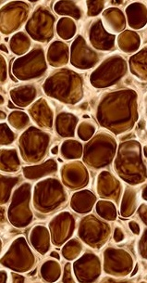

2

Lesson

Powerful Bones. Powerful Foods



** Objectives:** ➊ Know daily calcium requirements. ➋ Identify dairy and non-dairy calcium-rich foods. ➌ Know types of calcium supplements.

**Keywords:** Calcium-rich foods, lactose intolerance, dairy, non-dairy, supplements

**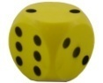**

**Games:** Wizard Mat, Discovery Chain – My Pair, Chopsticks, Oh My Word, Heavy Duty Words

**Utah State Office of Education Objective**

*Food and Nutrition II.* STANDARD 20.0118-03.

Objective 20.0118-0302. Classify common food and nutrition related health concerns.

National Standard 14.2.3 (The emphasis is on understanding the relationship of diet in the prevention, control and maintenance of these health concerns. A doctor should always be consulted regarding any of these concerns)

Discuss specific health concerns and risk factors for: anemia, colon and rectal cancer and osteoporosis.

**TIPS:** For an ice breaker or a more interactive introduction to the lesson, begin with the game called “My Pair”

Lesson Plan

1. Give Pre-test (Folders)
2. Teach
3. Games
4. Give Post-test (Folders)

**A. Daily Requirements of Calcium**

|  |  |
| --- | --- |
| **Age** | **Amount** |
| Birth – 6 months | 210 milligrams |
| 6 months – 1 year | 270 milligrams |
| 1 – 3 years old | 500 milligrams |
| 4 – 8 years old | 800 milligrams |
| 9 – 18 years old | 1,300 milligrams |
| 19 – 50 years old | 1,000 milligrams |
| Over 50 years old | 1,200 milligrams |

**Ask: How much calcium do you need every day?** (1,300)

* One cup (8FO) of milk has about 300 mg of calcium.
* The fat content in milk determines how much calcium you get from it. The lower the fat content, the higher the amount of calcium you get from milk.
* To get enough calcium to build strong bones and teeth, you should drink 3 cups of milk every day to get most of the calcium you need, and get the rest of the calcium from other sources.

**Ask: How many cups of milk should you drink every day to get most of the calcium you need?** (3 Cups)

**B. Sources of Calcium**

**Ask: Do you know what food is high in calcium?**

* Milk is a great source because it is widely available and may already be a part of your diet.
* Also, the human body easily absorbs milk. Some milk contains added vitamin D, which helps the body absorb calcium.
* Low fat or fat free dairy foods (i.e., milk and milk products) are the best choices of calcium. They allow more calcium than whole milk to be absorbed and contain fewer calories from fat.
* Non-dairy foods include:
  + Almonds, canned fish (like sardines with bones and salmon), some dried beans, oatmeal, tofu with added calcium sulfate, calcium-fortified soy milks calcium-fortified cereals or breads, calcium-fortified orange juice, and some leafy greens (like collard and turnip greens, kale, spinach, broccoli, Brussels sprouts, bok choy).
* Combination foods like pizza, yogurt added to fruit salad, fruity milkshake, sardine sandwich, sushi, and nachos with cheese are also good sources of calcium.
* A calcium supplement is also another way for us to get calcium.
* There are two common kinds of calcium supplements, calcium citrate and calcium carbonate.
  + Calcium citrate is the best choice of calcium supplement because the human body absorbs it very well. It comes mainly from citrus fruits.
  + Calcium carbonate is the worst choice because the human body absorbs it very poorly. Coming mainly from seashells and corals.

**C. What Do You Do If You Are Lactose Intolerant?**

* Lactose intolerance means that the body has a hard time digesting lactose.

**Ask: What is lactose?**

* Lactose is a natural sugar found in dairy products.
* People with lactose intolerance may experience different symptoms
  + Stomach pain, diarrhea, bloating, gas, and sometimes a white layer on the tongue.
* To get enough calcium from food, you can choose lactose-free milk and milk products or use over-the-counter pills or drops to help you digest lactose.
* Lactose intolerance may become milder by eating low fat or fat free dairy food with meals.
* If you drink calcium-fortified soymilk, make sure to shake the container really well before pouring it out because as much as three-quarter (75%) of all the added calcium may remain at the bottom of the container.

Visuals in power point form and other documents available online at

<http://extension.usu.edu/nic>

**Handout**

H-1. Hi-Lo Calcium

High calcium foods High calcium food

I like: I want to try:

C:\Documents and Settings\Siewsun\Local Settings\Temporary Internet Files\Content.IE5\ESFJZXOY\MCj03710220000[1].wmf1. \_\_\_\_\_\_\_\_\_\_\_\_\_\_\_\_ 1. \_\_\_\_\_\_\_\_\_\_\_\_\_\_\_\_\_

2. \_\_\_\_\_\_\_\_\_\_\_\_\_\_\_\_ 2. \_\_\_\_\_\_\_\_\_\_\_\_\_\_\_\_\_

Low calcium foods Low calcium food

I like: I want to cut back:

1. \_\_\_\_\_\_\_\_\_\_\_\_\_\_\_\_\_\_ 1. \_\_\_\_\_\_\_\_\_\_\_\_\_\_\_\_\_

2. \_\_\_\_\_\_\_\_\_\_\_\_\_\_\_\_\_\_ 2. \_\_\_\_\_\_\_\_\_\_\_\_\_\_\_\_\_

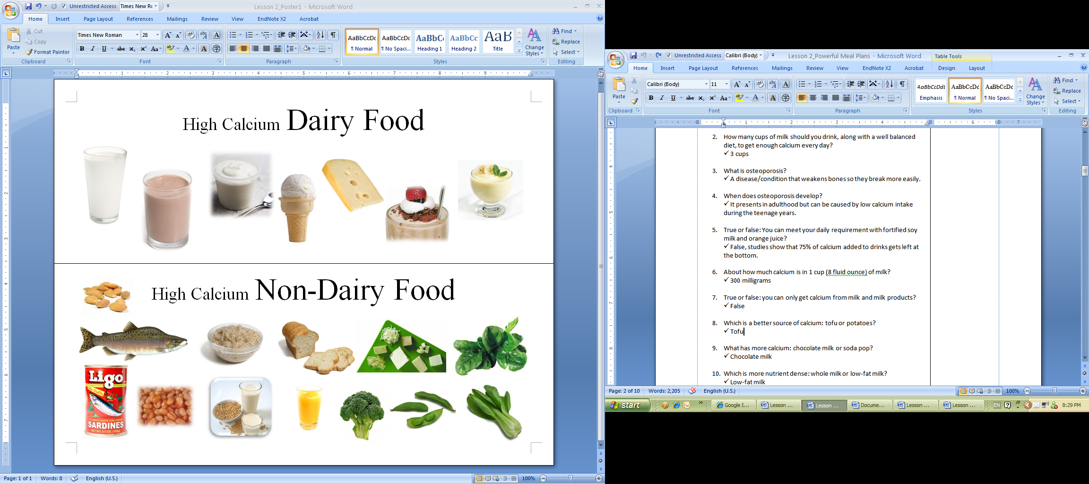

Baked Beans

Sardines with Bones

Calcium-fortified Soymilk Orange Juice Broccoli Edamame/Soybeans Bok Choy

Calcium-fortified bread Tofu with added calcium sulfate Spinach

*Oatmeal*

Salmon

Almonds

Milk Chocolate Milk Yogurt Ice Cream Cheese Milkshake Pudding

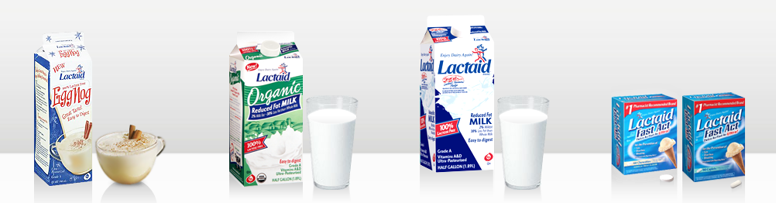

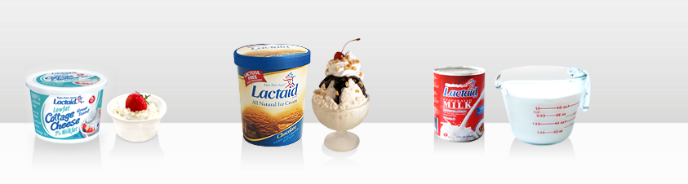

P-2. Lactose-Free Products

**Restroom Sign.pngRestroom Sign.pngcraft_Scissors.jpg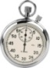**

**Restroom Sign.pngRestroom Sign.pngPlayers:** 2 or more (individually or team of 3).

**craft_Scissors.jpg**

**Materials:** Game mat, 2 foam die, question and answer set, Mystery Moves and Treats cards.

****

**Duration:** 15-30 minutes. *Modification:* Use two dice if you have less time to play this game.

****

**Goal:** Be the first player or team to move forward one round and return to the starting point.

**How to Play**

1. Each team rolls a die. The team with the highest number starts moving first.

2. Each team assigns a member to move as a game piece by standing in the box where the team lands.

1. The first team rolls two dice. The sum represents the number of steps the team can move forward in that turn.

Your team must correctly answer a question. If you fail to answer the question, you will lose the next turn and attempt to answer a question. If you fail to answer the second time, you will go to TIMEOUT CORNER.

\*\*You must stay in the TIMEOUT CORNER until you answer two questions correctly in the same turn. After answering correctly, roll the die (dice) to move immediately.

Immediately draw a MYSTERY MOVES CARD and follow the directions.

Immediately draw a TREATS CARD and follow the directions.

Safe zone. No action is needed.

The player must give a big smile to all other players.

1. The first team to make it around once (or more depending on time) wins.

Question Set

**Easy**

1. What are good sources of calcium? Give two examples.
   1. Milk and milk products, sardines, salmon, calcium-fortified soymilk and orange juice
2. True or false: You can meet your daily calcium requirements by drinking fortified soy milk and orange juice?
   1. True if you shake the container well
3. Give one example of a dairy product high in calcium.
   1. Milk, cheese, yogurt, ice cream, milkshake
4. True or false: you can only get calcium from dairy food (milk and milk products).
   1. False
5. Which menu has more calcium?

Menu 1: 1 cup low-fat milk, spinach salad with dressing, peanut butter and jelly sandwich.

Menu 2: Grilled cheese sandwich, soda pop, and potato chips

* 1. Menu 1

1. What has more calcium: chocolate milk or soda pop?
   1. Chocolate milk

**Medium**

1. How many cups of milk should a person without lactose intolerance drink everyday to get most of the calcium he or she needs, along with a well balanced diet?
   1. 3 cups of milk
2. Give one example of a non-dairy product high in calcium
   1. Tofu with added calcium, calcium-fotified soymilk, calcium-fortified orange juice, sardines with bones, salmon, green leafy vegetables, baked beans, edamame-soybeans.
3. What is a better source of calcium: tofu or potatoes
   1. Tofu
4. True or false: 1 cup of fat free, low fat , and whole milk have the same amount of calcium.
   1. False(the higher the fat content, the lower the absorption of calcium)
5. How much calcium will you get from 3 cups of milk?
   1. 300x3=900 milligrams
6. Would you be getting a lot of calcium if you had salmon, peas, and low-fat milk for dinner?
   1. Yes
7. Which calcium supplement is best absorbed by the human body?
   1. **Calcium citrate**
   2. Calcium sulfate
   3. Calcium carbonate
8. Which calcium supplement is most poorly absorbed by the human body?
   1. Calcium citrate
   2. Calcium sulfate
   3. **Calcium carbonate**

**Difficult**

1. What is osteoporosis
   1. A disease where bones do not have enough calcium, they become holey or porous and break more easily
2. About how much calcium is in 1 cup (8 fluid-ounce) of milk?
   1. 300 milligrams
3. What is the benefit of drinking low fat or fat free milk instead of whole milk?
   1. You get the same amount of calcium but less calories from fat
4. What has more calcium: sesame seeds or popcorn?
   1. Sesame seeds
5. Can you get calcium from dark, leafy green vegetables? (If yes, give an example)
   1. Spinach, broccoli, kale, bok choy, brussel sprouts
6. True or false: all nuts are rich in calcium?
   1. False, almonds are the only calcium-rich nut
7. If a person is lactose intolerant, what happens when he or she eats dairy food.
   1. Stomach pain, diarrhea, bloating, gas, and sometimes a white layer on the tongue

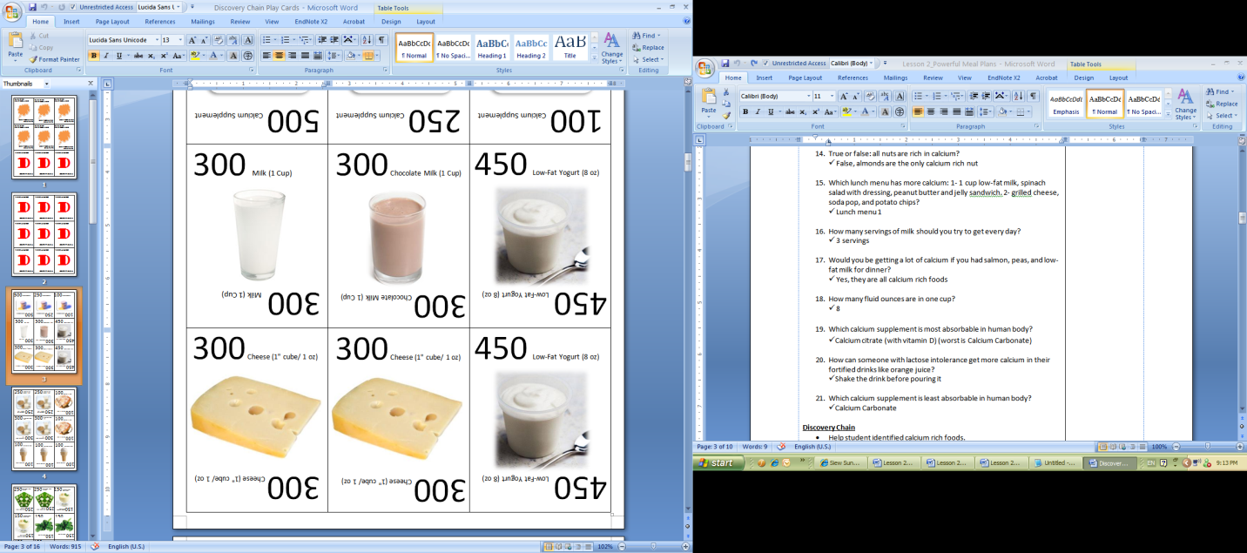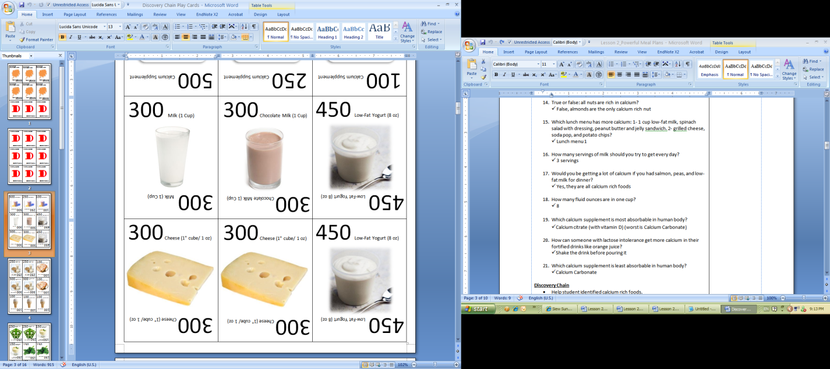 … 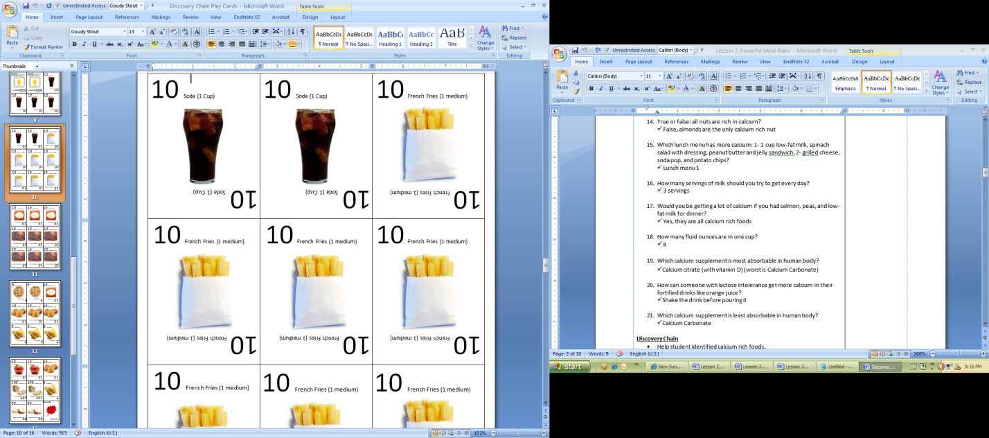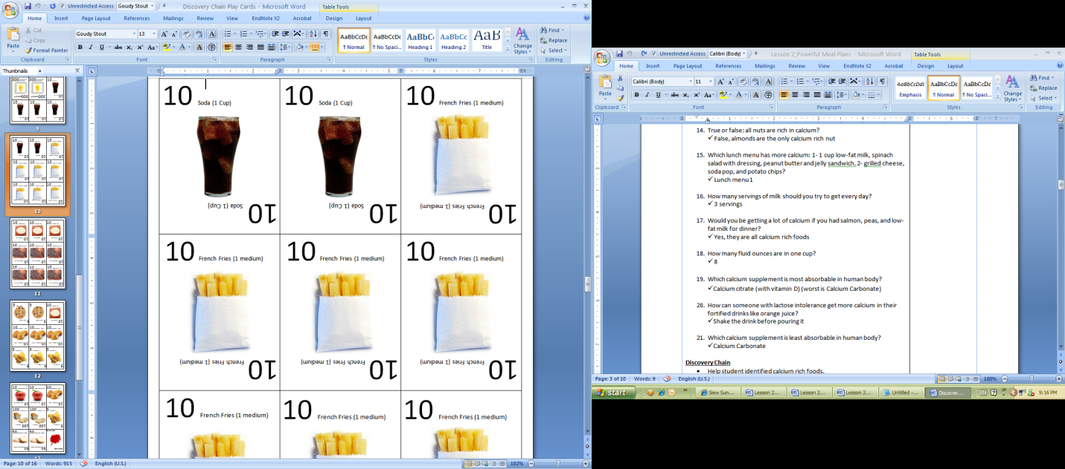

Restroom Sign.pngRestroom Sign.png

**Players:** 10 to 12 players.

**craft_Scissors.jpg**

**Materials:** 5 to 6 pairs of calcium cards selected from the *Calcium Chain* card set. Each pair of cards represents a different food but both contain the same amount of calcium. Place all cards in a bag.

****

**Duration:** 10 minutes.

****

**Goal:** Find the other player with the same amount of calcium. Line up from the highest number to the lowest number.

**How to Play**

* + 1. All players stand in a circle. Everyone draws a card from the bag and does not reveal their cards to others.
    2. When the teacher announces “Start”, each player can reveal their cards, and search for their pair whose card shows the same number.
    3. Matched pair will stand together, and line up from the highest number (left) to the lowest number (right) in a line.
    4. Starting from the highest number, each player will hold up his or her card, read out the name of the food, the amount of food, and the amount of calcium contained in that food, (e.g., Milk, 1 cup of milk has 300 mg of calcium).
    5. There is no winner in this game, only to increase the awareness of calcium in foods.

**TIPS**: Sometimes, players with the lowest calcium numbers may feel unimportant. Encourage them by saying, “Look, it is very important to remember what foods are very low in calcium so that we will eat less of these foods to prevent osteoporosis.”

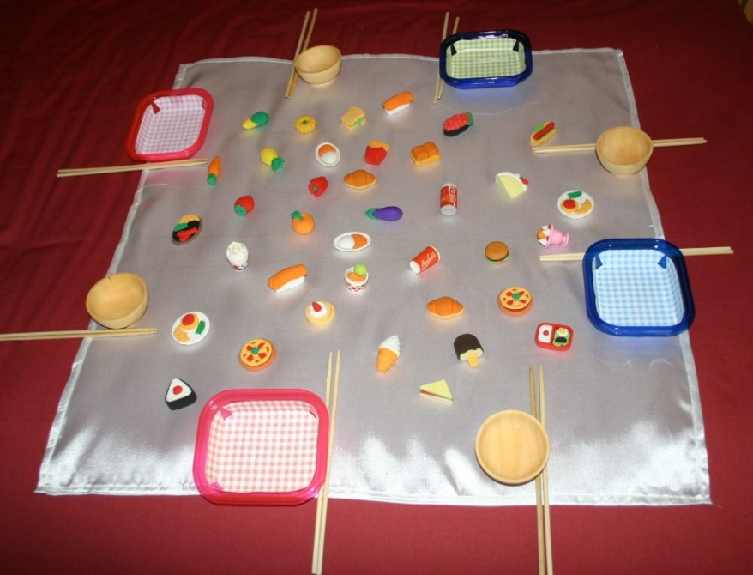

Restroom Sign.pngRestroom Sign.png

**Players:** 4-8 players, two players per team.

**craft_Scissors.jpg**

**Materials:** Miniature food models (made from eraser), 2-4 Wildcards, 4-8 pairs of chopsticks, plates or bowls, masking tape or a piece of 2’x2’ cloth.

****

**Duration:** 5-10 minutes.

****

**Goal:** Be the team who picks up the highest number of calcium-rich foods.

**How to Play**

1. Lay the 2’x2’ cloth on the floor, or use the masking tape to form a 2’x2’ square.
2. Place miniature food models and all Wildcards on the cloth or in the playing area.
3. Divide players in teams. Arrange players to sit in alternate teams around the square. Each player holds a pair of chopstick and a plate or bowl. Those who do not know how to use the chopsticks are allowed to use both hands to hold the chopsticks.
4. Each team competes to pick up as many calcium-rich foods as possible. Encourage your students to use their ‘wildest imagination’ to find foods high in calcium.
5. At the end, each player counts the number of food items in their own plate or bowl. Each explains why he or she considers the food rich in calcium.
6. Anyone who picks up a Wildcard needs to name a calcium-rich food that is different from all items in his or her bowl. If the answer is correct, the Wildcard is counted as an additional food item.
7. The team with the highest number of calcium-rich foods wins.

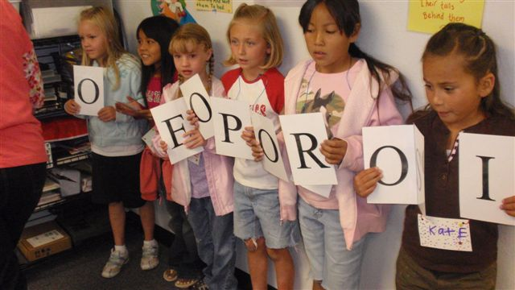

**Restroom Sign.pngRestroom Sign.png**

**Players:** 2teams of 5 or more players.

**craft_Scissors.jpg**

**Materials:** Keywords,4.25” x 5.5” laminated alphabet cards and ‘blank’ cards.

****

**Duration:** 5-10 minutes.

****

**Goal:** Be the first team to spell a keyword correctly.

… Moving around …

**How to Play**

1. Spread all alphabet cards on the floor.
2. Each team selects a leader. All players stand around the alphabet cards.
3. The judge hands over a keyword or keyword pair with the same number of alphabets to each team leader. Both teams will begin together and compete to form a chain of the alphabets that spell out the keyword.
4. Each player holds at least an alphabet card. The fastest team that completes the spelling correctly wins.

**Keyword Examples**

* Dairy
* Non-dairy
* Lactose
* Calcium Rich Food
* Lactose Intolerance
* Supplements vs. Intolerance

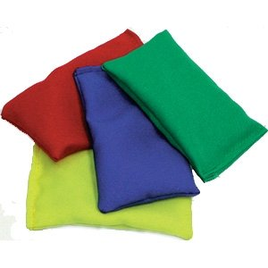

… Need a little weight-bearing? ...

**Restroom Sign.pngRestroom Sign.png**

**Players:** 2 players or more.

**craft_Scissors.jpg**

**Materials:** Keyword cards, keyword bag, bean bags.

****

**Duration:** 5-10 minutes.

****

**Goal:** Be the first one to spell a keyword correctly without dropping any bean bags.

**How to Play**

1. Place one bean bag on the back of each speller’s hands. Each player will spell with their arms straight.
2. The judge will announce a keyword drawn from the ‘keyword bag’.
3. All spellers will stand in one line facing the judge. The size of each letter spelt with hand movements must not be smaller than a letter-sized paper.
4. Starting together, every speller will act out each alphabet of the keyword in right order without dropping any bean bags.
5. If any bean bag falls before a word is completely spelled out, the speller has to start over.
6. The fastest speller who spells out the whole word without dropping any bean bags wins.

**TIPS**: To make the game more advanced, double the number of bean bags in Round 2.

Answer Key (Student Copy found in folder) Time: First 5 Minutes

1. For ages 9 to 18, how much calcium do you need every day?

a. 1000 mg

**b. 1300 mg**

c. 1500 mg

2. 1 cup (8 fluid ounce) of milk contains about how much calcium?

a. 100 mg

b. 200 mg

**c. 300 mg**

3. You can only get calcium from milk and milk products?

a. True

**b. False**

4. Which has more calcium: Chocolate milk or soda pop?

**a. Chocolate milk**

b. Soda

5. Which calcium supplement is most absorbable (the best choice) in human body?

a. Calcium carbonate

b. Calcium sulfate

**c. Calcium citrate**

Score: \_\_\_\_\_\_\_ Points

Answer Key (Student Copy In folders) Time: Last 5 Minutes

1. Every day, 9-18 year olds need \_\_\_\_\_\_\_ mg of calcium to build strong bones and teeth, and prevent osteoporosis.

a. 500

b. 1000

**c. 1300**

2. How many cups of milk should a person **with no lactose intolerance** drink every day to get most of the calcium he or she needs, along with a well balanced diet?

a. 2 cups

**b. 3 cups**

c. 4 cups

3. Name two **non-dairy foods** that are also rich in calcium.

**Calcium-fortified soymilk, Calcium-fortified orange juice, Dark leafy vegetables, Tofu, Seaweed, Sesame seeds**

4. Which is a better source of calcium: Tofu or potato?

(Circle the right answer)

5. Which calcium supplement is most poorly absorbed in human body?

**a. Calcium carbonate**

b. Calcium sulfate

c. Calcium citrate

Score: \_\_\_\_\_\_\_ points

To be completed at the end of Lesson 4 if all four lessons are taught. If not, have your students complete this survey at the end of this lesson.

Name: \_\_\_\_\_\_\_\_\_\_\_\_\_\_\_\_\_\_\_\_\_\_ School: \_\_\_\_\_\_\_\_\_\_\_\_\_\_\_\_\_\_\_\_\_\_\_\_\_\_\_

Date: \_\_\_\_\_\_\_\_ Age: \_\_\_\_\_\_ Gender: 🞏 Boy 🞏 Girl

Ethnicity: 🞏 White 🞏 Hispanic 🞏 Asian 🞏 Native American

🞏 African American 🞏 Other: ­\_\_\_\_\_\_\_\_\_\_\_\_\_\_\_\_\_\_\_\_\_\_\_\_\_\_\_\_

1. Things I like about this class:

🞏 Short Lesson

🞏 Games

🞏 Handouts

🞏 Treats

🞏 Something else: \_\_\_\_\_\_\_\_\_\_\_\_\_\_\_\_\_\_\_\_\_\_\_\_\_\_\_\_\_\_\_\_\_\_

1. Things I don’t like about this class are:



Teacher’s Name: \_\_\_\_\_\_\_\_\_\_\_\_\_\_\_\_\_\_\_\_\_\_\_\_\_\_\_\_ Date: \_\_\_\_\_\_\_\_\_\_\_\_\_

Age group taught: \_\_\_\_\_\_\_ years old Years of Teaching:\_\_\_\_\_

**Grading Scale**:

A+ = Excellent A = Very Good B = Good C = Average D = Poor F = Fail

Reading and Comprehension Level

|  |  |  |
| --- | --- | --- |
| **Aspects** | **Grade** | **Comments** |
| Reading Level |  |  |
| Clear Purpose |  |  |
| Appropriate word usage |  |  |
| Appropriate sentence and paragraph structures |  |  |
| Overall organization |  |  |
| Appropriate tone |  |  |

Content

|  |  |  |
| --- | --- | --- |
| **Aspects** | **Grade** | **Comments** |
| Accurate, credible information |  |  |
| Age Appropriate information |  |  |
| Practical information |  |  |
| Appropriate recipes |  |  |

Design and Quality

|  |  |  |
| --- | --- | --- |
| **Aspects** | **Grade** | **Comments** |
| Appropriate use of color |  |  |
| Readable type size and style |  |  |
| Appropriate illustration |  |  |
| Appropriate tables, charts, and graphs |  |  |
| Organized, balanced layout |  |  |

Which game(s) did you use to teach this lesson?

Which is the best game that you consider most effective in helping your students learn and apply?

Overall grade = \_\_\_\_\_\_\_\_

Additional comments:

\_\_\_\_\_\_\_\_\_\_\_\_\_\_\_\_\_\_\_\_\_\_\_\_\_\_\_\_\_\_\_\_\_\_\_\_\_\_\_\_\_\_\_\_\_\_\_\_\_\_\_\_\_\_\_\_\_\_\_\_\_\_\_\_\_\_\_\_\_\_\_\_\_\_\_\_\_\_\_\_\_\_\_\_\_\_\_\_\_\_\_\_\_\_\_\_\_\_\_\_\_\_\_\_\_\_\_\_\_\_\_\_\_\_\_\_\_\_\_\_\_\_\_\_\_\_\_\_\_\_\_\_\_\_\_\_\_\_\_\_\_\_\_\_\_\_\_\_\_\_\_\_\_\_\_\_\_\_\_\_\_\_\_\_\_\_\_\_\_\_\_\_\_\_\_\_\_\_\_\_\_\_\_\_\_\_\_\_\_\_\_\_\_\_\_\_\_\_\_\_\_\_\_\_\_\_\_\_\_\_\_\_\_\_\_\_\_\_\_\_\_\_\_\_\_\_\_\_\_\_\_\_\_\_\_\_\_\_\_\_\_\_\_\_\_\_\_\_\_\_\_\_\_\_\_\_\_\_\_\_\_\_\_\_\_\_\_\_\_\_\_\_\_\_\_\_\_\_\_\_\_\_\_\_\_\_\_\_\_\_\_\_\_\_\_\_\_\_\_\_\_\_\_\_\_\_\_\_\_\_\_\_\_\_\_\_\_\_\_\_\_\_\_\_\_\_\_\_\_\_\_\_\_\_\_\_\_\_\_\_\_\_\_\_\_\_\_\_\_\_\_\_\_\_\_\_\_\_\_\_\_\_\_\_\_\_\_\_\_\_\_\_\_\_\_\_\_\_\_\_\_\_\_\_\_\_\_\_\_\_\_\_\_\_\_\_\_\_\_\_\_\_\_\_\_\_\_\_\_\_\_\_\_\_\_\_\_\_\_\_\_\_\_\_\_\_\_\_\_\_\_\_\_\_\_\_\_\_\_\_\_\_\_\_\_\_\_\_\_\_\_\_\_\_\_\_\_\_\_\_\_\_\_\_\_\_\_\_\_\_\_\_\_\_\_\_\_\_\_\_\_\_\_\_\_\_\_\_\_\_\_\_\_\_\_\_\_\_\_\_\_\_\_\_\_\_\_\_\_\_\_\_\_\_\_\_\_\_\_\_\_\_\_\_\_\_\_\_\_\_\_\_\_\_\_\_\_\_\_\_\_\_\_\_\_\_\_\_\_\_\_\_\_\_\_\_\_\_\_\_\_\_\_\_\_\_\_\_\_\_\_\_\_\_\_\_\_\_\_\_\_\_\_\_\_\_\_\_\_\_\_\_\_\_\_\_\_\_\_\_\_\_\_\_\_\_\_\_\_\_\_\_\_\_\_\_\_\_\_\_\_\_\_\_\_\_\_\_\_\_\_\_\_\_\_\_\_\_\_\_\_\_\_\_\_\_\_\_\_\_\_\_\_\_\_\_\_\_\_\_\_\_\_\_\_\_\_\_\_\_\_\_\_\_\_\_\_\_\_\_\_\_\_\_\_\_\_\_\_\_\_\_\_\_\_\_\_\_\_\_\_\_\_\_\_\_\_\_\_\_\_\_\_\_\_\_\_\_\_\_\_\_\_\_\_\_\_\_\_\_\_\_\_\_\_\_\_\_\_\_\_\_\_\_\_\_\_\_\_\_\_\_\_\_\_\_\_\_\_\_\_\_\_\_\_\_\_\_\_\_\_\_\_\_\_\_\_\_\_\_\_\_\_\_\_\_\_\_\_\_\_\_\_\_\_\_\_\_\_\_\_\_\_\_\_\_\_\_\_\_\_\_\_\_\_\_\_\_\_\_\_\_\_\_\_\_\_\_\_\_\_\_\_\_\_\_\_\_\_\_\_\_\_\_\_\_\_\_\_\_\_\_\_\_\_\_\_\_\_\_\_\_\_\_\_\_\_\_\_\_\_\_\_\_\_\_\_\_\_\_\_\_\_\_\_\_\_\_\_\_\_\_\_\_\_\_\_\_\_\_\_\_\_\_\_\_\_\_\_\_\_\_\_\_\_\_\_\_\_\_\_\_\_\_\_\_\_\_\_\_\_\_\_\_\_\_\_\_\_\_\_\_\_\_\_\_\_\_\_\_\_\_\_\_\_\_\_\_\_\_\_\_\_\_\_\_\_\_\_\_\_\_\_\_\_\_\_\_\_\_\_\_\_\_\_\_\_\_\_\_\_\_\_\_\_\_\_\_\_\_\_\_\_\_\_\_\_\_\_\_\_\_\_\_\_\_\_\_\_\_\_\_\_\_\_\_\_\_\_\_\_\_\_\_\_\_\_\_\_\_\_\_\_\_\_\_\_\_\_\_\_\_\_\_\_\_\_\_\_\_\_\_\_\_\_\_\_\_\_\_\_\_\_\_\_\_\_\_\_\_\_\_\_\_\_\_\_\_\_\_\_\_\_\_\_\_\_\_\_\_\_\_\_\_\_\_\_\_\_\_\_\_\_\_\_\_\_\_\_\_\_\_\_\_\_\_\_\_\_\_\_\_\_\_\_\_\_\_\_\_\_\_\_\_\_\_\_\_\_\_\_\_\_\_\_\_\_\_\_\_\_\_\_\_\_\_\_\_\_\_\_\_\_\_\_\_\_\_\_\_\_\_\_\_\_\_\_\_\_\_\_\_\_\_\_\_\_\_\_\_\_\_\_\_\_\_\_\_\_\_\_\_\_\_\_\_\_\_\_\_\_\_\_\_\_\_\_\_\_\_\_\_\_\_\_\_\_\_\_\_\_\_\_\_\_\_\_\_\_\_\_\_\_\_\_\_\_\_\_\_\_\_\_\_\_\_\_\_\_\_\_\_\_\_\_\_\_\_\_\_\_\_\_\_\_\_\_\_\_\_\_\_\_\_\_\_\_\_\_\_\_\_\_\_\_\_\_\_\_\_\_\_\_\_\_\_\_\_\_\_\_\_\_\_\_\_\_\_\_\_\_\_\_\_\_\_\_\_\_\_\_\_\_\_\_\_\_\_\_\_\_\_\_\_\_\_\_\_\_\_\_\_\_\_\_\_\_\_\_\_\_\_\_\_\_\_\_\_\_\_\_\_\_\_\_\_\_\_\_\_\_\_\_\_\_\_\_\_\_\_\_\_\_\_\_\_\_\_\_\_\_\_\_\_\_\_\_\_\_\_\_\_\_\_\_\_\_\_\_\_\_\_\_\_\_\_\_\_\_\_\_\_\_\_\_\_\_\_\_\_\_\_\_\_\_\_\_\_\_\_\_\_\_\_\_\_\_\_\_\_\_\_\_\_\_\_\_\_\_\_\_\_\_\_\_\_\_\_\_\_\_\_\_\_\_\_\_\_\_\_\_\_\_\_\_\_\_\_\_\_\_\_\_\_\_\_\_\_\_\_\_\_\_\_\_\_\_\_\_\_\_\_\_\_\_\_\_\_\_\_\_\_\_\_\_\_\_\_\_\_\_\_\_\_\_\_\_\_\_\_\_\_\_\_\_\_\_\_\_\_\_\_\_\_\_\_\_\_\_\_\_\_\_\_\_\_\_\_\_\_\_\_\_\_\_\_\_\_\_\_\_\_\_\_\_\_\_\_\_\_\_\_\_\_\_\_\_\_\_\_\_\_\_\_\_\_\_\_\_\_\_\_\_\_\_\_\_\_\_\_\_\_\_\_\_\_\_\_\_\_\_\_\_\_\_\_\_\_\_\_\_\_\_\_\_\_\_\_\_\_\_\_\_\_\_\_\_\_\_\_\_\_\_\_\_\_\_\_\_\_\_\_\_\_\_\_\_\_\_\_\_\_\_\_\_\_\_\_\_\_\_\_\_\_\_\_\_\_\_\_\_\_\_\_\_\_\_\_\_\_\_\_\_\_\_\_\_\_\_\_\_\_\_\_\_\_\_\_\_\_\_\_\_\_\_\_\_\_\_\_\_\_\_\_\_\_\_\_\_\_\_\_\_\_\_\_\_\_\_\_\_\_\_\_\_\_\_\_\_\_\_\_\_\_\_\_\_\_\_\_\_\_\_\_\_\_\_\_\_\_\_\_\_\_\_\_\_\_\_\_\_\_\_\_\_\_\_\_\_\_\_\_\_\_\_\_\_\_\_\_\_\_\_\_\_\_\_\_\_\_\_\_\_\_\_\_\_\_\_\_\_\_\_\_\_\_\_\_\_\_\_\_\_\_\_\_\_\_\_\_\_\_\_\_\_\_\_\_\_\_

**Tracking Sheet** Teacher’s Initial: \_\_\_\_\_\_

Start Date: \_\_\_\_\_\_\_\_\_\_ End Date: \_\_\_\_\_\_\_\_\_\_

|  |  |  |  |  |  |  |
| --- | --- | --- | --- | --- | --- | --- |
| # | Full Name | Consent Submitted | Pre-Test Score | Calcium Countdown Score | Post-Test Score | Feedback Submitted |
| 1 |  |  |  |  |  |  |
| 2 |  |  |  |  |  |  |
| 3 |  |  |  |  |  |  |
| 4 |  |  |  |  |  |  |
| 5 |  |  |  |  |  |  |
| 6 |  |  |  |  |  |  |
| 7 |  |  |  |  |  |  |
| 8 |  |  |  |  |  |  |
| 9 |  |  |  |  |  |  |
| 10 |  |  |  |  |  |  |
| 11 |  |  |  |  |  |  |
| 12 |  |  |  |  |  |  |
| 13 |  |  |  |  |  |  |
| 14 |  |  |  |  |  |  |
| 15 |  |  |  |  |  |  |
| 16 |  |  |  |  |  |  |
| 17 |  |  |  |  |  |  |
| 18 |  |  |  |  |  |  |
| 19 |  |  |  |  |  |  |
| 20 |  |  |  |  |  |  |
| 21 |  |  |  |  |  |  |
| 22 |  |  |  |  |  |  |
| 23 |  |  |  |  |  |  |
| 24 |  |  |  |  |  |  |
| 25 |  |  |  |  |  |  |

Extra Notes

\_\_\_\_\_\_\_\_\_\_\_\_\_\_\_\_\_\_\_\_\_\_\_\_\_\_\_\_\_\_\_\_\_\_\_\_\_\_\_\_\_\_\_\_\_\_\_\_\_\_\_\_\_\_\_\_\_\_\_\_\_\_\_\_\_\_\_\_\_\_\_\_\_\_\_\_\_\_\_\_\_\_\_\_\_\_\_\_\_\_\_\_\_\_\_\_\_\_\_\_\_\_\_\_\_\_\_\_\_\_\_\_\_\_\_\_\_\_\_\_\_\_\_\_\_\_\_\_\_\_\_\_\_\_\_\_\_\_\_\_\_\_\_\_\_\_\_\_\_\_\_\_\_\_\_\_\_\_\_\_\_\_\_\_\_\_\_\_\_\_\_\_\_\_\_\_\_\_\_\_\_\_\_\_\_\_\_\_\_\_\_\_\_\_\_\_\_\_\_\_\_\_\_\_\_\_\_\_\_\_\_\_\_\_\_\_\_\_\_\_\_\_\_\_\_\_\_\_\_\_\_\_\_\_\_\_\_\_\_\_\_\_\_\_\_\_\_\_\_\_\_\_\_\_\_\_\_\_\_\_\_\_\_\_\_\_\_\_\_\_\_\_\_\_\_\_\_\_\_\_\_\_\_\_\_\_\_\_\_\_\_\_\_\_\_\_\_\_\_\_\_\_\_\_\_\_\_\_\_\_\_\_\_\_\_\_\_\_\_\_\_\_\_\_\_\_\_\_\_\_\_\_\_\_\_\_\_\_\_\_\_\_\_\_\_\_\_\_\_\_\_\_\_\_\_\_\_\_\_\_\_\_\_\_\_\_\_\_\_\_\_\_\_\_\_\_\_\_\_\_\_\_\_\_\_\_\_\_\_\_\_\_\_\_\_\_\_\_\_\_\_\_\_\_\_\_\_\_\_\_\_\_\_\_\_\_\_\_\_\_\_\_\_\_\_\_\_\_\_\_\_\_\_\_\_\_\_\_\_\_\_\_\_\_\_\_\_\_\_\_\_\_\_\_\_\_\_\_\_\_\_\_\_\_\_\_\_\_\_\_\_\_\_\_\_\_\_\_\_\_\_\_\_\_\_\_\_\_\_\_\_\_\_\_\_\_\_\_\_\_\_\_\_\_\_\_\_\_\_\_\_\_\_\_\_\_\_\_\_\_\_\_\_\_\_\_\_\_\_\_\_\_\_\_\_\_\_\_\_\_\_\_\_\_\_\_\_\_\_\_\_\_\_\_\_\_\_\_\_\_\_\_\_\_\_\_\_\_\_\_\_\_\_\_\_\_\_\_\_\_\_\_\_\_\_\_\_\_\_\_\_\_\_\_\_\_\_\_\_\_\_\_\_\_\_\_\_\_\_\_\_\_\_\_\_\_\_\_\_\_\_\_\_\_\_\_\_\_\_\_\_\_\_\_\_\_\_\_\_\_\_\_\_\_\_\_\_\_\_\_\_\_\_\_\_\_\_\_\_\_\_\_\_\_\_\_\_\_\_\_\_\_\_\_\_\_\_\_\_\_\_\_\_\_\_\_\_\_\_\_\_\_\_\_\_\_\_\_\_\_\_\_\_\_\_\_\_\_\_\_\_\_\_\_\_\_\_\_\_\_\_\_\_\_\_\_\_\_\_\_\_\_\_\_\_\_\_\_\_\_\_\_\_\_\_\_\_\_\_\_\_\_\_\_\_\_\_\_\_\_\_\_\_\_\_\_\_\_\_\_­­­­­­­­­­­­­­­­­­­­­­­­­­­­­­­­­­­­­­\_\_\_\_\_\_\_\_\_\_­­­­­­­­­­­­­­­­­­­­­­­­­­­­­­­­­­­­­­­­­­­­­­­­­­­­­­­­­­­­­­­­­­­­­\_\_\_\_\_\_\_\_\_\_\_\_\_\_\_\_\_\_\_\_\_\_\_\_\_\_\_\_\_\_

\_\_\_\_\_\_\_\_\_\_\_\_\_\_\_\_\_\_\_\_\_\_\_\_\_\_\_\_\_\_\_\_\_\_\_\_\_\_\_\_\_\_\_\_\_\_\_\_\_\_\_\_\_\_\_\_\_\_\_\_\_\_\_\_\_\_\_\_\_\_\_\_\_\_\_\_\_\_\_\_\_\_\_\_\_\_\_\_\_\_\_\_\_\_\_\_\_\_\_\_\_\_\_\_\_\_\_\_\_\_\_\_\_\_\_\_\_\_\_\_\_\_\_\_\_\_\_\_\_\_\_\_\_\_\_\_\_\_\_\_\_­­­­­­­­­­­­­­­­­­­­­­­­­­­­­­­­­­­­­­\_\_\_\_\_\_\_\_\_\_­­­­­­­­­­­­­­­­­­­­­­­­­­­­­­­­­­­­­­­­­­­­­­­­­­­­­­­­­­­­­­­­­­­­­\_\_\_\_\_\_\_\_\_\_\_\_\_\_\_\_\_\_\_\_\_\_\_\_\_\_\_\_\_

****

**USU Extension is an equal opportunity, affirmative action educator and employer.**Utah State University is committed to providing an environment free from harassment and other forms of illegal discrimination based on race, color, religion, sex, national origin, age (40 and older), disability, and veteran’s status. USU’s policy also prohibits discrimination on the basis of sexual orientation in employment and academic related practices and decisions.

Utah State University employees and students cannot, because of race, color, religion, sex, national origin, age, disability, or veteran’s status, refuse to hire; discharge; promote; demote; terminate; discriminate in compensation; or discriminate regarding terms, privileges, or conditions of employment, against any person otherwise qualified. Employees and students also cannot discriminate in the classroom, residence halls, or in on/off campus, USU-sponsored events and activities.

This publication is issued in furtherance of Cooperative Extension work, acts of May 8 and June 30, 1914, in cooperation with the U.S. Department of Agriculture, Noelle E. Cockett, Vice President for Extension and Agriculture, Utah State University.

**References**

1. American Academy of Pediatrics. <http://www.aap.org>.

1. American School Health Association. <http://www.ashaweb.org>.
2. Dietary Guidelines for Americans 2005. <http://www.healthierus.gov/dietaryguidelines>.
3. Establishing Peak Bone Mass. National Council of Strength and Fitness. <http://www.ncsf.org/pdf/ceu/establishing-peak-bone-mass.pdf>
4. Matkovic V, Fontana D, Tominac C, Goel P., Chesnut III CH. Factors that Influence Peak Bone Mass Formation: A Study of Calcium Balance and the Inheritance of Bone Mass in Adolescent Females. *American Journal of Clinical Nutrition*, 52:878-888, 1990.
5. MyPyramid. <http://MyPyramid.gov>.
6. National Institute of Child Health and Human Development – Milk Matters Calcum Education Campaign. <http://www.nichd.nih.gov/milk>.
7. National Institutes of Health – Bone Health. <http://www.niams.nih.gov/Health_Info/Bone/>.
8. National Osteoporosis Foundation. <http://www.NOF.org>.
9. Powerful Girls Have Powerful Bones. National institutes of Health. <http://www.girlshealth.gov/bones/>.
10. U.S. Department of Health and Human Services – Healthier U.S. <http://healthierus.gov/index.html>.
11. Weaver CM and Heaney RP. Calcium in Human Health. New York, NY: Humana Press; 2006.
12. What We Eat in America, NHANES 2005-2006 - Usual Nutrient Intakes From Food and Water Compared to 1997 Dietary Reference Intakes for Vitamin D, Calcium, Phosphorus, and Magnesium. <http://www.ars.usda.gov/SP2UserFiles/Place/12355000/pdf/0506/usual_nutrient_intake_vitD_ca_phos_mg_2005-06.pdf>.