MCSY00294_0000[1]Lesson

Every ‘Body’ Is Different

50 min

****

**Objective:** ➊ Explain natural body differences. ➋Learn to accept own body shape and size. ➌ Learn ways to build positive body image and self-esteem. ➍ Learn to discover and appreciate own and other’s true beauty.

**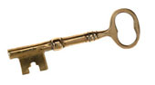**

**Keywords:** Body shape, body size, body frame, healthy weight, Yo-Yo Diet, eating disorders

**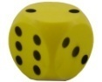**

**Activities:** Media Message, Body Frame and Fame, Beauty from the Heart

**Utah State Office of Education Objective**

*Food and Nutrition II.* STANDARD 20.0118-03.

Objective 20.0118-0302. Classify common food and nutrition related health concerns.

National Standard 14.2.3 (The emphasis is on understanding the relationship of diet in the prevention, control and maintenance of these health concerns. A doctor should always be consulted regarding any of these concerns)

Discuss specific health concerns and risk factors for: anemia, colon and rectal cancer and osteoporosis.

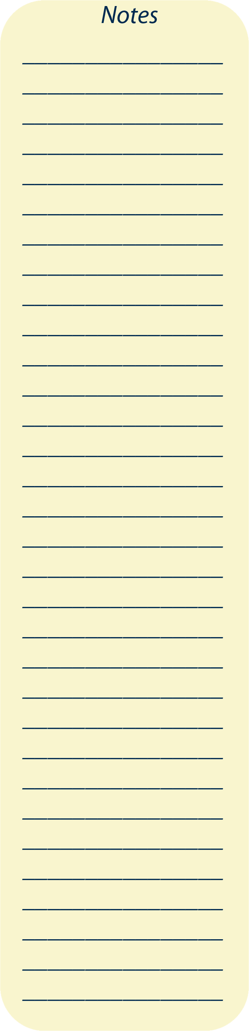Lesson Plan

1. Give Pre-test (Folders)

2. Teach

3. Games (Pick and choose game(s) that fit your class time)

4. Give Post-test (Folders)

1. **What is Body Image?**
2. Body image is “a picture of the body seen through the mind’s eye.” This personal view and interpretation of our body involves mental, physical, emotional, and historical components. (Adapted definitions from Human and Health Services and The Dairy Council of California)
3. Body image and self-esteem have a tie because how we feel about our bodies affects our whole self.

**Ask: Do we tend to overreact about how we look much more than what someone else thinks about us?**

1. Many often feel ‘I don’t look good enough’. Do you know, in America, 7 in 10 overweight females dislike their bodies? And 4 in 10 thin females dislike their bodies? (Report from ‘Shape Up America’).
2. Unfortunately, this feeling of not being good enough with our body begins from a young age as exposure to negative influence increases.
3. Look at Poster P-1. Among 100 American women, only two can become fashion models that are 5’11” tall and weigh 117 pounds. Only two, compared to the other 98 average women who are 5’4” tall and weigh 140 pounds. And these 2 models may not be as healthy as the other 98 women.

**Suggested game for transition: Media Messages**

**B. The Wrong Standards of Beauty**

1. The media, such as magazines, advertisements, television, websites, MTVs, and movies, are very powerful influences on one wrong standard of beauty.
2. Through the media, we see attractive images of unrealistic body shapes of women, or extremely muscular men.
3. These images are considered ‘normal’ in media but when in reality, they are not! As a result, can you see how it is affecting us? It causes many teens, and even adults, to feel like a loser all the time. It makes us feel that our body does not look ‘good enough’.

**Ask: If we successfully lose weight, have cosmetic surgeries to improve our looks, and wear high heels to gain a few inches, and touch up our photo with Photoshop, what harms did we do to ourselves?**

* We may lose weight too fast and negatively impact our health.
* Cosmetic surgeries can cause infections and other side effects that we think won’t happen to us.
* Wearing high heels puts a lot of pressure to the hip and backbones. When uneven pressure is used while walking, back pain begins, worsens, and continues later at older ages.
* Wearing high heels also causes more risk of falling and hurting ourselves and others.
* Many cover page photos have been “touched up” by the photographer. Hiding our true selves makes it more difficult to accept who we really are. Feeling imperfect can cause frustration, anger, doubts, and low self-esteem. It is destructive!

1. Media can be misleading. When we use certain products or methods, anyone can look like the models they advertise.
2. The social standard of beauty varies with cultures. For example, beauty to women in ancient China was small feet, in Africa was large hips; and in today’s modern world, tall, thin women and tall, muscular men in most culture.

**Ask: Have you noticed that there are no worldwide beauty characteristics and these characteristics are always changing?**

**C. The Wrong Way to Be Beautiful**

1. Many people unwisely choose a ‘quick fix’ to make them look better. Many choose fad diets. Fad diets are popular but unrealistic weight loss diets. They can cause very serious health problems and even death.

**Ask: What are some fad diets that you have heard of?** (“Atkins Diet”, “Lose 32 pounds in one month”, “Mommy lost 37 pounds in a week!”, “10 diet pills deliver results”, “Cabbage soup diet, lose 10 lbs in a week”, etc.)

**Ask: Do you know what Yo-Yo Dieting is?** A Yo-Yo Diet is the practice of repeatedly losing weight by dieting and then regaining it”.

1. There are 3 major types of eating disorders. These include anorexia, bulimia, and binge eating. (Use poster to go through details) (See poster P-2)
2. What about starving ourselves to lose weight? Diets of starvation are set up to fail. Our body simply cannot survive like that.
3. A famous model from Brazil named Ana Carolina Reston died at 20 years old because she heard that some people thought she was fat. So, she starved herself by just eating apples and tomatoes. She died from an infection.

**D. True Beauty**

**Ask: What are true beauties that come from the heart? Can you name one?** Beauty is being loving, honest, kind, humble, thankful, caring, careful, considerate, compassionate, cheerful, diligent, helpful, loyal, faithful, neat and tidy, hopeful, optimistic, encouraging, generous, peaceful, and many more ways that build yourself and others up.

1. True beauty comes from the heart. It begins there. Then, it glows and grows from the inside out.
2. There are factors like age, genetics, and stage of life, which affect our body shape and size, and we don’t have much control over them.
3. However, other factors, such as diet, physical activity, and our attitudes are in the control of our minds and hands!

**Suggested game for application: G-2. Body Frame & Fame**

Visuals in power point form and other documents available online at <http://extension.usu.edu/nic>

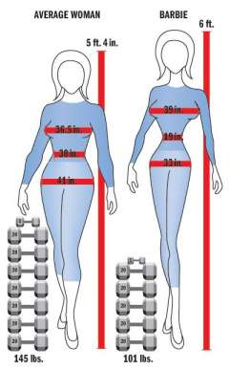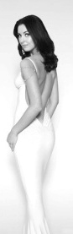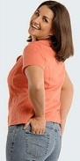 2 in 100? Very tough! P-1. Body Shapes

5 ft. 7 in.

5 ft. 4 in.

AVERAGE WOMEN FASHION MODEL

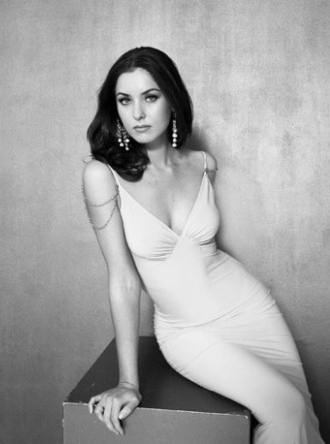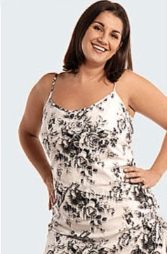 How about health and quality of life?

140 lbs 117 lbs

P-2. Eating Disorders

Anorexia Bulimia Binge Eating

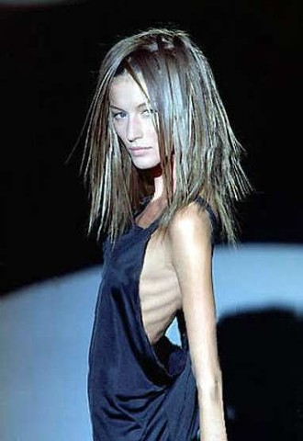

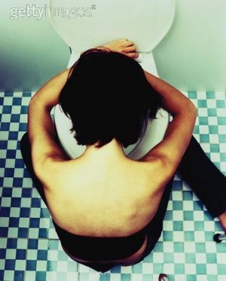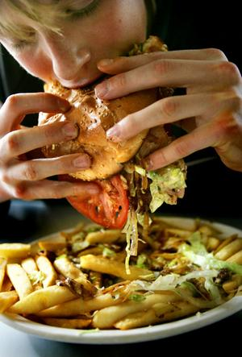

|  |  |  |
| --- | --- | --- |
| * See themselves fat even when they are dangerously underweight * Only eat small amounts of low-calorie foods because they are very afraid of gaining weight or becoming fat | * Repeated binge eating episodes (twice a week for at least 3 months) * Compensate weight gain with self-induced vomiting; misuse of laxatives, diuretics, enemas, or other medications; fasting; or excessive exercise | * Lack of control in eating much more food than most people would eat in the same period of time * Eat even when not hungry * Eat much more rapidly than normal * Eat until feeling uncomfortably full * Eat alone or secretly |
|  |  |  |



**Do you do this? Score yourself!**

Add 1 point to every ‘yes’ you answer.

**Body Image**

1. Spending a lot of time in front of a mirror, obsessing about specific body parts.
2. Weighing myself multiple times a day.
3. Hide my body with oversized clothes.
4. Avoid enjoyable activities because I feel ashamed or self conscious about my body.
5. Talk about the flaws in my body and minimize other qualities, such as intelligence, humor, creativity, and athleticism.
6. Obsess about food, weight and level of fitness in private and in public.

\_\_\_\_\_\_ Points

**Eating Disorders**

1. Gradual or dramatic changes in food intake and eating patterns.
2. Gradual or dramatic changes in body weight.
3. Highly charged emotional responses to changes in daily schedule, meals or activity level.
4. Eating very little at meals but insisting that “I am full”.
5. Eating large quantities of food and then "disappearing" to the bathroom.
6. Feeling isolated, irritable, and/or depressed.

\_\_\_\_\_\_ Points

*If you answer “yes” to one or more of these reactions, especially that you have done it for a few weeks or month, or years, please seek help. You teacher can help you.*

**Test Your Self-Esteem**

**If you have high or healthy self-esteem, you will agree with the following statements:**

* I feel good about who I am.
* I am proud of what I can do, but I do not show off.
* I know there are some things that I am good at and some things I need to improve.
* I am responsible for the things I do and say, both good and bad.
* It is okay if I win or if I lose.
* Before I do something, I usually think “I can do it.”

Does this sound like you? If some of the items in this checklist sound like you, that’s good… you’re on the right track. Remember to tell yourself everyday that you are a great person! And if your self-esteem ever slips, seek help.

**If you have low or poor self-esteem, you might agree with the following statements:**

* 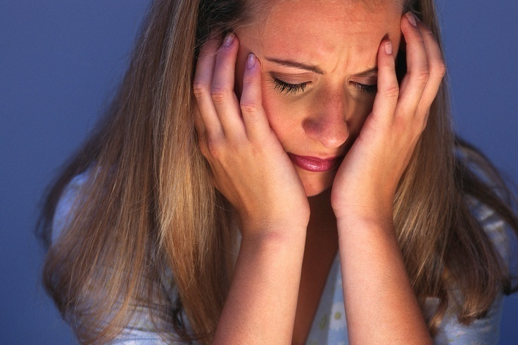I can’t do anything right.
* I am ugly or dumb.
* I do not have any friends.
* I do not like to try new things.
* It really upsets me to make mistakes.
* I do not think I am as nice, pretty, or smart as the other girls in my class.
* I have a hard time making friends.
* I have a hard time making friends because I end up getting angry and fighting with people.
* It makes me uncomfortable when people say nice things about me.
* Sometimes I feel better if I say mean things to other people.

If many or all of these items sound like you, it will be helpful for you to work on raising your self-esteem.

**Test Your Self-Esteem**

**If you have high or healthy self-esteem, you will agree with the following statements:**

* I feel good about who I am.
* I am proud of what I can do, but I do not show off.
* I know there are some things that I am good at and some things I need to improve.
* I am responsible for the things I do and say, both good and bad.
* It is okay if I win or if I lose.
* Before I do something, I usually think “I can do it.”

Does this sound like you? If some of the items in this checklist sound like you, that’s good… you’re on the right track. Remember to tell yourself everyday that you are a great person! And if your self-esteem ever slips, seek help.

**If you have low or poor self-esteem, you might agree with the following statements:**

* 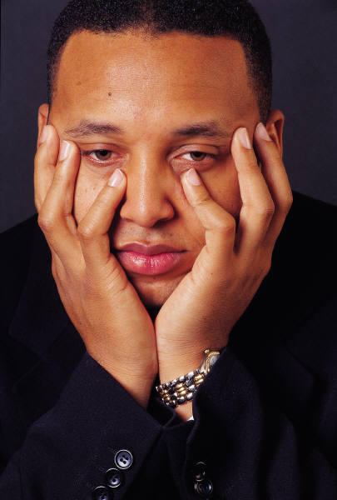I can’t do anything right.
* I am ugly or dumb.
* I do not have any friends.
* I do not like to try new things.
* It really upsets me to make mistakes.
* I do not think I am as nice, good looking, or smart as the other guys in my class.
* I have a hard time making friends.
* I have a hard time making friends because I end up getting angry and fighting with people.
* It makes me uncomfortable when people say nice things about me.
* Sometimes I feel better if I say mean things to other people.

If many or all of these items sound like you, it will be helpful for you to work on raising your self-esteem.

BOOSTYour Self-Esteem

1. Tell yourself that it is okay not to be the best at everything.
2. Help out by doing chores around the house and volunteering in your community.
3. Do things that you enjoy, or learn about new things you would like to try.
4. Understand that there will be times when you will feel disappointed in yourself and other people. No one is perfect!
5. If you are angry, try talking it over with an adult you trust (parents/guardians, relatives or a school counselor).
6. Think positively about yourself and the things you can do. Think: "I will try!"
7. If you still find that you are not feeling good about yourself, talk to your parents/guardian, a school counselor, or your doctor because you may be at risk for depression. (You can also ask the school nurse for help through tough times. Some schools offer counseling.) Learn more about depression and other health issues that can affect your mind.

**Other Ways:**

**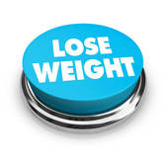Restroom Sign.pngRestroom Sign.png**

**Players:** Teams of 2-4

**craft_Scissors.jpg**

**Materials:** Teens Magazines

**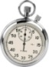**

**Duration:** 10 minutes

****

**Goal:** Identify different messages from the media about body image.

**How to Play**

1. Divide the class into 2-4 groups of people.
2. Pass out magazines to each group. Tell them to identify and make a list of the characteristics that make the people in the magazine attractive/beautiful/handsome.
3. When the class is done writing the list, discuss what characteristics they wrote down.
4. Facilitate a class discussion by asking these questions:
   1. **Ask: Why do we associate those characteristics (e.g., thin, long hair, body shapes) with beauty?**
   2. **Ask: How do media shape our views of what is “beautiful”?**
   3. **Ask: Are these characteristics realistic for all people to achieve? Why?**

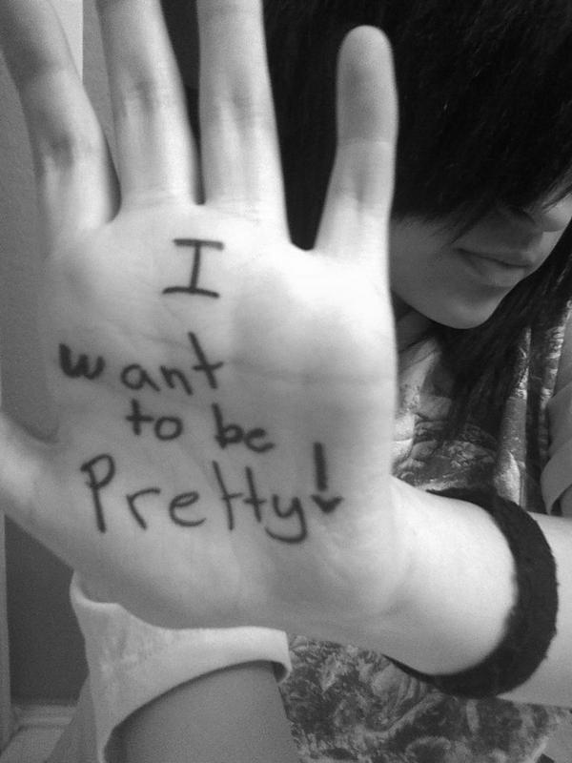

**Restroom Sign.pngRestroom Sign.pngPlayers:** 1+

**craft_Scissors.jpg**

**Materials:** Paper, pen/pencil, calculator (optional), growth charts, measuring tape for height (optional), weighing scale

****

**Duration:** 10 minutes.

****

**Goal:** Identify own body frame, healthy body weight range, BMI

**How to Play**

1. **Ask: Do you know what your body frame is?**

Tell students to use their thumb and middle finger to wrap around their wrist.

* If both fingers overlap, it represents small body frame.
* If both finger tips barely connect, it represents medium frame.
* If both fingers do not connect at all, it represents large frame.

The purpose is to help students be aware of the larger their body frame, the bigger their bones. So, a large frame person will never look like a small frame person even though they are at the same height.

2. Distribute Handout 1. Have students write down their height and weight. For those who need to measure, direct them to the ‘measurement station’.

3. Ask students to find their Body Mass Index from the chart.

4. For older students who are taller than 5 feet, use chart on page 13, or give them this formula to calculate their healthy weight range.

Males: (5 feet or 60 inches = 106 pounds + 6 pounds for every inch over 5 feet) ± 10%

Females: (5 feet or 60 inches = 100 pounds + 5 pounds for every inch over 5 feet) ± 10%

*This formula is called the “Hamwi Formula”.*

**Body Mass Index - BOYS**

****

**BODY MASS INDEX - GIRLS**

****

**Ideal Body Weight Range**

|  |  |  |  |  |  |  |  |
| --- | --- | --- | --- | --- | --- | --- | --- |
| **MALE** | | | | **FEMALE** | | | |
| **Height** | **Ideal Weight** | **Min** | **Max** | **Height** | **Ideal Weight** | **Min** | **Max** |
| 5'0" | 105 | 95 | 116 | 5'0" | 100 | 90 | 110 |
| 5'1" | 111 | 100 | 122 | 5'1" | 105 | 95 | 116 |
| 5'2" | 117 | 105 | 129 | 5'2" | 110 | 99 | 121 |
| 5'3" | 123 | 111 | 135 | 5'3" | 115 | 104 | 127 |
| 5'4" | 129 | 116 | 142 | 5'4" | 120 | 108 | 132 |
| 5'5" | 135 | 122 | 149 | 5'5" | 125 | 113 | 138 |
| 5'6" | 141 | 127 | 155 | 5'6" | 130 | 117 | 143 |
| 5'7" | 147 | 132 | 162 | 5'7" | 135 | 122 | 149 |
| 5'8" | 153 | 138 | 168 | 5'8" | 140 | 126 | 154 |
| 5'9" | 159 | 143 | 175 | 5'9" | 145 | 131 | 160 |
| 5'10" | 165 | 149 | 182 | 5'10" | 150 | 135 | 165 |
| 5'11" | 171 | 154 | 188 | 5'11" | 155 | 140 | 171 |
| 6'0" | 177 | 159 | 195 | 6'0" | 160 | 144 | 176 |
| 6'1" | 183 | 165 | 201 | 6'1" | 165 | 149 | 182 |
| 6'2" | 189 | 170 | 208 | 6'2" | 170 | 153 | 187 |
| 6'3" | 195 | 176 | 215 | 6'3" | 175 | 158 | 193 |
| 6'4" | 201 | 181 | 221 | 6'4" | 180 | 162 | 198 |
| 6'5" | 207 | 186 | 228 | 6'5" | 185 | 167 | 204 |

**Weight Conversion**

1 kilogram (kg) = 2.2 pounds (lbs)

\_\_\_\_\_\_ lbs/2.2 = \_\_\_ kg

**Height Conversion**

1 inch (in) = 2.54 centimeter (cm) = 0.0254 meter (m)

1 foot = 12 in

\_\_\_\_\_ inches x 0.0254 = \_\_\_\_ m



**Restroom Sign.pngRestroom Sign.pngPlayers:** 2+

**craft_Scissors.jpg**

**Materials:** Paper and pen/pencil (for teacher)

****

**Duration:** 2 minutes per player

****

**Goal:** Get reassurance from peers about own beauty

**How to Play**

1. Ask students to sit in a circle.
2. The teacher will be the note taker and moderator.
3. In each round, every student will take turn say a good quality they observe and appreciate about Student A. Limit to 2 minutes or less per round.
4. In the next round, students will comment about Student B who sits on the left of Student A.
5. Go around so that everyone receives this self-esteem booster!
6. At the end, the teacher gives the note to individuals. It will be a precious gift.

**CAUTION:** Any negative comments, although said unintentionally, will ruin the purpose of this game. So, please make sure you encourage your students to be very considerate, kind, and careful not to hurt anyone’s feelings in their words.

TIPS: 1. If your younger students prefer to separate into two groups (boys vs. girls), then do so.

2. If your class is shy, they can write their comments on pieces of paper, then collect them in an envelop for each student. The teacher will go through all messages before giving them back to the students to avoid having any negative message.

Answer Key (Student copy in folders) Time: First 5 minutes

1. Is your body image generally the same as others see you?

a. True

**b. False**

2. The media’s portrayal of *attractiveness* is the only right way to be cute.

a. True

**b. False**

3. Yo-yo diet is a good way to lose weight and feel good about yourself.

a. True

**b. False**

4. Eating disorders include \_\_\_\_\_\_\_\_\_\_\_\_\_\_\_\_.

a. Anorexia

b. Bulimia

c. Binge eating

d. a and b

**e. All of the above**

5. What influences our body image?

a. Genetics and culture

b. Self esteem

c. Media

d. a and b

**e. All of the above**

Score: \_\_\_\_\_\_\_ Points

Answer Key (Student Version found in folders) Time: Last 5 Minutes

1. What is body image?

**a. The way you see yourself.**

b. The way others see you.

2. What do the media portray as “attractive”?

a. Slightly overweight

**b. Very thin women and muscular men**

c. Muscular women and very thin men

3. What is a Yo-Yo diet?

**a. A diet where you lose a lot of weight, then gain it all back because you can’t keep up with it.**

b. You play a lot of yo-yo to burn off calories.

c. You exercise by jumping up and down a lot like a yo-yo to burn off calories.

4. What is one thing you can do to help yourself create a positive body image?

a. Learn more about your ideal body weight.

b. Recognize that everyone’s body shape is different.

**c. a and b.**

d. Keep comparing yourself to others whom you think are more attractive than you do.

5. List three qualities of true beauty:

**Honesty, faithfulness, etc… (see page 3).**

Score: \_\_\_\_\_\_\_ points

To be completed at the end of Lesson 4 if all four lessons are taught. If not, have your students complete this survey at the end of this lesson.

Name: \_\_\_\_\_\_\_\_\_\_\_\_\_\_\_\_\_\_\_\_\_\_ School: \_\_\_\_\_\_\_\_\_\_\_\_\_\_\_\_\_\_\_\_\_\_\_\_\_\_\_

Date: \_\_\_\_\_\_\_\_ Age: \_\_\_\_\_\_ Gender: 🞏 Boy 🞏 Girl

Ethnicity: 🞏 White 🞏 Hispanic 🞏 Asian 🞏 Native American

🞏 African American 🞏 Other: ­\_\_\_\_\_\_\_\_\_\_\_\_\_\_\_\_\_\_\_\_\_\_\_\_\_\_\_\_

1. Things I like about this class:

🞏 Short Lesson

🞏 Games

🞏 Handouts

🞏 Treats

🞏 Something else: \_\_\_\_\_\_\_\_\_\_\_\_\_\_\_\_\_\_\_\_\_\_\_\_\_\_\_\_\_\_\_\_\_\_

2. Things I don’t like about this class are:



Teacher’s Name: \_\_\_\_\_\_\_\_\_\_\_\_\_\_\_\_\_\_\_\_\_\_\_\_\_\_\_\_ Date: \_\_\_\_\_\_\_\_\_\_\_\_\_

Age group taught: \_\_\_\_\_\_\_ years old Years of Teaching:\_\_\_\_\_

**Grading Scale**:

A+ = Excellent A = Very Good B = Good C = Average D = Poor F = Fail

Reading and Comprehension Level

|  |  |  |
| --- | --- | --- |
| **Aspects** | **Grade** | **Comments** |
| Reading Level |  |  |
| Clear Purpose |  |  |
| Appropriate word usage |  |  |
| Appropriate sentence and paragraph structures |  |  |
| Overall organization |  |  |
| Appropriate tone |  |  |

**Content**

|  |  |  |
| --- | --- | --- |
| **Aspects** | **Grade** | **Comments** |
| Accurate, credible information |  |  |
| Age Appropriate information |  |  |
| Practical information |  |  |
| Appropriate recipes |  |  |

**Design and Quality**

|  |  |  |
| --- | --- | --- |
| **Aspects** | **Grade** | **Comments** |
| Appropriate use of color |  |  |
| Readable type size and style |  |  |
| Appropriate illustration |  |  |
| Appropriate tables, charts, and graphs |  |  |
| Organized, balanced layout |  |  |

Which game(s) did you use to teach this lesson?

Which is the best game that you consider most effective in helping your students learn and apply?

Overall grade = \_\_\_\_\_\_\_\_

Additional comments:

\_\_\_\_\_\_\_\_\_\_\_\_\_\_\_\_\_\_\_\_\_\_\_\_\_\_\_\_\_\_\_\_\_\_\_\_\_\_\_\_\_\_\_\_\_\_\_\_\_\_\_\_\_\_\_\_\_\_\_\_\_\_\_\_\_\_\_\_\_\_\_\_\_\_\_\_\_\_\_\_\_\_\_\_\_\_\_\_\_\_\_\_\_\_\_\_\_\_\_\_\_\_\_\_\_\_\_\_\_\_\_\_\_\_\_\_\_\_\_\_\_\_\_\_\_\_\_\_\_\_\_\_\_\_\_\_\_\_\_\_\_\_\_\_\_\_\_\_\_\_\_\_\_\_\_\_\_\_\_\_\_\_\_\_\_\_\_\_\_\_\_\_\_\_\_\_\_\_\_\_\_\_\_\_\_\_\_\_\_\_\_\_\_\_\_\_\_\_\_\_\_\_\_\_\_\_\_\_\_\_\_\_\_\_\_\_\_\_\_\_\_\_\_\_\_\_\_\_\_\_\_\_\_\_\_\_\_\_\_\_\_\_\_\_\_\_\_\_\_\_\_\_\_\_\_\_\_\_\_\_\_\_\_\_\_\_\_\_\_\_\_\_\_\_\_\_\_\_\_\_\_\_\_\_\_\_\_\_\_\_\_\_\_\_\_\_\_\_\_\_\_\_\_\_\_\_\_\_\_\_\_\_\_\_\_\_\_\_\_\_\_\_\_\_\_\_\_\_\_\_\_\_\_\_\_\_\_\_\_\_\_\_\_\_\_\_\_\_\_\_\_\_\_\_\_\_\_\_\_\_\_\_\_\_\_\_\_\_\_\_\_\_\_\_\_\_\_\_\_\_\_\_\_\_\_\_\_\_\_\_\_\_\_\_\_\_\_\_\_\_\_\_\_\_\_\_\_\_\_\_\_\_\_\_\_\_\_\_\_\_\_\_\_\_\_\_\_\_\_\_\_\_\_\_\_\_\_\_\_\_\_\_\_\_\_\_\_\_\_\_\_\_\_\_\_\_\_\_\_\_\_\_\_\_\_\_\_\_\_\_\_\_\_\_\_\_\_\_\_\_\_\_\_\_\_\_\_\_\_\_\_\_\_\_\_\_\_\_\_\_\_\_\_\_\_\_\_\_\_\_\_\_\_\_\_\_\_\_\_\_\_\_\_\_\_\_\_\_\_\_\_\_\_\_\_\_\_\_\_\_\_\_\_\_\_\_\_\_\_\_\_\_\_\_\_\_\_\_\_\_\_\_\_\_\_\_\_\_\_\_\_\_\_\_\_\_\_\_\_\_\_\_\_\_\_\_\_\_\_\_\_\_\_\_\_\_\_\_\_\_\_\_\_\_\_\_\_\_\_\_\_\_\_\_\_\_\_\_\_\_\_\_\_\_\_\_\_\_\_\_\_\_\_\_\_\_\_\_\_\_\_\_\_\_\_\_\_\_\_\_\_\_\_\_\_\_\_\_\_\_\_\_\_\_\_\_\_\_\_\_\_\_\_\_\_\_\_\_\_\_\_\_\_\_\_\_\_\_\_\_\_\_\_\_\_\_\_\_\_\_\_\_\_\_\_\_\_\_\_\_\_\_\_\_\_\_\_\_\_\_\_\_\_\_\_\_\_\_\_\_\_\_\_\_\_\_\_\_\_\_\_\_\_\_\_\_\_\_\_\_\_\_\_\_\_\_\_\_\_\_\_\_\_\_\_\_\_\_\_\_\_\_\_\_\_\_\_\_\_\_\_\_\_\_\_\_\_\_\_\_\_\_\_\_\_\_\_\_\_\_\_\_\_\_\_\_\_\_\_\_\_\_\_\_\_\_\_\_\_\_\_\_\_\_\_\_\_\_\_\_\_\_\_\_\_\_\_\_\_\_\_\_\_\_\_\_\_\_\_\_\_\_\_\_\_\_\_\_\_\_\_\_\_\_\_\_\_\_\_\_\_\_\_\_\_\_\_\_\_\_\_\_\_\_\_\_\_\_\_\_\_\_\_\_\_\_\_\_\_\_\_\_\_\_\_\_\_\_\_\_\_\_\_\_\_\_\_\_\_\_\_\_\_\_\_\_\_\_\_\_\_\_\_\_\_\_\_\_\_\_\_\_\_\_\_\_\_\_\_\_\_\_\_\_\_\_\_\_\_\_\_\_\_\_\_\_\_\_\_\_\_\_\_\_\_\_\_\_\_\_\_\_\_\_\_\_\_\_\_\_\_\_\_\_\_\_\_\_\_\_\_\_\_\_\_\_\_\_\_\_\_\_\_\_\_\_\_\_\_\_\_\_\_\_\_\_\_\_\_\_\_\_\_\_\_\_\_\_\_\_\_\_\_\_\_\_\_\_\_\_\_\_\_\_\_\_\_\_\_\_\_\_\_\_\_\_\_\_\_\_\_\_\_\_\_\_\_\_\_\_\_\_\_\_\_\_\_\_\_\_\_\_\_\_\_\_\_\_\_\_\_\_\_\_\_\_\_\_\_\_\_\_\_\_\_\_\_\_\_\_\_\_\_\_\_\_\_\_\_\_\_\_\_\_\_\_\_\_\_\_\_\_\_\_\_\_\_\_\_\_\_\_\_\_\_\_\_\_\_\_\_\_\_\_\_\_\_\_\_\_\_\_\_\_\_\_\_\_\_\_\_\_\_\_\_\_\_\_\_\_\_\_\_\_\_\_\_\_\_\_\_\_\_\_\_\_\_\_\_\_\_\_\_\_\_\_\_\_\_\_\_\_\_\_\_\_\_\_\_\_\_\_\_\_\_\_\_\_\_\_\_\_\_\_\_\_\_\_\_\_\_\_\_\_\_\_\_\_\_\_\_\_\_\_\_\_\_\_\_\_\_\_\_\_\_\_\_\_\_\_\_\_\_\_\_\_\_\_\_\_\_\_\_\_\_\_\_\_\_\_\_\_\_\_\_\_\_\_\_\_\_\_\_\_\_\_\_\_\_\_\_\_\_\_\_\_\_\_\_\_\_\_\_\_\_\_\_\_\_\_\_\_\_\_\_\_\_\_\_\_\_\_\_\_\_\_\_\_\_\_\_\_\_\_\_\_\_\_\_\_\_\_\_\_\_\_\_\_\_\_\_\_\_\_\_\_\_\_\_\_\_\_\_\_\_\_\_\_\_\_\_\_\_\_\_\_\_\_\_\_\_\_\_\_\_\_\_\_\_\_\_\_\_\_\_\_\_\_\_\_\_\_\_\_\_\_\_\_\_\_\_\_\_\_\_\_\_\_\_\_\_\_\_\_\_\_\_\_\_\_\_\_\_\_\_\_\_\_\_\_\_\_\_\_\_\_\_\_\_\_\_\_\_\_\_\_\_\_\_\_\_\_\_\_\_\_\_\_\_\_\_\_\_\_\_\_\_\_\_\_\_\_\_\_\_\_\_\_\_\_\_\_\_\_\_\_\_\_\_\_

**Tracking Sheet** Teacher’s Initial: \_\_\_\_\_

Start Date: \_\_\_\_\_\_\_\_\_\_ End Date: \_\_\_\_\_\_\_\_\_\_

|  |  |  |  |  |  |  |  |
| --- | --- | --- | --- | --- | --- | --- | --- |
| # | Full Name | Consent Submitted | Knowledge Pre-Test Score | Behavioral Checklist Score | Physical Activity Checklist | Post-Test Score | Feedback Submitted |
| 1 |  |  |  |  |  |  |  |
| 2 |  |  |  |  |  |  |  |
| 3 |  |  |  |  |  |  |  |
| 4 |  |  |  |  |  |  |  |
| 5 |  |  |  |  |  |  |  |
| 6 |  |  |  |  |  |  |  |
| 7 |  |  |  |  |  |  |  |
| 8 |  |  |  |  |  |  |  |
| 9 |  |  |  |  |  |  |  |
| 10 |  |  |  |  |  |  |  |
| 11 |  |  |  |  |  |  |  |
| 12 |  |  |  |  |  |  |  |
| 13 |  |  |  |  |  |  |  |
| 14 |  |  |  |  |  |  |  |
| 15 |  |  |  |  |  |  |  |
| 16 |  |  |  |  |  |  |  |
| 17 |  |  |  |  |  |  |  |
| 18 |  |  |  |  |  |  |  |
| 19 |  |  |  |  |  |  |  |
| 20 |  |  |  |  |  |  |  |
| 21 |  |  |  |  |  |  |  |
| 22 |  |  |  |  |  |  |  |
| 23 |  |  |  |  |  |  |  |
| 24 |  |  |  |  |  |  |  |
| 25 |  |  |  |  |  |  |  |

Extra Notes

\_\_\_\_\_\_\_\_\_\_\_\_\_\_\_\_\_\_\_\_\_\_\_\_\_\_\_\_\_\_\_\_\_\_\_\_\_\_\_\_\_\_\_\_\_\_\_\_\_\_\_\_\_\_\_\_\_\_\_\_\_\_\_\_\_\_\_\_\_\_\_\_\_\_\_\_\_\_\_\_\_\_\_\_\_\_\_\_\_\_\_\_\_\_\_\_\_\_\_\_\_\_\_\_\_\_\_\_\_\_\_\_\_\_\_\_\_\_\_\_\_\_\_\_\_\_\_\_\_\_\_\_\_\_\_\_\_\_\_\_\_\_\_\_\_\_\_\_\_\_\_\_\_\_\_\_\_\_\_\_\_\_\_\_\_\_\_\_\_\_\_\_\_\_\_\_\_\_\_\_\_\_\_\_\_\_\_\_\_\_\_\_\_\_\_\_\_\_\_\_\_\_\_\_\_\_\_\_\_\_\_\_\_\_\_\_\_\_\_\_\_\_\_\_\_\_\_\_\_\_\_\_\_\_\_\_\_\_\_\_\_\_\_\_\_\_\_\_\_\_\_\_\_\_\_\_\_\_\_\_\_\_\_\_\_\_\_\_\_\_\_\_\_\_\_\_\_\_\_\_\_\_\_\_\_\_\_\_\_\_\_\_\_\_\_\_\_\_\_\_\_\_\_\_\_\_\_\_\_\_\_\_\_\_\_\_\_\_\_\_\_\_\_\_\_\_\_\_\_\_\_\_\_\_\_\_\_\_\_\_\_\_\_\_\_\_\_\_\_\_\_\_\_\_\_\_\_\_\_\_\_\_\_\_\_\_\_\_\_\_\_\_\_\_\_\_\_\_\_\_\_\_\_\_\_\_\_\_\_\_\_\_\_\_\_\_\_\_\_\_\_\_\_\_\_\_\_\_\_\_\_\_\_\_\_\_\_\_\_\_\_\_\_\_\_\_\_\_\_\_\_\_\_\_\_\_\_\_\_\_\_\_\_\_\_\_\_\_\_\_\_\_\_\_\_\_\_\_\_\_\_\_\_\_\_\_\_\_\_\_\_\_\_\_\_\_\_\_\_\_\_\_\_\_\_\_\_\_\_\_\_\_\_\_\_\_\_\_\_\_\_\_\_\_\_\_\_\_\_\_\_\_\_\_\_\_\_\_\_\_\_\_\_\_\_\_\_\_\_\_\_\_\_\_\_\_\_\_\_\_\_\_\_\_\_\_\_\_\_\_\_\_\_\_\_\_\_\_\_\_\_\_\_\_\_\_\_\_\_\_\_\_\_\_\_\_\_\_\_\_\_\_\_\_\_\_\_\_\_\_\_\_\_\_\_\_\_\_\_\_\_\_\_\_\_\_\_\_\_\_\_\_\_\_\_\_\_\_\_\_\_\_\_\_\_\_\_\_\_\_\_\_\_\_\_\_\_\_\_\_\_\_\_\_\_\_\_\_\_\_\_\_\_\_\_\_\_\_\_\_\_\_\_\_\_\_\_\_\_\_\_\_\_\_\_\_\_\_\_\_\_\_\_\_\_\_\_\_\_\_\_\_\_\_\_\_\_\_\_\_\_\_\_\_\_\_\_\_\_\_\_\_\_\_\_\_\_\_\_\_\_\_\_\_\_\_\_\_\_\_\_\_\_\_\_\_\_\_\_\_\_\_\_\_\_\_\_\_\_\_\_\_\_\_\_\_\_\_\_\_\_\_\_\_\_\_\_\_\_\_\_\_\_\_\_\_\_\_\_\_\_\_\_\_\_\_\_\_\_\_\_\_\_\_\_\_\_\_\_\_\_\_\_\_\_\_\_\_\_\_\_\_\_\_\_\_\_\_\_\_\_\_\_\_\_\_\_\_\_\_\_\_\_\_\_\_\_\_\_\_\_\_\_\_\_\_\_\_\_\_\_\_\_\_\_\_\_\_\_\_\_\_\_\_\_\_\_\_\_\_\_\_\_\_\_\_\_\_\_\_\_\_\_\_\_\_\_\_\_\_\_\_\_\_\_\_\_\_\_\_\_\_\_\_\_\_\_\_\_\_\_\_\_\_\_\_\_\_\_\_\_\_\_\_\_\_\_\_\_\_\_\_\_\_\_\_\_\_\_\_\_\_\_\_\_\_\_\_\_\_\_\_\_\_\_\_\_\_\_\_\_\_\_\_\_\_\_\_\_\_\_\_\_\_\_\_\_\_\_\_\_\_\_\_\_\_\_\_\_\_\_\_\_\_\_\_\_\_\_\_\_\_\_\_\_\_\_\_\_\_\_\_\_\_\_\_\_\_\_\_\_\_\_\_\_\_\_\_\_\_\_\_\_\_\_\_\_\_\_\_\_\_\_\_\_\_\_\_\_\_\_\_\_\_\_\_\_\_\_\_\_\_\_\_\_\_\_\_\_\_\_\_\_\_\_\_\_\_\_\_\_\_\_\_\_\_\_\_\_\_\_\_\_\_\_\_\_\_\_\_\_\_\_\_\_\_\_\_\_\_\_\_\_\_\_\_\_\_\_\_\_\_\_\_\_\_\_\_\_\_\_\_\_\_\_\_\_\_\_\_\_\_\_\_\_\_\_\_\_\_\_\_\_\_\_\_\_\_\_\_\_\_\_\_\_\_\_\_\_\_



**USU Extension is an equal opportunity, affirmative action educator and employer.**Utah State University is committed to providing an environment free from harassment and other forms of illegal discrimination based on race, color, religion, sex, national origin, age (40 and older), disability, and veteran’s status. USU’s policy also prohibits discrimination on the basis of sexual orientation in employment and academic related practices and decisions.

Utah State University employees and students cannot, because of race, color, religion, sex, national origin, age, disability, or veteran’s status, refuse to hire; discharge; promote; demote; terminate; discriminate in compensation; or discriminate regarding terms, privileges, or conditions of employment, against any person otherwise qualified. Employees and students also cannot discriminate in the classroom, residence halls, or in on/off campus, USU-sponsored events and activities.

This publication is issued in furtherance of Cooperative Extension work, acts of May 8 and June 30, 1914, in cooperation with the U.S. Department of Agriculture, Noelle E. Cockett, Vice President for Extension and Agriculture, Utah State University.

**References**

1. Brazil Model Who Battled Anorexia Dies. The Washington Post - Associated Press. November 16, 2006.
2. Be Healthy. Be Happy. Be You. Beautiful. Available at <http://www.girlshealth.gov/emotions/bodyimage/index.cfm>.
3. Dairy Council of California. Definition of Body Image. Adolescence: Developing a Positive Body Image. Available at <http://www.dairycouncilofca.org/Educators/ClassroomPrograms/ProgramsEYOBodyImage.aspx>
4. Overweight Women Dislike Their Bodies. USA Today (Society for the Advancement of Education). Available at <http://findarticles.com/p/articles/mi_m1272/is_2647_127/ai_54367234/>.