MCSY00293_0000[1]Lesson

The Starting Point To A Healthy You

50 min



**Objective:** Identify personalized needs in nutrition and the importance of a healthy diet.

**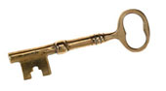**

**Keywords:** MyPyramid, food groups, recommended portions, balanced diet

**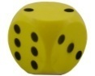**

**Games:** Wizard Mat,Food Relay, Chopsticks

**Utah State Office of Education Objective**

*Food and Nutrition II.* STANDARD 20.0118-03.

Objective 20.0118-0302. Classify common food and nutrition related health concerns.

National Standard 14.2.3 (The emphasis is on understanding the relationship of diet in the prevention, control and maintenance of these health concerns. A doctor should always be consulted regarding any of these concerns)

Discuss specific health concerns and risk factors for: anemia, colon and rectal cancer and osteoporosis.

**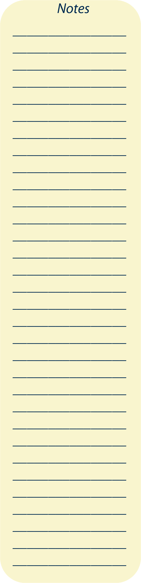 TIPS**: To set up the momentum, this lesson is best team-taught where each teacher switches between major sections.

Lesson Plan

1. Give Pre-test (Folders)

2. Teach

3. Games (pick and choose game(s) that fit your class duration)

4. Give Post-test (Folders)

1. **MyPyramid**

**Ask: What do you know about MyPyramid (the new Food Guide Pyramid)?**

1. MyPyramid was created in April 2005 for Americans to keep us healthy.
2. The goal of MyPyramid is to help Americans make healthy food choices and be physically active every day.
3. MyPyramid emphasizes variety, moderation, taking small steps to improve, and choosing the right proportion of food for healthy diet.
4. **Food Groups and the Daily Recommendations**

**Ask: Can anyone list the five different food groups shown on the MyPyramid poster?** Grains, Vegetables, Fruits, Milk, Meat & Beans. (Oils is no longer a food group)

To achieve and maintain a healthy weight, we need food from every food group.

1. **Grains (6 oz)** 
   * The grain group is rich in Vitamin B and fiber.
   * Vitamin B, like folate, prevents birth defects.
   * Fiber makes us feel full with lower calories, and can help with weight loss. It is found in whole grains.
2. **Vegetables** **(2 ½ cups)**
   * The vegetable group is high in vitamins and minerals.
   * It is low in fat and calories and can help prevent chronic diseases.
3. **Fruits (2 cups)**
   * The fruit group is high in vitamins, minerals, and antioxidants.
   * It is low in fat and calories. Like vegetables, fruits also help prevent chronic diseases.
   * We need to catch a rainbow every day from your fruits and vegetables!
4. **Milk (3 cups)**
   * The milk group is rich in calcium, vitamin D, potassium, and protein.
   * Calcium is needed to build strong bones and teeth therefore preventing osteoporosis. Calcium also helps maintain healthy blood pressure.
   * Choose low fat or fat free food to prevent unnecessary weight gain.
   * A serving is 8 ounces (1 cup).
5. **Meat & Beans (5 ½ oz)**
   * The meat and beans group is high in protein and iron.
   * It is important for building muscles and transporting oxygen to our body cells like our brain.
   * A serving is 3 ounces.
6. **Oils (sparingly)**
   * Our body needs some fats and oils in our diet.
   * Some are necessary to help our body function properly and are called essential fatty acids.
     + There are two kinds of fatty acids
     + Omega-3 and omega-6 fatty acids
   * Fish oil, olive oil and flaxseed oil are high in omega-3 fatty acids, which may help lower cholesterol; therefore, preventing heart disease**.**
   * Avoid solid fats like saturated or trans-fat and choose unsaturated fat sources (liquid at room temperature) like monounsaturated or polyunsaturated.
     + Found in nuts, fish, avocados, olives, and vegetable oils.
7. **How Do I Read A Nutrition Facts Label? Why Should I?**

Knowing how to read a nutrition facts label can help you compare food choices and choose the better food. There are 4 key things to look at.

1. Look at the **serving size**.

This is important because often it is assumed that some drinks like chocolate milk, have only one serving per container, when in reality they have two or more. In this case you would have to multiply the calories by amount of servings to get the total calories consumed, if you drank the whole container at once.

1. Check **total calories**.
2. Look at **fats**, **cholesterol**, and **sodium**. These are the nutrients that we want to limit. If more than half of the total calories come from fat, that food is considered a high fat food.
3. Look at the **dietary fiber**, **vitamins**, and **minerals**. These are the nutrients that we want to get enough of each day.
4. **Basic Nutrition Tips**

Here are a few tips for you:

* Balancing energy is important.
  1. Balance eating with exercise to affect our weight
  2. If we eat more than we exercise we can gain weight.
  3. If we exercise as much as we eat we maintain weight.
  4. Exercising more than we eat can help us lose weight.

**Ask: When your caloric intake EQUALS caloric output, what happens?** (Weight does not change).

**Ask: But, if your input is GREATER than your output, what happens?** (We gain weight).

1. Limiting **fat** in your meals.
   * Trim the fat off the meat before cooking; remove skin from chicken, and bake/broil/grill instead of frying to reduce fat calories.
2. Limit the use of **salt**.
   * To add more flavor try using spices instead of salt.
   * Salt has a sour taste so vinegar or lemon juice could be used as a flavor
3. Limit **sugar**.
   * Try eating fruit as a dessert.
   * Use dried fruits to sweeten your salad.
   * Add cinnamon for sweet flavor
4. **Summary**
5. Eat a variety of foods from each food group.
   * When eating fruits and vegetables remember the color of the rainbow.
6. Choose high nutrient but low calorie foods to get many vitamins, minerals, and other nutrients.

Variety and moderation in food choices will help us achieve a healthy lifestyle!

Visuals in power point form and other documents available online at <http://extension.usu.edu/nic>

P-1. H-1 MyPyramid for Kids – Basic

P-2. MyPyramid For Kids - Advanced

P-3. Whole Grain

*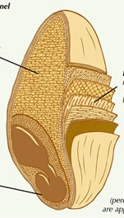*

**Bran**

makes up 14%

of the kernel

**Germ**

makes up 3%

of the kernel

**Endosperm**

makes up 83%

of the kernel

*(percentages are approximate)*

In refined grains, the germ and bran are normally lost. As a result, fiber and some vitamins and minerals are lost too.

**Restroom Sign.pngRestroom Sign.pngPlayers:** 2 or more (individually or team of 3).

**craft_Scissors.jpg**

**Materials:** Game mat, foam dice, question and answer set, Mystery Moves and Treats cards.

**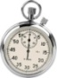**

**Duration:** 15-30 minutes. *Modification:* Use two dice if you have less time to play this game.

****

**Goal:** Be the first player or team to move forward one round and return to the starting point.

**How to Play**

1. Each team rolls a die. The team with the highest number starts moving first.

2. Each team assigns a member to move as a game piece by standing in the box where the team lands.

1. The first team rolls two dice. The sum represents the number of steps the team can move forward in that round.

Your team must correctly answer a question. If you fail to answer the question, you will lose the next turn and attempt to answer a question. Answer incorrectly the second time and you will go to TIMEOUT CORNER.

* You must stay in the TIMEOUT CORNER until you answer two questions correctly in the same turn. After answering correctly, roll the die (dice) to move.

Immediately draw a MYSTERY MOVES CARD and follow the directions.

Immediately draw a TREATS CARD and follow the directions.

Safe zone. No action is needed.

The player must give a big smile to others.

1. The first team to make it around once (or more depending on time) wins.

Wizard Mat Question Set

**Easy**

1. How many food groups does MyPyramid have?
   1. 5
2. What is your favorite food from the grain group?
   1. Bread, rice, noodles, pasta, etc
3. What is your favorite food from the vegetable group?
   1. Broccoli, cabbage, lettuce, squash, bell peppers, chili, etc.
4. What is your favorite food from the fruit group?
   1. Orange, banana, pineapple, kiwi, guava, papaya, grapes, strawberry, etc.
5. What is your favorite food from the milk group?
   1. Chocolate milk, ice cream, milkshake, yogurt, etc.
6. True or false? Vegetables and fruits can help prevent chronic diseases.
   1. True
7. True or false? Whole grains are higher in fiber than refined grains.
   1. True

**Medium**

1. What is the name of the new Food Guide Pyramid?
   1. MyPyramid
2. Why is the meat and bean group important?
   1. Iron-oxygen transportation, Protein-build muscles
3. True or false? When a food has more than half of the total calories coming from fat, it is considered a high fat food
   1. True
4. Energy Balance. If a person’s energy input equals energy output, what happens to this person’s weight?
   1. No change.
5. Energy Balance. If a person’s energy input is greater than the energy output, what happens to this person’s weight?
   1. Gain weight.
6. Energy Balance. If a person’s energy input is less than the energy output, what happens to this person’s weight?
   1. Lose weight
7. A serving of meat is how many ounces?
   1. 3

**Difficult**

1. Name one thing that MyPyramid emphasizes.
   1. Variety, moderation, taking small steps to improve, choosing the right proportion of food for healthy diet, personalization
2. Name all five food groups in MyPyramid
   1. Grains, vegetables, fruits, milk, meat and beans
3. Vitamin B is rich in which food group?
   1. Grains
4. Fiber is rich in which food groups?
   1. Grains, vegetables, and fruits
5. Some oils are high in omega-3 fatty acids that are good for our body. Name one oil that is high in omega-3 fatty acids.
   1. Fish oil, olive oil, and flaxseed oil

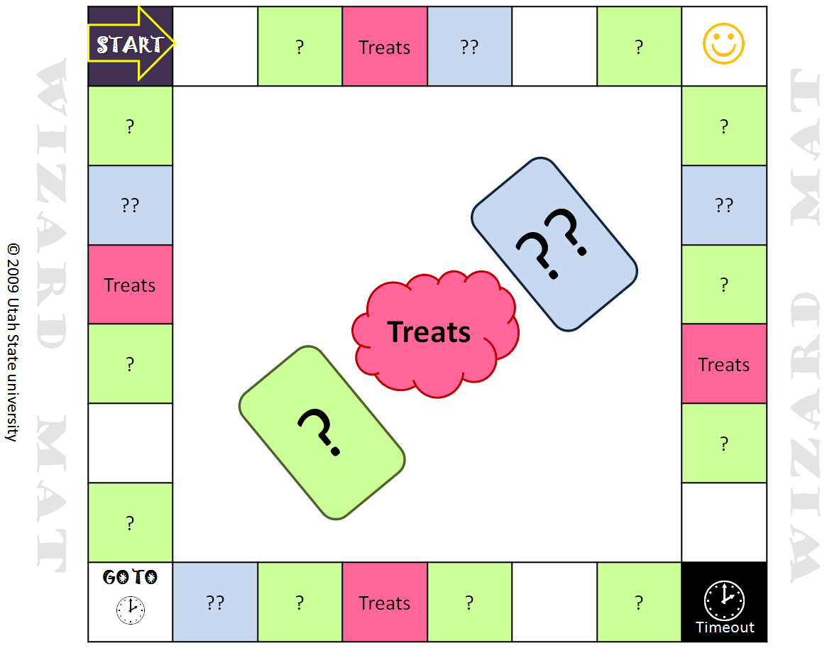 DIY Instructions for Wizard Mat

**Fabric Version**

**Materials** Duck tape, scissors, sewing machine, ruler, marker, fabric paint

***Mat:***

* Part A. 13-inch square fabric (2 black, 4 red, 4 blue, 7 white, 11 green)
* Part B. 6.5-foot square fabric as top center piece
* Part C. 8.5-foot square fabric as bottom piece
* Leftover fabric to make the three center pieces (green, red, and blue) that are either sewn own or as loose pieces

***Game pieces:*** laminated printout from page 20, two foam dice, 2 small bags

**Duration** 60 minutes

**Steps** 1. Sew Part A. 2. Sew Part B to Part A. 3. Sew Part C to cover the bottom of Part A & Part B. 4. Use fabric paint to drawpatterns. 5. Air dry play mat for 4 hours.

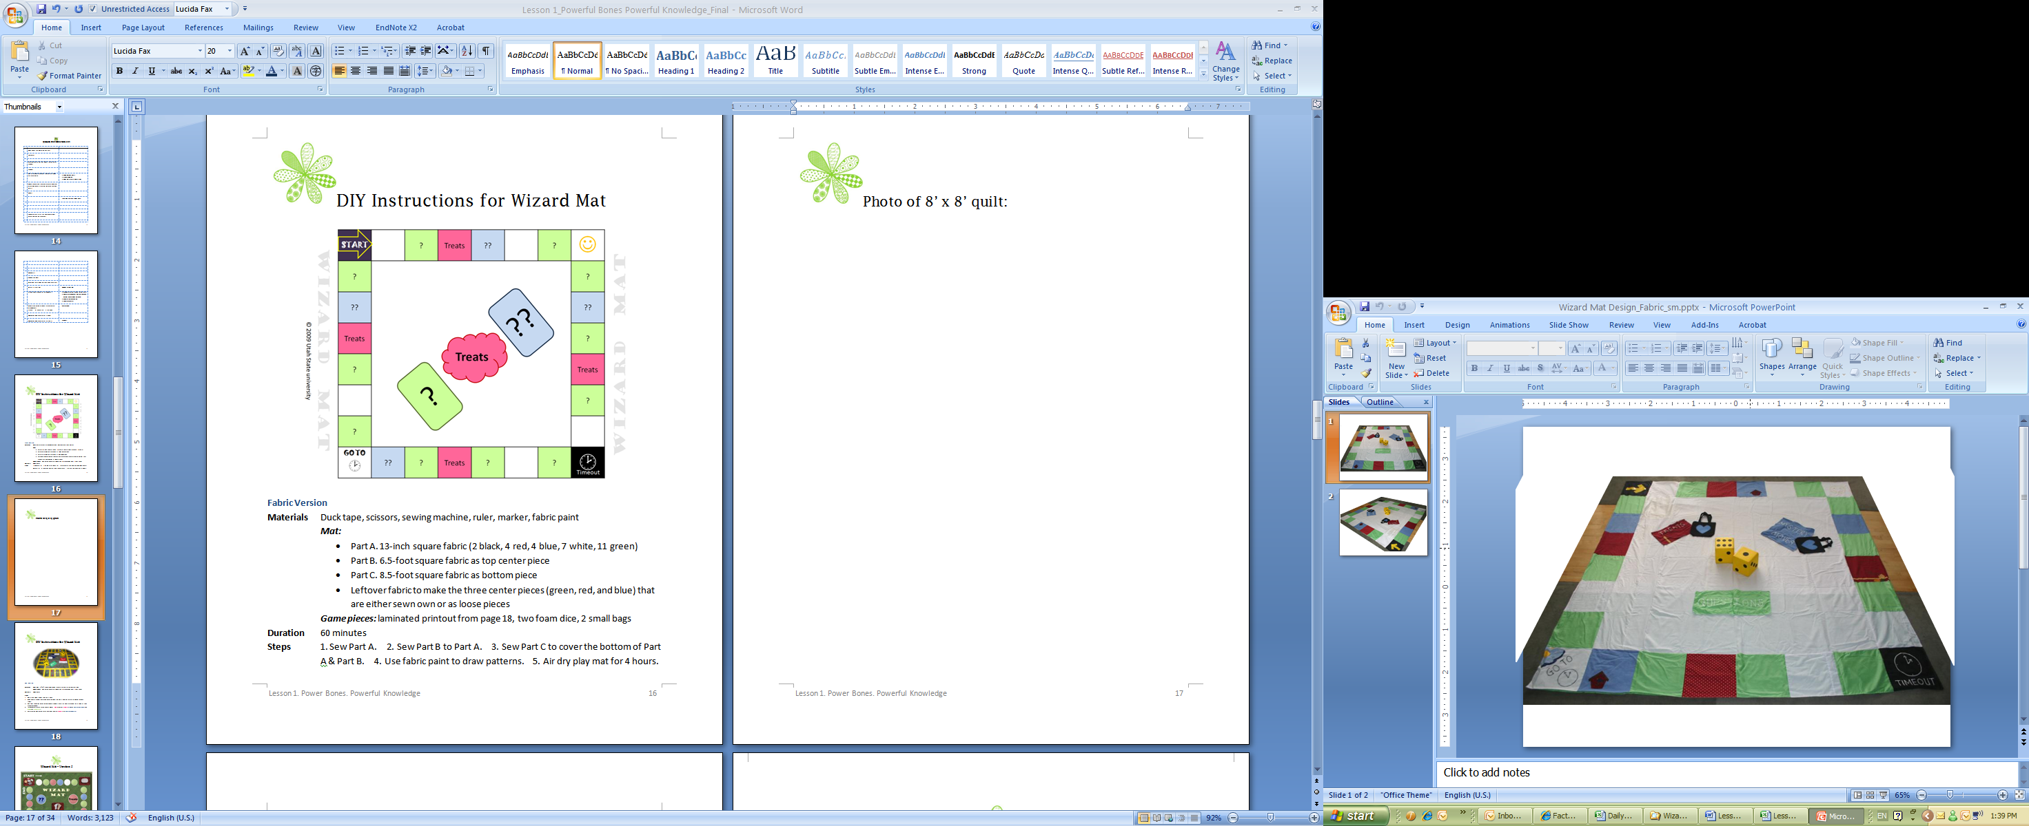Fabric Version: 8’ x 8’ Quilt Vinyl Version: 5’ x 5’ mat

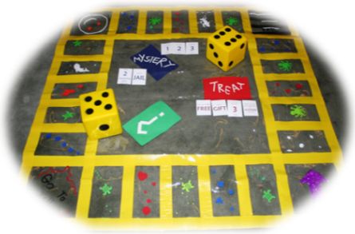

**Vinyl Version**

**Materials *Mat:*** Vinyl (6’x6’), duck tape, foam stickers, scissors, ruler, marker pen

***Game pieces:*** laminated printout from page 20, two foam dice, 2 small bags

**Duration** 30 minutes

**Steps**

* 1. On a clean floor, layout the vinyl sheet.
  2. Using a marker pen, mark connecting points on vinyl sheet for quick alignment of duck tapes.
  3. To fill out the color of each box, adhere foam stickers in the pattern you like as long as they are color-coded.
  4. In the center, create three center pieces: **Red** color for ***Treats***, **Blue** for ***Mystery Moves***, and **Green** for ***Questions***.
  5. Put assorted laminated cards into bags next to ***Treats*** and ***Mystery Moves****.*

Wizard Mat –Game Board Version

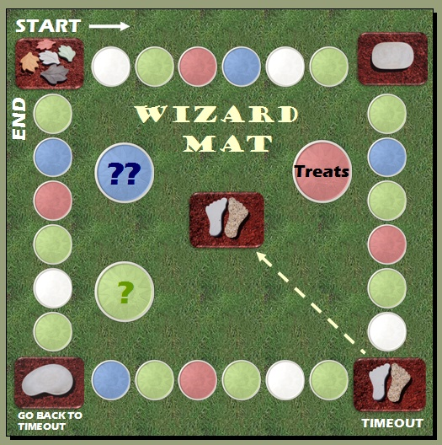

**Restroom Sign.pngRestroom Sign.png Players:** 2teams.

**craft_Scissors.jpg**

**Materials:** Discovery Chain – Food Relay cards, Food Group Labels (2 sets), 2 tables, a bag or a box to hold cards.

****

**Duration:** 5-10 minutes.

****

**Goal:** Be the team who sorts the highest number of cards correctly by food group and from the lowest to the highest calories.

**How to Play**

1. At one end of the room, place two tables. Arrange each set of Food Group Labels in a row.

2. Line up the teams at the other end of the room.

3. In each run, Player 1 from each team runs toward the bag or box containing the Food Relay cards, draws ONE card from the bag, run towards the tables to sort the card by its food group.

4. Immediately after that, Player 1 will run back to his or her line. Player 2 will continue the relay.

5. Subsequent players will also need to rank all cards from the lowest calories to the highest calories. The last player is responsible for checking all cards if they were all sorted correctly.

6. The teacher will examine the results. While doing that, the teacher will also ask players to guess or explain why certain foods are higher in calories, e.g., “What makes this food higher in calories?”

Restroom Sign.pngRestroom Sign.png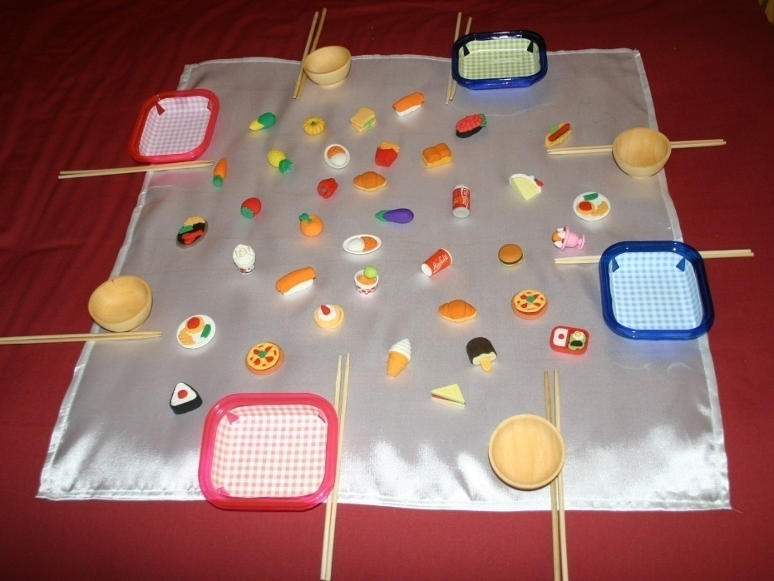

**Players:** 4-8 players, two players per team.

**craft_Scissors.jpg**

**Materials:** Miniature food models (made from eraser), 2-4 Wildcards, 4-8 pairs of chopsticks, plates or bowls, masking tape or a piece of 2’x2’ cloth.

****

**Duration:** 5-10 minutes.

****

**Goal:** Be the team who picks up the highest number of calcium-rich foods.

**How to Play**

1. Lay the 2’x2’ cloth on the floor, or use the masking tape to form a 2’x2’ square.
2. Place miniature food models and all Wildcards on the cloth or in the playing area.
3. Divide players in teams. Arrange players to sit in alternate teams around the square. Each player holds a pair of chopstick and a plate or bowl. Those who do not know how to use the chopsticks are allowed to use both hands to hold the chopsticks.
4. Each team competes to pick up as many calcium-rich foods as possible. Encourage your students to use their ‘wildest imagination’ to find foods high in calcium.
5. At the end, each player counts the number of food items in their own plate or bowl. Each explains why he or she considers the food rich in calcium.
6. Anyone who picks up a Wildcard needs to name a calcium-rich food that is different from all items in his or her bowl. If the answer is correct, the Wildcard is counted as an additional food item.
7. The team with the highest number of calcium-rich foods wins.

Answer Key (Student copy in folders) Time: First 10 minutes

1. When eating a healthy diet you should eat only one kind of food every day.

a. True

**b. False**

1. Fruits help protect us against
   1. **Heart disease or cardiovascular disease**
   2. Fever
   3. Stomach ache
2. Grains are a good source of what vitamin?
   1. **B vitamins**
   2. C vitamins
   3. D vitamins
3. From what food group should you eat to reduce osteoporosis?
   1. **Dairy**
   2. Grain
   3. Fruits
4. How many ounces is a serving of meat  **3 ?**

Score: \_\_\_\_\_\_\_ Points

**How often did you do these things in the past week?**

|  |  |  |  |  |  |  |  |  |  |
| --- | --- | --- | --- | --- | --- | --- | --- | --- | --- |
| **#** | **Choices** | **Number of Days (🗸)** | | | | | | | |
| **0** | **1** | **2** | **3** | **4** | **5** | **6** | **7** |
| 1 | I think about healthy food choices and plan my meals ahead of time. |  |  |  |  |  |  |  |  |
| 2 | I make half of my grains whole. |  |  |  |  |  |  |  |  |
| 3 | I eat 2 ½ cups of vegetables every day. |  |  |  |  |  |  |  |  |
| 4 | I eat 1 ½ cup of fruits every day. |  |  |  |  |  |  |  |  |
| 5 | I drink 3 cups of milk (or soymilk) every day. |  |  |  |  |  |  |  |  |
| 6 | I eat 5 ounce of meat or beans every day. |  |  |  |  |  |  |  |  |
| 7 | I watch portion size of my food. |  |  |  |  |  |  |  |  |
| 8 | I skip meals because I was not hungry or was in a hurry. |  |  |  |  |  |  |  |  |
| 9 | I read and use the “Nutrition Facts” on the food label to make food choices. |  |  |  |  |  |  |  |  |
| 10 | Eat meals with my family at least once a day. |  |  |  |  |  |  |  |  |
| 11 | Eat meals at home at least once a day. |  |  |  |  |  |  |  |  |
| 12 | Eat at fast-food restaurant. |  |  |  |  |  |  |  |  |
| 13 | I am aware of my body weight and size but I also know my strengths that are not related to my appearance. |  |  |  |  |  |  |  |  |
| 14 | I practice positive self-talk (say things I like about myself). |  |  |  |  |  |  |  |  |
| 15 | I plan my exercise and stick to it. |  |  |  |  |  |  |  |  |
| 16 | I exercise at least 30 minutes. |  |  |  |  |  |  |  |  |
| 17 | I walk, take the stairs, run, and take other opportunities to be physically active. |  |  |  |  |  |  |  |  |



One mini goal I am going to reach or change for my health is: \_\_\_\_\_\_\_\_\_\_\_\_\_\_\_\_\_\_\_\_\_\_\_\_\_\_\_\_\_

**Physical Activity Checklist for Ages 7-11**

1. Circle one answer below

Yesterday, I played/exercised for

* 1. Less than 30 minutes
  2. 30 to 60 minutes
  3. 60 minutes or more

2. Put a **✓**mark next to the activities you had yesterday.

|  |  |  |  |  |
| --- | --- | --- | --- | --- |
| **Did you do this?** | **✓** |  | **Did You Play this Sport?** | **✓** |
|  |
| Chat on the phone |  |  | Aerobics (steps, water) |  |
| Cook |  |  | Badminton |  |
| Draw/Paint |  |  | Basketball |  |
| Dress |  |  | Biking |  |
| Drive or travel in a car |  |  | Bowling |  |
| Eat a meal or snack |  |  | Dancing |  |
| Housekeeping |  |  | Football |  |
| Play a musical instrument |  |  | Golf |  |
| Play with kids |  |  | Gymnastic |  |
| Play with pets |  |  | Hiking |  |
| Read |  |  | Hockey |  |
| Run |  |  | Ice Skating |  |
| Screen time (TV/Computer) |  |  | Jogging |  |
| Sew |  |  | Jumping Rope |  |
| Shop |  |  | Ping Pong |  |
| Shower |  |  | Skiing |  |
| Sing |  |  | Snowboarding |  |
| Sit (in class/meeting) |  |  | Snowshoeing |  |
| Sleep |  |  | Soccer |  |
| Walk |  |  | Swimming |  |
| Write |  |  | Tennis |  |
| OTHER |  |  | Volleyball |  |
|  |  |  | Weightlifting |  |

**Physical Activity Checklist for Age 12+**

1. Circle one answer below

Yesterday, I played/exercised for

1. Less than 30 minutes
2. 30 to 60 minutes
3. 60 minutes or more

2. Put a **✓**mark next to the activities you had yesterday. If you can please estimate how much time you spent on doing each activity.

|  |  |  |  |  |  |  |  |  |
| --- | --- | --- | --- | --- | --- | --- | --- | --- |
| **✓** | **Routines/Hobbies** | **Time** | |  | **✓** | **Sports** | **Time** | |
| **Hours** | **Min** |  | **Hours** | **Min** |
|  | Chat on the phone |  |  |  |  | Aerobics (steps, water) |  |  |
|  | Cook |  |  |  |  | Badminton |  |  |
|  | Draw/Paint |  |  |  |  | Basketball |  |  |
|  | Dress |  |  |  |  | Biking |  |  |
|  | Drive or travel in a car |  |  |  |  | Bowling |  |  |
|  | Eat a meal or snack |  |  |  |  | Dancing |  |  |
|  | Housekeeping |  |  |  |  | Football |  |  |
|  | Play a musical instrument |  |  |  |  | Golf |  |  |
|  | Play with kids |  |  |  |  | Gymnastic |  |  |
|  | Play with pets |  |  |  |  | Hiking |  |  |
|  | Read |  |  |  |  | Hockey |  |  |
|  | Run |  |  |  |  | Ice Skating |  |  |
|  | Screen time (TV/Computer) |  |  |  |  | Jogging |  |  |
|  | Sew |  |  |  |  | Jump Roping |  |  |
|  | Shop |  |  |  |  | Ping Pong |  |  |
|  | Shower |  |  |  |  | Skiing |  |  |
|  | Sing |  |  |  |  | Snowboarding |  |  |
|  | Sit (in class/meeting) |  |  |  |  | Snowshoeing |  |  |
|  | Sleep |  |  |  |  | Soccer |  |  |
|  | Walk |  |  |  |  | Swimming |  |  |
|  | Write |  |  |  |  | Tennis |  |  |
|  | OTHER |  |  |  |  | Volleyball |  |  |
|  |  |  |  |  |  | Weightlifting |  |  |

TOTAL = \_\_\_\_\_\_\_\_\_ (about 24 hours)

Answer Key (Student Version found in folders) Time: Last 5 Minutes

1. A healthy diet consists of food from each food group.

**a. True**

b. False

2. We can prevent cardiovascular diseases by eating foods from which food group? **Fruits or vegetables**

3. To get B vitamins from your diet, you should eat foods from which food group? **Grains**

4. By getting enough calcium from the dairy group, we can prevent what bone disease? **Osteoporosis**

5. A serving of meat is 5 ounces (oz).

a. True

**b. False**

Score: \_\_\_\_\_\_\_ points

To be completed at the end of Lesson 4 if all four lessons are taught. If not, have your students complete this survey at the end of this lesson.

Name: \_\_\_\_\_\_\_\_\_\_\_\_\_\_\_\_\_\_\_\_\_\_ School: \_\_\_\_\_\_\_\_\_\_\_\_\_\_\_\_\_\_\_\_\_\_\_\_\_\_\_

Date: \_\_\_\_\_\_\_\_ Age: \_\_\_\_\_\_ Gender: 🞏 Boy 🞏 Girl

Ethnicity: 🞏 White 🞏 Hispanic 🞏 Asian 🞏 Native American

🞏 African American 🞏 Other: ­\_\_\_\_\_\_\_\_\_\_\_\_\_\_\_\_\_\_\_\_\_\_\_\_\_\_\_\_

1. Things I like about this class:

🞏 Short Lesson

🞏 Games

🞏 Handouts

🞏 Treats

🞏 Something else: \_\_\_\_\_\_\_\_\_\_\_\_\_\_\_\_\_\_\_\_\_\_\_\_\_\_\_\_\_\_\_\_\_\_

2. Things I don’t like about this class are:



Teacher’s Name: \_\_\_\_\_\_\_\_\_\_\_\_\_\_\_\_\_\_\_\_\_\_\_\_\_\_\_\_ Date: \_\_\_\_\_\_\_\_\_\_\_\_\_

Age group taught: \_\_\_\_\_\_\_ years old Years of Teaching:\_\_\_\_\_

**Grading Scale**:

A+ = Excellent A = Very Good B = Good C = Average D = Poor F = Fail

Reading and Comprehension Level

|  |  |  |
| --- | --- | --- |
| **Aspects** | **Grade** | **Comments** |
| Reading Level |  |  |
| Clear Purpose |  |  |
| Appropriate word usage |  |  |
| Appropriate sentence and paragraph structures |  |  |
| Overall organization |  |  |
| Appropriate tone |  |  |

Content

|  |  |  |
| --- | --- | --- |
| **Aspects** | **Grade** | **Comments** |
| Accurate, credible information |  |  |
| Age Appropriate information |  |  |
| Practical information |  |  |
| Appropriate recipes |  |  |

Design and Quality

|  |  |  |
| --- | --- | --- |
| **Aspects** | **Grade** | **Comments** |
| Appropriate use of color |  |  |
| Readable type size and style |  |  |
| Appropriate illustration |  |  |
| Appropriate tables, charts, and graphs |  |  |
| Organized, balanced layout |  |  |

Which game(s) did you use to teach this lesson?

Which is the best game that you consider most effective in helping your students learn and apply?

Overall grade = \_\_\_\_\_\_\_\_

Additional comments:

\_\_\_\_\_\_\_\_\_\_\_\_\_\_\_\_\_\_\_\_\_\_\_\_\_\_\_\_\_\_\_\_\_\_\_\_\_\_\_\_\_\_\_\_\_\_\_\_\_\_\_\_\_\_\_\_\_\_\_\_\_\_\_\_\_\_\_\_\_\_\_\_\_\_\_\_\_\_\_\_\_\_\_\_\_\_\_\_\_\_\_\_\_\_\_\_\_\_\_\_\_\_\_\_\_\_\_\_\_\_\_\_\_\_\_\_\_\_\_\_\_\_\_\_\_\_\_\_\_\_\_\_\_\_\_\_\_\_\_\_\_\_\_\_\_\_\_\_\_\_\_\_\_\_\_\_\_\_\_\_\_\_\_\_\_\_\_\_\_\_\_\_\_\_\_\_\_\_\_\_\_\_\_\_\_\_\_\_\_\_\_\_\_\_\_\_\_\_\_\_\_\_\_\_\_\_\_\_\_\_\_\_\_\_\_\_\_\_\_\_\_\_\_\_\_\_\_\_\_\_\_\_\_\_\_\_\_\_\_\_\_\_\_\_\_\_\_\_\_\_\_\_\_\_\_\_\_\_\_\_\_\_\_\_\_\_\_\_\_\_\_\_\_\_\_\_\_\_\_\_\_\_\_\_\_\_\_\_\_\_\_\_\_\_\_\_\_\_\_\_\_\_\_\_\_\_\_\_\_\_\_\_\_\_\_\_\_\_\_\_\_\_\_\_\_\_\_\_\_\_\_\_\_\_\_\_\_\_\_\_\_\_\_\_\_\_\_\_\_\_\_\_\_\_\_\_\_\_\_\_\_\_\_\_\_\_\_\_\_\_\_\_\_\_\_\_\_\_\_\_\_\_\_\_\_\_\_\_\_\_\_\_\_\_\_\_\_\_\_\_\_\_\_\_\_\_\_\_\_\_\_\_\_\_\_\_\_\_\_\_\_\_\_\_\_\_\_\_\_\_\_\_\_\_\_\_\_\_\_\_\_\_\_\_\_\_\_\_\_\_\_\_\_\_\_\_\_\_\_\_\_\_\_\_\_\_\_\_\_\_\_\_\_\_\_\_\_\_\_\_\_\_\_\_\_\_\_\_\_\_\_\_\_\_\_\_\_\_\_\_\_\_\_\_\_\_\_\_\_\_\_\_\_\_\_\_\_\_\_\_\_\_\_\_\_\_\_\_\_\_\_\_\_\_\_\_\_\_\_\_\_\_\_\_\_\_\_\_\_\_\_\_\_\_\_\_\_\_\_\_\_\_\_\_\_\_\_\_\_\_\_\_\_\_\_\_\_\_\_\_\_\_\_\_\_\_\_\_\_\_\_\_\_\_\_\_\_\_\_\_\_\_\_\_\_\_\_\_\_\_\_\_\_\_\_\_\_\_\_\_\_\_\_\_\_\_\_\_\_\_\_\_\_\_\_\_\_\_\_\_\_\_\_\_\_\_\_\_\_\_\_\_\_\_\_\_\_\_\_\_\_\_\_\_\_\_\_\_\_\_\_\_\_\_\_\_\_\_\_\_\_\_\_\_\_\_\_\_\_\_\_\_\_\_\_\_\_\_\_\_\_\_\_\_\_\_\_\_\_\_\_\_\_\_\_\_\_\_\_\_\_\_\_\_\_\_\_\_\_\_\_\_\_\_\_\_\_\_\_\_\_\_\_\_\_\_\_\_\_\_\_\_\_\_\_\_\_\_\_\_\_\_\_\_\_\_\_\_\_\_\_\_\_\_\_\_\_\_\_\_\_\_\_\_\_\_\_\_\_\_\_\_\_\_\_\_\_\_\_\_\_\_\_\_\_\_\_\_\_\_\_\_\_\_\_\_\_\_\_\_\_\_\_\_\_\_\_\_\_\_\_\_\_\_\_\_\_\_\_\_\_\_\_\_\_\_\_\_\_\_\_\_\_\_\_\_\_\_\_\_\_\_\_\_\_\_\_\_\_\_\_\_\_\_\_\_\_\_\_\_\_\_\_\_\_\_\_\_\_\_\_\_\_\_\_\_\_\_\_\_\_\_\_\_\_\_\_\_\_\_\_\_\_\_\_\_\_\_\_\_\_\_\_\_\_\_\_\_\_\_\_\_\_\_\_\_\_\_\_\_\_\_\_\_\_\_\_\_\_\_\_\_\_\_\_\_\_\_\_\_\_\_\_\_\_\_\_\_\_\_\_\_\_\_\_\_\_\_\_\_\_\_\_\_\_\_\_\_\_\_\_\_\_\_\_\_\_\_\_\_\_\_\_\_\_\_\_\_\_\_\_\_\_\_\_\_\_\_\_\_\_\_\_\_\_\_\_\_\_\_\_\_\_\_\_\_\_\_\_\_\_\_\_\_\_\_\_\_\_\_\_\_\_\_\_\_\_\_\_\_\_\_\_\_\_\_\_\_\_\_\_\_\_\_\_\_\_\_\_\_\_\_\_\_\_\_\_\_\_\_\_\_\_\_\_\_\_\_\_\_\_\_\_\_\_\_\_\_\_\_\_\_\_\_\_\_\_\_\_\_\_\_\_\_\_\_\_\_\_\_\_\_\_\_\_\_\_\_\_\_\_\_\_\_\_\_\_\_\_\_\_\_\_\_\_\_\_\_\_\_\_\_\_\_\_\_\_\_\_\_\_\_\_\_\_\_\_\_\_\_\_\_\_\_\_\_\_\_\_\_\_\_\_\_\_\_\_\_\_\_\_\_\_\_\_\_\_\_\_\_\_\_\_\_\_\_\_\_\_\_\_\_\_\_\_\_\_\_\_\_\_\_\_\_\_\_\_\_\_\_\_\_\_\_\_\_\_\_\_\_\_\_\_\_\_\_\_\_\_\_\_\_\_\_\_\_\_\_\_\_\_\_\_\_\_\_\_\_\_\_\_\_\_\_\_\_\_\_\_\_\_\_\_\_\_\_\_\_\_\_\_\_\_\_\_\_\_\_\_\_\_\_\_\_\_\_\_\_\_\_\_\_\_\_\_\_\_\_\_\_\_\_\_\_\_\_\_\_\_\_\_\_\_\_\_\_\_\_\_\_\_\_\_\_\_\_\_\_\_\_\_\_\_\_\_\_\_\_\_\_\_\_\_\_\_\_\_\_\_\_\_\_\_\_\_\_\_\_\_\_\_\_\_\_\_\_\_\_\_\_\_\_\_\_\_\_\_\_\_\_\_\_\_\_\_\_\_\_\_\_\_\_\_\_\_\_\_\_\_\_\_\_\_\_\_\_\_\_\_\_\_\_\_\_\_\_\_\_\_\_\_\_\_\_\_\_\_\_\_\_\_\_\_\_\_\_\_\_\_\_\_\_\_\_\_\_\_\_\_\_\_\_\_\_\_\_\_\_\_\_\_\_\_\_\_\_\_\_\_\_\_\_\_\_\_\_\_\_\_\_\_\_\_\_\_\_\_\_\_\_\_\_\_\_\_\_\_\_\_\_

**Tracking Sheet** Teacher’s Initial: \_\_\_\_\_

Start Date: \_\_\_\_\_\_\_\_\_\_ End Date: \_\_\_\_\_\_\_\_\_\_

|  |  |  |  |  |  |  |  |
| --- | --- | --- | --- | --- | --- | --- | --- |
| # | Full Name | Consent Submitted | Knowledge Pre-Test Score | Behavioral Checklist Score | Physical Activity Checklist | Post-Test Score | Feedback Submitted |
| 1 |  |  |  |  |  |  |  |
| 2 |  |  |  |  |  |  |  |
| 3 |  |  |  |  |  |  |  |
| 4 |  |  |  |  |  |  |  |
| 5 |  |  |  |  |  |  |  |
| 6 |  |  |  |  |  |  |  |
| 7 |  |  |  |  |  |  |  |
| 8 |  |  |  |  |  |  |  |
| 9 |  |  |  |  |  |  |  |
| 10 |  |  |  |  |  |  |  |
| 11 |  |  |  |  |  |  |  |
| 12 |  |  |  |  |  |  |  |
| 13 |  |  |  |  |  |  |  |
| 14 |  |  |  |  |  |  |  |
| 15 |  |  |  |  |  |  |  |
| 16 |  |  |  |  |  |  |  |
| 17 |  |  |  |  |  |  |  |
| 18 |  |  |  |  |  |  |  |
| 19 |  |  |  |  |  |  |  |
| 20 |  |  |  |  |  |  |  |
| 21 |  |  |  |  |  |  |  |
| 22 |  |  |  |  |  |  |  |
| 23 |  |  |  |  |  |  |  |
| 24 |  |  |  |  |  |  |  |
| 25 |  |  |  |  |  |  |  |

Extra Notes

\_\_\_\_\_\_\_\_\_\_\_\_\_\_\_\_\_\_\_\_\_\_\_\_\_\_\_\_\_\_\_\_\_\_\_\_\_\_\_\_\_\_\_\_\_\_\_\_\_\_\_\_\_\_\_\_\_\_\_\_\_\_\_\_\_\_\_\_\_\_\_\_\_\_\_\_\_\_\_\_\_\_\_\_\_\_\_\_\_\_\_\_\_\_\_\_\_\_\_\_\_\_\_\_\_\_\_\_\_\_\_\_\_\_\_\_\_\_\_\_\_\_\_\_\_\_\_\_\_\_\_\_\_\_\_\_\_\_\_\_\_\_\_\_\_\_\_\_\_\_\_\_\_\_\_\_\_\_\_\_\_\_\_\_\_\_\_\_\_\_\_\_\_\_\_\_\_\_\_\_\_\_\_\_\_\_\_\_\_\_\_\_\_\_\_\_\_\_\_\_\_\_\_\_\_\_\_\_\_\_\_\_\_\_\_\_\_\_\_\_\_\_\_\_\_\_\_\_\_\_\_\_\_\_\_\_\_\_\_\_\_\_\_\_\_\_\_\_\_\_\_\_\_\_\_\_\_\_\_\_\_\_\_\_\_\_\_\_\_\_\_\_\_\_\_\_\_\_\_\_\_\_\_\_\_\_\_\_\_\_\_\_\_\_\_\_\_\_\_\_\_\_\_\_\_\_\_\_\_\_\_\_\_\_\_\_\_\_\_\_\_\_\_\_\_\_\_\_\_\_\_\_\_\_\_\_\_\_\_\_\_\_\_\_\_\_\_\_\_\_\_\_\_\_\_\_\_\_\_\_\_\_\_\_\_\_\_\_\_\_\_\_\_\_\_\_\_\_\_\_\_\_\_\_\_\_\_\_\_\_\_\_\_\_\_\_\_\_\_\_\_\_\_\_\_\_\_\_\_\_\_\_\_\_\_\_\_\_\_\_\_\_\_\_\_\_\_\_\_\_\_\_\_\_\_\_\_\_\_\_\_\_\_\_\_\_\_\_\_\_\_\_\_\_\_\_\_\_\_\_\_\_\_\_\_\_\_\_\_\_\_\_\_\_\_\_\_\_\_\_\_\_\_\_\_\_\_\_\_\_\_\_\_\_\_\_\_\_\_\_\_\_\_\_\_\_\_\_\_\_\_\_\_\_\_\_\_\_\_\_\_\_\_\_\_\_\_\_\_\_\_\_\_\_\_\_\_\_\_\_\_\_\_\_\_\_\_\_\_\_\_\_\_\_\_\_\_\_\_\_\_\_\_\_\_\_\_\_\_\_\_\_\_\_\_\_\_\_\_\_\_\_\_\_\_\_\_\_\_\_\_\_\_\_\_\_\_\_\_\_\_\_\_\_\_\_\_\_\_\_\_\_\_\_\_\_\_\_\_\_\_\_\_\_\_\_\_\_\_\_\_\_\_\_\_\_\_\_\_\_\_\_\_\_\_\_\_\_\_\_\_\_\_\_\_\_\_\_\_\_\_\_\_\_\_\_\_\_\_\_\_\_\_\_\_\_\_\_\_\_\_\_\_\_\_\_\_\_\_\_\_\_\_\_\_\_\_\_\_\_\_\_\_\_\_\_\_\_\_\_\_\_\_\_\_\_\_\_\_\_\_\_\_\_\_\_\_\_\_\_\_\_\_\_\_\_\_\_\_\_\_\_\_\_\_\_\_\_\_\_\_\_\_\_\_\_\_\_\_\_\_\_\_\_\_\_\_\_\_\_­­­­­­­­­­­­­­­­­­­­­­­­­­­­­­­­­­­­­­\_\_\_\_\_\_\_\_\_\_­­­­­­­­­­­­­­­­­­­­­­­­­­­­­­­­­­­­­­­­­­­­­­­­­­­­­­­­­­­­­­­­­­­­­\_\_\_\_\_\_\_\_\_\_\_\_\_\_\_\_\_\_\_\_\_\_\_\_\_\_\_\_\_\_

****

**USU Extension is an equal opportunity, affirmative action educator and employer.**Utah State University is committed to providing an environment free from harassment and other forms of illegal discrimination based on race, color, religion, sex, national origin, age (40 and older), disability, and veteran’s status. USU’s policy also prohibits discrimination on the basis of sexual orientation in employment and academic related practices and decisions.

Utah State University employees and students cannot, because of race, color, religion, sex, national origin, age, disability, or veteran’s status, refuse to hire; discharge; promote; demote; terminate; discriminate in compensation; or discriminate regarding terms, privileges, or conditions of employment, against any person otherwise qualified. Employees and students also cannot discriminate in the classroom, residence halls, or in on/off campus, USU-sponsored events and activities.

This publication is issued in furtherance of Cooperative Extension work, acts of May 8 and June 30, 1914, in cooperation with the U.S. Department of Agriculture, Noelle E. Cockett, Vice President for Extension and Agriculture, Utah State University.

**References**

1. Centers for Disease Control and Prevention (CDC). Childhood Overweight and Obesity. <http://www.cdc.gov/obesity/childhood/index.html>
2. CDC. Overweight Children Ages 6-17: Increased from 6% in 1976-1980 to 17% in 2005-2006. <http://www.cdc.gov/Features/dsOverweightChildren/>
3. CDC. Overweight and Obesity. <http://www.cdc.gov/obesity/index.html>
4. Department of Health and Human Services and National Institutes of Health. Obesity Education Initiative. <http://www.nhlbi.nih.gov/about/oei/index.htm>
5. Meals Matter: [www.MealsMatter.org](http://www.MealsMatter.org)
6. MyPyramid: [www.MyPyramid.gov](http://www.MyPyramid.gov)
7. Utah Department of Health. Utah Physical Activity, Nutrition, and Obesity Program (PANO). Results of 2009 Local Health District Needs Assessment for PANO Program. July 2009. <http://health.utah.gov/obesity/docs/2009%20LHD%20Needs%20Assessment.pdf>
8. Utah Department of Health. Tipping the Scales Toward A Healthier Population. The Utah Blueprint to Promote Healthy Weight for Children, Youth, and Adults. May 2006. <http://health.utah.gov/obesity/docs/Blueprint.pdf>
9. Utah Department of Health. Tipping the Scales Toward A Healthier Population. A Report of Overweight and Obesity in Utah. August 2005. <http://health.utah.gov/obesity/docs/Blueprint.pdf>

**Online Games**

1. Department of Health and Human Services and National Institutes of Health. Portion Distortion Interactive Quiz. <http://hp2010.nhlbihin.net/portion/portion2.cgi?action=question&number=1>

2. MyPyramid Blast Off Game. <http://www.mypyramid.gov/kids/kids_game.html>